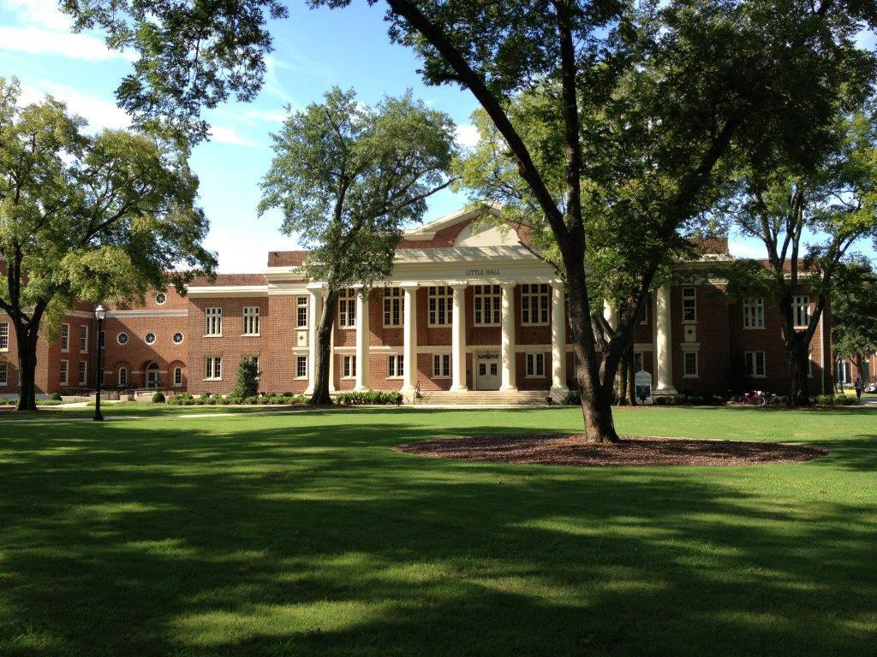

BSW Program Handbook 2023-2024

Revised August 2023

This handbook was prepared to provide information and does not constitute a contract. Although every effort has been made to ensure the accuracy of the information in this University of Alabama BSW Student Handbook, those who use the Handbook should note that policies and procedures change from time to time and the changes may not yet be reflected in this document. In addition, a document of this size cannot include all of the policies and information pertaining to students. More current or complete information may be obtained from your advisor, the Program Director, the Associate Dean, or other appropriate individuals in the School of Social Work or The University of Alabama.

School of Social Work Mission Statement
The University of Alabama’s School of Social Work prepares scholar-practitioners and researchers committed to ending adverse social conditions and promoting societal well-being through teaching, research, and service.

Teaching: We provide students with a high-quality educational experience to prepare them to become tomorrow’s global leaders in the social work field. Our innovative degree programs are designed to produce social workers for today’s workforce.

Research: Our students and highly distinguished faculty researchers use innovation in the classroom and interdisciplinary, research-based knowledge to address social problems, transform lives and develop solutions that change our world for the better.

Service: We provide resources and leadership by partnering with individuals, families, groups, community agencies and organizations at all levels. Our goal is to improve the delivery of social services, with an emphasis on public social services.

As a diverse community of teachers, researchers, learners, and support persons with shared values and aspirations, the school promotes lifelong learning, research, and service initiatives to individuals, families, groups, organizations, and communities.

BSW Program Mission Statement

The BSW Program prepares practitioners committed to promoting social justice and improving the well-being of individuals, families, groups, and communities.

BSW Program Goals
Graduates of the BSW program will be able to:

- Demonstrate skills in generalist social work practice informed by the best available evidence.
- Engage in culturally sensitive and culturally effective social work practice with diverse groups.
- Apply social work values and ethics.
- Advocate for vulnerable and oppressed populations.
- Create sustainable local and global change that improves societal wellbeing.

Diversity, Equity, and Inclusion Statement
The University of Alabama School of Social Work affirms its commitment to affecting an inclusive and equitable work and educational environment that allows diversity to thrive for persons regardless of race, ethnicity, sexual orientation, gender identity or expression, age, citizenship status/nation of origin, political belief, religion, or ability status. Within this commitment is an intentionality to operationalize the frameworks of anti-oppression and social justice so that we are accountable to ourselves, each other, the profession, our students, the School, and the community. We recognize that the university environment is comprised of persons who are multifaceted in their social identities and perspectives. We are committed to cultivating constructive environments within which we resolve to engage each other with empathy, openness, and respect. We are also committed to conversations and actions that hold people and systems accountable. Recognizing the profession’s values of dignity and worth of the person and the importance of human relationships, UASSW will use a restorative and healing approach. By upholding our commitment to anti-racism and social justice within our teaching, research, scholarship, and service, we empower students to advance equity and justice in all domains of practice, thereby improving social, political, economic, environmental, and health outcomes in partnership with the communities our profession serves.

Information Self-Reliance
The School of Social Work is dedicated to preparing social work students to retrieve, identify, and assess information relevant to professional social work practice during their course of study at the school. Our goal is that students be competent to identify, locate, and effectively use information in print and electronic formats. These skills are essential to the competent practice of professional social work. The faculty believes that these competencies not only contribute to the quality of professional practice and scholarship but can also enhance an individual’s lifelong information needs and quality of life (School Policy, adopted by the faculty on April 24, 1996).

Greetings from the

BSW Program Director

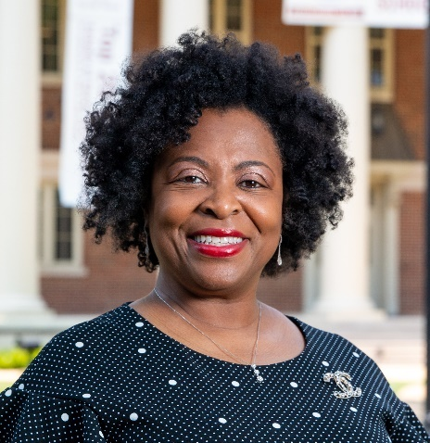

Welcome to the Bachelor of Social Work (BSW) program at The University of Alabama School of Social Work. A degree in social work provides the rare opportunity to learn valuable professional skills while improving the health and wellbeing of individuals, families, and communities. Our administrators, faculty, and staff provide students with rich learning experiences both in the classroom and field practicum, while creating a friendly and supportive community within the larger university campus. Our rigorous academic program prepares BSW graduates for generalist social work practice, graduate study, and any career that requires skills in critical thinking, problem-solving, communication, and inter-professional collaboration. The program emphasizes the value of diversity, equity, and inclusion, and the importance of promoting social and economic justice, which are rooted in the National Association of Social Workers (NASW) Code of Ethics. Graduates of our program are prepared to assist people of all ages, from all walks of life, in a variety of settings. We offer many resources to help our students as they navigate through the BSW Program of study. In this handbook, you will find information regarding requirements for admission to the Professional Program, graduation, and the social welfare minor. As Director of the BSW Program, I am available to answer your questions during my office hours, via e-mail, telephone, or appointment. Other members of administration, faculty, and staff are available, as well, and you can find their contact information on pages 12 through 14.

I wish you the best as you begin this exciting and challenging academic journey in pursuit of your BSW degree or your Social Welfare minor. Again, welcome to The University of Alabama School of Social Work and Roll Tide!

Dr. Sherron Wilkes, DSW, MSW
BSW Program Director, Assistant Professor of Practice
skwilkes@ua.edu
205-348-4750

Table of Contents

School of Social Work Mission Statement 3
BSW Program Mission Statement 3
BSW Program Goals 3
Diversity, Equity, and Inclusion Statement 3
Information Self-Reliance 4
Greetings from the 5
BSW Program Director 5
Purpose of the Handbook 8
The University of Alabama School of Social Work 8
The School of Social Work in the University Context 8
The Baccalaureate Program in Social Work 8
Graduate Programs in Social Work 9
History of the University of Alabama School of Social Work 10
School of Social Work Administrators and Staff 12
School of Social Work Faculty 13
Goals and CSWE Core Competencies of the 15
Undergraduate Program in Social Work 15
School of Social Work Requirements 20
The BSW Program Curriculum 20
Required Courses 20
Curriculum 21
BSW Degree Requirements 23
Optional Writing Assessment 23
Admission to the Professional Program 23
Declaration of a Minor 29
Application for Degree Form 29
Academic Advising and Student Responsibilities 29
Academic Policies 31
Academic Bankruptcy 31
Academic Misconduct 32
Academic Progress and Academic Standing 33
Scholastic Progress Standard (SPS) 33
The University Honors Program 35
Class Attendance, Assignments, and Assessment 38
University-wide Academic Grievance Procedures 39
Voluntary Student Review Process 39
Withdrawal from the University 39
Resources for Students 40
Student Activities 48
Student Organizations 49
Appendix A: Educational Policy and Accreditation Standards 51
Appendix B: Summary of the NASW Code of Ethics 92
Appendix D: Academic Bankruptcy 107
Appendix F: Policy on Plagiarism and Falsification of Data 118
Appendix G: Independent Study Policy and Proposal Form 123
Appendix H: University-wide Academic Grievance Procedures 126
Appendix I: Policies and Procedures for Evaluating Students’ Professional Preparedness 130
Appendix J: The University of Alabama Harassment Policy 134
Appendix K: BSW FAQs 141

Purpose of the Handbook

This handbook has been designed to supplement The University of Alabama 2023-2024 Undergraduate Catalog with details about the BSW Program in the School of Social Work. It provides an overview of the policies governing the BSW Program and of the procedures for successful progress toward the completion of a bachelor’s degree in social work at The University of Alabama. The faculty and staff of the UA School of Social Work provide education, leadership, mentoring, and guidance to assist students in obtaining the maximum possible benefit from their education. For additional advice and/or clarification of policies and procedures, students should consult their assigned academic advisor, student services office personnel, or the BSW Program Director. Please keep in mind that the responsibility for completion of requirements for an undergraduate degree in social work from The University of Alabama rests with the student.

The University of Alabama School of Social Work

The School of Social Work in the University Context
The University of Alabama

The University of Alabama, the state's oldest public university, is the senior comprehensive doctoral- level institution in Alabama. Established by constitutional provision with subsequent statutory mandates and authorizations, the University's purpose is to advance the intellectual and social condition of all the people of the state through quality programs of research, instruction, and service.

The University offers a wide array of continuing educational opportunities to adult and nontraditional students. UA recognizes the importance of educating students to live and work in a global community of increasingly interdependent countries. Additionally, UA’s research and instructional programs form a base for extensive service activities. This extends the University's influence and continuing linkages with business, industry, and government beyond the bounds of the state as it assists developmental efforts at regional, national, and international levels.

The Baccalaureate Program in Social Work

The primary goal of the BSW Program is to prepare students for generalist social work practice. Graduates are prepared to assist people of all ages, from all walks of life, with all kinds of problems in a variety of settings. As generalist practitioners, graduates are prepared with skills to assist individuals, families, groups, organizations, and communities in achieving goals and solving problems. The BSW is the first practice degree. Graduates of the program are expected to work in beginning-level positions under the supervision of an experienced MSW practitioner. The BSW Program also prepares students for graduate study in social work and related fields.

Students can declare a major in social work when they are freshmen, sophomores, or juniors. To take 400- level practice courses, they must be accepted into the Professional Program. The Bachelor of Social Work degree is awarded to students who complete a minimum of 120 semester hours of course work as outlined in the BSW course requirements; achieve a “C-” or better in all courses required by the School of Social Work, including two social work electives; and have a grade point average of at least 2.25 overall GPA and 2.50 GPA in social work courses. A field placement is required during the senior year.

The UA School of Social Work offers a complete 18-credit-hour honors program. Students enrolled in this program will gain extensive knowledge and skills to assist individuals, families, groups, organizations, and communities in achieving goals and solving problems. In congruence with the social work profession, the social work curriculum emphasizes the value of diversity and the importance of the promotion of social and economic justice.

The School of Social Work also offers a minor in Social Welfare. Requirements for an undergraduate minor in Social Welfare include SW 100, SW 200, SW 351, and nine additional hours of social work courses. At least one of the additional courses must be at the 300 level or above.

Students must also maintain a 2.0 overall GPA and a 2.0 resident GPA on all SW courses to earn the social welfare minor.

Graduate Programs in Social Work

The MSW program is designed to educate students for advanced practice and leadership roles. Typically, students complete a one-year sequence of professional foundation courses followed by a year in which they take courses in a specific content area. Students with a BSW from a CSWE- accredited program, however, are eligible to apply to the advanced-standing program, in which the foundation classes are completed in one full-time semester. Our MSW program is available on- campus in Tuscaloosa, as well as in a primarily online format with some face-to-face skills labs on Saturdays in several locations in Alabama. Graduate study at the doctoral level is designed for students who wish to focus on independent scholarship, originality, and competence in research.
Doctoral students prepare for scholarly roles by advancing their knowledge and increasing their skills in theory building, research methods, and critical evaluation of social work policies and practice. See the UA Graduate School Catalog, the handbook for the program of interest, or the School of Social Work website (www.socialwork.ua.edu) for further information.

History of the University of Alabama School of Social Work

The University of Alabama, located in Tuscaloosa, Alabama, is a public coeducational institution that began admitting students in 1831. The School of Social Work was established in 1965 by the Alabama Legislature to address Alabama's critical shortage of and pressing need for professionally educated social workers. The school’s first dean was appointed the following year. The School of Social Work currently offers the degrees of Bachelor of Social Work (BSW), Master of Social Work (MSW), Doctor of Social Work (DSW), and Doctor of Philosophy (PhD) and is the only school in the state of Alabama to offer all four degrees.

The bachelor’s and master’s programs of The University of Alabama School of Social Work are accredited by the Commission on Accreditation of the Council on Social Work Education (CSWE). Accreditation standards established by CSWE guide the way curriculum and other aspects of BSW and MSW programs are evaluated. These standards are described in the CSWE Educational Policy and Accreditation Standards (see Appendix A). Students are encouraged to be familiar with the accreditation process and the standards that guide social work educational programs.

BSW Program

The undergraduate program in social work admitted its first students in 1970. In 1975, the Council on Social Work Education began accrediting BSW programs, and The University of Alabama’s was accredited that year. The program’s accreditation was reaffirmed in 1995 and 2011 for eight years each time, the maximum period for accreditation. Since 1971, the program has conferred over 1600 BSW degrees.

MSW Program

The Council on Social Work Education first accredited the MSW program in 1969, and master’s degrees were first awarded at UA that same year. The program’s accreditation was reaffirmed in 1995 and 2011 for the maximum period of eight years each time. Since 1979, the program has conferred nearly 3,300 MSW degrees. For additional information about the MSW program, please see the website: http://socialwork.ua.edu/academics/msw-program/.

DSW Program

The current DSW program was approved in November 2018, with the first cohort of DSW students beginning in Fall 2019. Given increased demand for advanced clinical and administrative social work education and training, the DSW was created as the state of Alabama’s first practice-based doctorate degree in social work. For additional information about the DSW program, please see the website: https://socialwork.ua.edu/dsw/.

PhD Program

The PhD program began as a Doctor of Social Work (DSW) program in 1975 to prepare teachers and researchers for the social work profession. Over the years, recognizing the need for increased emphasis on research within the profession, the faculty substantially revised the program. It became a Doctor of Philosophy (PhD) program in 1992. It has conferred over 100 doctoral degrees since 1975. For additional information about the PhD program, please see the website: http://socialwork.ua.edu/academics/phd-program/.

School of Social Work Administrators and Staff

Area | Title | Name | Phone | Office | Email
Dean’s Office | Dean | Schnavia Hatcher | 8-3924 | 1002 Little Hall | schnavia.hatcher@ua.edu
 | Administrative Operations Coord / Dean’s Assistant | Darcel Green | 8-3924 | 1001 Little Hall | dmgreen@ua.edu
 | Executive Director of Strategic Initiatives | Ruth Pionke | 8-3935 | 1022 Little Hall | ruth.pionke@ua.edu
 | Associate Director of Development (SSW & CCHS) | Taylor Mooney | 8-7109 | 1005 Little Hall | taylor.mooney@ua.edu
 | Program Assistant  Development & Events & Alumni Relations | TBD | 8-2509 | 1006 Little Hall | TBD
Fiscal | Director of Financial Affairs | Angela Young-Hobbs | 8-3436 | 1008 Little Hall | alyoung4@ua.edu
 | Accounting Specialist | Latoria Jackson | 8-3949 | 1007 Little Hall | lcjackson5@ua.edu
 | Accountant I | Megan Stewart | 8-3923 | 1004 Little Hall | mstewart@ua.edu
 | Accounting Assistant | Lynisha Glenn | 8-3928 | 1007 Little Hall | lcglenn@ua.edu
Student Services | Associate Dean of Educational Programs and Student Services | Sebrena Jackson | 8-4726 | 1034 Little Hall | msjackson5@ua.edu
 | Program Assistant  Educational Programs and  Student Services | Nakia Washington | 8-5020 | 1033 Little Hall | nswashington@ua.edu
 | Manager of Student Services | Morion Siler | 8-5897 | 1003 Little Hall | mtsiler@ua.edu
 | Student Services Coordinator  (BSW Advising) | Mary Sella | 8-8557 | 1028 Little Hall | msella@sw.ua.edu
 | Student Services Coordinator (MSW Advising) | Aubree Cuip | 8-4547 | 1027 Little Hall | ajcuip@ua.edu
 | Recruitment Coordinator | Dre Vaden | 8-5272 | 2031 Little Hall | apvaden@ua.edu
 | Recruitment Coordinator | Brooke McCorkle | 8-5405 | 2031 Little Hall | bdgann@ua.edu
Educational Programs | DSW & PhD Program Assistant  (Alameda-Lawson & Nelson-Gardell) | Becky Allen | 8-0798 | 1029 Little Hall | allen030@ua.edu
 | MSW Program Assistant  (John) | LeCretia Crumpton | 8-3944 | 1009 Little Hall | lscrumption@ua.edu
 | BSW Program Assistant  (Wilkes) | Christie Crow | 8-4683 | 1009 Little Hall | crcrow@ua.edu
 | Field Program Specialist  (Thomas) | Debbie Swift | 8-5544 | 2015 Little Hall | ringram3@ua.edu
 | Program Manager  Distance Education Programs | Chris Blackmon | 8-4669 | 3013 Little Hall | cblackmon2@ua.edu
 | Coordinator of Field Placements | Destiny Thomas | 8-4998 | 2022 Little Hall | dbmcfall@ua.edu
Admin Services | Program Assistant  Admin Services & Special Projects  (Green, Pionke, & Smith) | TBD | 8-7027 | 1020 Little Hall | TBD
 | Communications Specialist | Ambre Adams | 8-4686 | 1025 Little Hall | ambre.adams@ua.edu
 | Coordinator of Events and Alumni Relations | Brie Campbell | 8-5384 | 1012 Little Hall | bacampbell6@ua.edu
Research | Associate Dean of Research | Nicole Ruggiano | 8-4654 | 129 Farrah Hall | nruggiano@ua.edu
 | Grants and Contracts Specialist | Amber Skinner | 8-8750 | 127 Farrah Hall | amber.skinner@ua.edu
 | Program Assistant Research | Angela Stevens | 8-0626 | 127 Farrah Hall | astevens@ua.edu
 | Project Coordinator for Dr. Lee | Shaquita Chapman | 8-6875 | 110 Farrah Hall | smchapman@ua.edu
Title IV-E  (Cain) | Coordinator & Training Specialist | Kristy Holt | 8-0753 | 1605 Capital Hall | krholt@sw.ua.edu
 | Stipend Program Coordinator | Melody Denton | 8-0207 | 1605 Capital Hall | mjdenton@ua.edu
 | Simulation Program Coordinator | Donna Harrison | 8-5277 | 1605 Capital Hall | donna.l.mccall@ua.edu

YSI  (partial list) | Director | Jill Beck | 8-2992 | 1500 Greensboro #3 | jrbeck2@ua.edu
 | Associate Director | Mandi R. Fowler | 8-5771 | 1500 Greensboro #3 | fowle014@sw.ua.edu
 | Program Assistant YSI | Angelia Gaddis | 8-4718 | 1500 Greensboro #3 | agaddis@sw.ua.edu
 | Accounting Assistant YSI | Karen Hannah | 8-8226 | 1500 Greensboro #3 | khannah@sw.ua.edu
 | Proposal Development Admin | Monica Roland | 205-586-1109 | 1500 Greensboro #3 | mphardenroland@ua.edu
 | Office Associate II YSI | Nate Owens | 8-6625 | 1500 Greensboro #3 | nrowens@ua.edu

WOW  (partial list) | Director | Jacalyn Tippey | 205-343-2880 | 6001 12th Ave E., Suite B | jtippe001@ua.edu
 | Assistant Director | Barry Waltman | 205-343-2874 | 6001 12th Ave E., Suite B | bwaltman@ua.edu
 | Office Associate II | Maggie Moore | 205-343-2883 | 6001 12th Ave E., Suite B | mmoore99@ua.edu
 | Control Room |  | 205-343-2875 | 6001 12th Ave E., Suite B
 | Control Room |  | 205-343-2876 | 6001 12th Ave E., Suite B

School of Social Work Faculty
Alameda-Lawson, Tania | 8-4396 | 1031 Little Hall | talamedalawson@sw.ua.edu | Associate Professor
Brunson, Amie | 8-3942 | 3022 Little Hall | abrunson1@ua.edu | Clinical Assistant Professor
Cain, Daphne | 8-9902 | 114 Farrah Hall | dscain@ua.edu | Professor
Carlson, Catherine | 8-0204 | 3027 Little Hall | ccarlson5@ua.edu | Associate Professor
Cheatham, Leah | 8-4655 | 3007 Little Hall | lpcheatham@ua.edu | Associate Professor
Csikai, Ellen | 8-4447 | 2028 Little Hall | ecsikai@sw.ua.edu | Professor
Davis, Curtis | 8-4323 | 3005 Little Hall | chdavis3@ua.edu | Assistant Professor
Giorgio Cosenzo, Luciana | 8-6791 | 3006 Little Hall | luciana.giorgio@ua.edu | Assistant Professor
Hatcher, Schnavia | 8-3924 | 1002 Little Hall | schnavia.hatcher@ua.edu | Dean and Professor
Hopson, Laura | 8-5270 | 2006 Little Hall | lmhopson@sw.ua.edu | Associate Professor
Jackson, M. Sebrena | 8-4726 | 1034 Little Hall | msjackson5@ua.edu | Associate Dean and Associate Professor
John, Dalila | 8-4731 | 1010 Little Hall | djohn2@ua.edu | Clinical Assistant Professor
Johnson, Karen | 8-3939 | 2005 Little Hall | kjohnson38@ua.edu | Assistant Professor
King, Dione | 8-2958 | 3026 Little Hall | dmoultrie@ua.edu | Associate Professor
Lee, Hee | 8-6553 | 2024 Little Hall | hlee94@ua.edu | Professor
Lee, Hyunjune | 8-0527 | 3008 Little Hall | hlee111@ua.edu | Assistant Professor
Lee, Lewis | 8-4822 | 3010 Little Hall | lhlee@ua.edu | Assistant Professor
Littleton, Tenesha | 8-0049 | 2007 Little Hall | tlittleton@ua.edu | Assistant Professor
McLean, Amy | 8-3926 | 3012 Little Hall | ahmclean@ua.edu | Instructor
Nelson-Gardell, Debra | 8-2990 | 1030 Little Hall | dnelsong@sw.ua.edu | Associate Professor
Noh, Hyunjin | 8-5265 | 3020 Little Hall | hnoh1@sw.ua.edu | Associate Professor
Olson, Lindamarie | 8-5571 | 200 Little Hall | 1eolson2@ua.edu | Assistant Professor
Payne, Nancy | 8-2186 | 3019 Little Hall | ngpayne@sw.ua.edu | Instructor Senior
Rhodes, Jennifer | 8-4207 | 3025 Little Hall | jrrhodes@ua.edu | Instructor
Ruggiano, Nicole | 8-4654 | 129 Farrah Hall | nruggiano@ua.edu | Associate Dean and Professor
Scales, Jade | 8-2498 | 2030 Little Hall | jawatters@ua.edu | Instructor
Scott, Uraina | 8-0206 | 3023 Little Hall | ulscott@ua.edu | Clinical Assistant Professor
Shah, Avani | 8-3937 | 3021 Little Hall | shah009@sw.ua.edu | Associate Professor
Simon, Cassandra | 8-4586 | 2008 Little Hall | csimon@ua.edu | Associate Professor
Smith, Brenda | 8-6528 | 2027 Little Hall | bsmith2@sw.ua.edu | Professor
Smith, Shayla | 8-4529 | 2012 Little Hall | stsmith7@sw.ua.edu | Instructor Senior
Starks, Karen | 8-6766 | 112 Farrah Hall | kcanada@sw.ua.edu | Clinical Assistant Professor
Thomas, Courtney | 8-3934 | 2016 Little Hall | courtney.thomas@ua.edu | Instructor
Traylor, Amy | 8-2189 | 2017 Little Hall | atraylor@sw.ua.edu | Associate Professor
Trosper, Peggy | 8-7764 | 3009 Little Hall | pswails@ua.edu | Instructor
Turner, Carrie | 8-7278 | 2011 Little Hall | ceturner6@ua.edu | Instructor Senior
Welker, Kathleen | 8-0033 | 2032 Little Hall | kwelker@sw.ua.edu | Instructor Senior
Wilkes, Sherron | 8-4750 | 1011 Little Hall | skwilkes@ua.edu | Clinical Assistant Professor

Goals and CSWE Core Competencies of the

Undergraduate Program in Social Work
Goals of the BSW Program

Graduates of the BSW program will be able to:

- Demonstrate skills in generalist social work practice informed by the best available evidence.
- Engage in culturally sensitive and effective social work practice with diverse groups.
- Apply social work values and ethics.
- Advocate for vulnerable and oppressed populations.
- Create sustainable local and global change that improves societal wellbeing.
CSWE Core Competencies
Competency 1: Demonstrate Ethical and Professional Behavior
Competency 2: Advance Human Rights and Social, Racial, Economic, and Environmental Justice
Competency 3: Engage Anti-Racism, Diversity, Equity, and Inclusion (ADEI) in Practice
Competency 4: Engage in Practice-Informed Research and Research-Informed Practice
Competency 5: Engage in Policy Practice
Competency 6: Engage with Individuals, Families, Groups, Organizations, and Communities
Competency 7: Assess Individuals, Families, Groups, Organizations, and Communities
Competency 8: Intervene with Individuals, Families, Groups, Organizations, and Communities
Competency 9: Evaluate Practice with Individuals, Families, Groups, Organizations, and Communities

Program Competencies

The following are the core competencies that guide the BSW curriculum, instruction, and assessment. Details of the CSWE competencies can be found in Appendix A.

Competency 1: Demonstrate Ethical and Professional Behavior

Social workers understand the value base of the profession and its ethical standards, as well as
relevant policies, laws, and regulations that may affect practice with individuals, families, groups,
organizations, and communities. Social workers understand that ethics are informed by principles
of human rights and apply them toward realizing social, racial, economic, and environmental
justice in their practice. Social workers understand frameworks of ethical decision making and
apply principles of critical thinking to those frameworks in practice, research, and policy arenas.
Social workers recognize and manage personal values and the distinction between personal and
professional values. Social workers understand how their evolving worldview, personal experiences,
and affective reactions influence their professional judgment and behavior. Social workers take
measures to care for themselves professionally and personally, understanding that self-care is
paramount for competent and ethical social work practice. Social workers use rights-based, anti-racist, and anti-oppressive lenses to understand and critique the profession’s history, mission,
roles, and responsibilities and recognize historical and current contexts of oppression in shaping
institutions and social work. Social workers understand the role of other professionals when engaged
in interprofessional practice. Social workers recognize the importance of lifelong learning and
are committed to continually updating their skills to ensure relevant and effective practice. Social
workers understand digital technology and the ethical use of technology in social work practice.

Social workers:
- make ethical decisions by applying the standards of the National Association of Social Workers Code of Ethics, relevant laws and regulations, models for ethical decision making, ethical conduct of research, and additional codes of ethics within the profession as appropriate to the context
- demonstrate professional behavior; appearance; and oral, written, and electronic communication
- use technology ethically and appropriately to facilitate practice outcomes; and
- use supervision and consultation to guide professional judgment and behavior.

Competency 2: Advance Human Rights and Social, Racial, Economic, and Environmental Justice

Social workers understand that every person regardless of position in society has fundamental human rights. Social workers are knowledgeable about the global intersecting and ongoing injustices throughout history that result in oppression and racism, including social work’s role and response. Social workers critically evaluate the distribution of power and privilege in society in order to promote social, racial, economic, and environmental justice by reducing inequities and ensuring dignity and respect for all. Social workers advocate for and engage in strategies to eliminate oppressive structural barriers to ensure that social resources, rights, and responsibilities are distributed equitably and that civil, political, economic, social, and cultural human rights are protected.

Social workers:
- advocate for human rights at the individual, family, group, organizational, and community system levels; and
- engage in practices that advance human rights to promote social, racial, economic, and environmental justice.

Competency 3: Engage Anti-Racism, Diversity, Equity, and Inclusion (ADEI) in Practice

Social workers understand how racism and oppression shape human experiences and how these two
constructs influence practice at the individual, family, group, organizational, and community levels
and in policy and research. Social workers understand the pervasive impact of White supremacy
and privilege and use their knowledge, awareness, and skills to engage in anti-racist practice. Social
workers understand how diversity and intersectionality shape human experiences and identity
development and affect equity and inclusion. The dimensions of diversity are understood as the
intersectionality of factors including but not limited to age, caste, class, color, culture, disability and
ability, ethnicity, gender, gender identity and expression, generational status, immigration status, legal status, marital status, political ideology, race, nationality, religion and spirituality, sex, sexual
orientation, and tribal sovereign status. Social workers understand that this intersectionality means
that a person’s life experiences may include oppression, poverty, marginalization, and alienation
as well as privilege and power. Social workers understand the societal and historical roots of
social and racial injustices and the forms and mechanisms of oppression and discrimination. Social
workers understand cultural humility and recognize the extent to which a culture’s structures and
values, including social, economic, political, racial, technological, and cultural exclusions, may
create privilege and power resulting in systemic oppression.

Social workers:
- demonstrate anti-racist and anti-oppressive social work practice at the individual, family, group, organizational, community, research, and policy levels; and
- demonstrate cultural humility by applying critical reflection, self-awareness, and self-regulation to manage the influence of bias, power, privilege, and values in working with clients and constituencies, acknowledging them as experts of their own lived experiences.

Competency 4: Engage in Practice-Informed Research and Research-Informed Practice

Social workers use ethical, culturally informed, anti-racist, and anti-oppressive approaches in
conducting research and building knowledge. Social workers use research to inform their practice
decision making and articulate how their practice experience informs research and evaluation
decisions. Social workers critically evaluate and critique current, empirically sound research to inform decisions pertaining to practice, policy, and programs. Social workers understand the inherent bias in research and evaluate design, analysis, and interpretation using an anti-racist and anti-oppressive perspective. Social workers know how to access, critique, and synthesize the current literature to develop appropriate research questions and hypotheses. Social workers demonstrate knowledge and skills regarding qualitative and quantitative research methods and analysis, and they interpret data derived from these methods. Social workers demonstrate knowledge about methods to assess reliability and validity in social work research. Social workers can articulate and share research findings in ways that are usable to a variety of clients and constituencies. Social workers understand the value of evidence derived from interprofessional and diverse research methods, approaches, and sources.

Social workers:
- apply research findings to inform and improve practice, policy, and programs; and
- identify ethical, culturally informed, anti-racist, and anti-oppressive strategies that address inherent biases for use in quantitative and qualitative research methods to advance the purposes of social work.

Competency 5: Engage in Policy Practice

Social workers identify social policy at the local, state, federal, and global level that affects well-being,
human rights and justice, service delivery, and access to social services. Social workers recognize the historical, social, racial, cultural, economic, organizational, environmental, and global influences that affect social policy. Social workers understand and critique the history and current structures of social policies and services and the role of policy in service delivery through rights-based, anti-oppressive, and anti-racist lenses. Social workers influence policy formulation, analysis, implementation, and evaluation within their practice settings with individuals, families, groups,
organizations, and communities. Social workers actively engage in and advocate for anti-racist and
anti-oppressive policy practice to effect change in those settings.

Social workers:
- use social justice, anti-racist, and anti-oppressive lenses to assess how social welfare policies affect the delivery of and access to social services; and
- apply critical thinking to analyze, formulate, and advocate for policies that advance human rights and social, racial, economic, and environmental justice.

Competency 6: Engage with Individuals, Families, Groups, Organizations, and Communities

Social workers understand that engagement is an ongoing component of the dynamic and
interactive process of social work practice with and on behalf of individuals, families, groups,
organizations, and communities. Social workers value the importance of human relationships. Social
workers understand theories of human behavior and person-in-environment and critically evaluate and apply this knowledge to facilitate engagement with clients and constituencies, including individuals, families, groups, organizations, and communities. Social workers are self-reflective and understand how bias, power, and privilege as well as their personal values and personal experiences may affect their ability to engage effectively with diverse clients and constituencies. Social workers use the principles of interprofessional collaboration to facilitate engagement with clients, constituencies, and other professionals as appropriate.

Social workers:
- apply knowledge of human behavior and person-in-environment, as well as interprofessional conceptual frameworks, to engage with clients and constituencies; and
- use empathy, reflection, and interpersonal skills to engage in culturally responsive practice with clients and constituencies.

Competency 7: Assess Individuals, Families, Groups, Organizations, and Communities

Social workers understand that assessment is an ongoing component of the dynamic and interactive process of social work practice. Social workers understand theories of human behavior and person-in-environment, as well as interprofessional conceptual frameworks, and they critically evaluate and apply this knowledge in culturally responsive assessment with clients and constituencies, including individuals, families, groups, organizations, and communities. Assessment involves a collaborative process of defining presenting challenges and identifying
strengths with individuals, families, groups, organizations, and communities to develop a mutually
agreed-upon plan. Social workers recognize the implications of the larger practice context in the
assessment process and use interprofessional collaboration in this process. Social workers are self-reflective and understand how bias, power, privilege, and their personal values and experiences may affect their assessment and decision making.

Social workers:
- apply theories of human behavior and person-in-environment, as well as other culturally responsive and interprofessional conceptual frameworks, when assessing clients and constituencies; and
- demonstrate respect for client self-determination during the assessment process by collaborating with clients and constituencies in developing a mutually agreed-upon plan.
Competency 8: Intervene with Individuals, Families, Groups, Organizations, and Communities

Social workers understand that intervention is an ongoing component of the dynamic and
interactive process of social work practice. Social workers understand theories of human behavior,
person-in-environment, and other interprofessional conceptual frameworks, and they critically
evaluate and apply this knowledge in selecting culturally responsive interventions with clients
and constituencies, including individuals, families, groups, organizations, and communities. Social
workers understand methods of identifying, analyzing, and implementing evidence-informed
interventions and participate in interprofessional collaboration to achieve client and constituency
goals. Social workers facilitate effective transitions and endings.

Social workers:
- engage with clients and constituencies to critically choose and implement culturally responsive, evidence-informed interventions to achieve client and constituency goals; and
- incorporate culturally responsive methods to negotiate, mediate, and advocate with and on behalf of clients and constituencies.

Competency 9: Evaluate Practice with Individuals, Families, Groups, Organizations,
and Communities

Social workers understand that evaluation is an ongoing component of the dynamic and
interactive process of social work practice with and on behalf of diverse individuals, families,
groups, organizations, and communities. Social workers evaluate processes and outcomes to
increase practice, policy, and service delivery effectiveness. Social workers apply anti-racist and
anti-oppressive perspectives in evaluating outcomes. Social workers understand theories of
human behavior and person-in-environment, as well as interprofessional conceptual frameworks,
and critically evaluate and apply this knowledge in evaluating outcomes. Social workers use
qualitative and quantitative methods for evaluating outcomes and practice effectiveness.

Social workers:
- select and use culturally responsive methods for evaluation of outcomes; and
- critically analyze outcomes and apply evaluation findings to improve practice effectiveness with individuals, families, groups, organizations, and communities.

School of Social Work Requirements

Students accepted to The University of Alabama as freshmen may enter the School of Social Work as majors. The school accepts transfer credits according to University policy (see the Undergraduate Catalog), but also requires students to meet the course requirements for the BSW degree. UA students who have grade point averages of 2.0 or higher for all college work may transfer from other divisions into the School of Social Work.

Residency

Questions regarding resident and nonresident status should be directed to the Office of the University Registrar. The office is in room 206 of the Student Services Center, Box 870134, Tuscaloosa, AL 35487-0134; (205) 348-2020.

The BSW Program Curriculum
Social Work majors spend much of their first two years completing general requirements and introductory social work courses. To be eligible for the professional courses in the program, they must be accepted into the Professional Program. The Professional Program includes courses in social welfare policy; human behavior in the social environment; practice with individuals, families, groups, organizations, and communities; social work research; and field education and seminars.

Students must also complete two social work electives. These can be completed before beginning the Professional Program or while in the Professional Program.

Required Courses

A list of required courses, a course requirement sheet, a sample schedule, and a schedule planning form are provided in Appendix C. The sample schedule shows one way a student may complete their program of study. Students can also log into the DegreeWorks system through their MyBama accounts to complete an online academic plan.

The freshman and sophomore years are flexible, but flexibility decreases once the student enters the Professional Program. Students have flexibility regarding most of the courses they take as part of their core university requirements—which courses they take and when they take them. Some courses, however, are prerequisites for the Professional Program, and the students’ advisors will help them plan an appropriate schedule. The courses in bold in Appendix C are especially important to take when advised because they are prerequisites for certain required courses.

Curriculum

Five basic components of the BSW Program prepare the student for practice as a generalist social worker:
      - Required liberal arts courses
      - Elective courses
      - Required social work courses
      - Elective social work courses
      - Supervised social work field education

Another way to look at the curriculum is to consider the general studies requirements (typically completed during the freshman and sophomore years) and the professional course sequence (completed in the junior and senior years). Most courses fall into these categories.

The following courses are required for the BSW degree and include University Core Curriculum requirements as well as the state’s general education requirements.

Courses Hours
Two of the following courses¹ 6
AAST 201; ANT 100, ANT 102, ANT 103, ANT 225; BUI 102; COM 220; EC 110 or 112 (honors),
EC 111 or 113 (honors); GY 105; PSC 101, PSC 211, PSC 370; SOC 202
Statistics (BER 345, CJ 381, PY 211, or ST 260) 3
BSC 108 with lab or BSC 109 with lab (N), or BSC 114/115, or BSC 116/117 4
COM 123 or 124 (honors) or COM 122 or 121 (honors) (H) 3
EN 101 and EN 102, or EN 103 (FC) 3-6
HY 101, HY 102, HY 105, HY 106, HY 117 or HY 118 (HI)² 3
PY 101 or PY 105 (honors) (SB) 3
PY 358 or SW 415 3
SOC 101 (SB) 3
SOC 205 or PY 372 3
SW 100 or SW 105 (honors) 3
SW 101 3
SW 200 or SW 205 (honors) 3
SW 310 3
SW 351 (W) or SW 355 (W/ honors) 3
SW 401 (W) or SW 405 (W/ honors) 3
SW 410 3
SW 411 3
SW 420 or SW 425 (honors) 3
SW 4404 (W) 3
SW 4414 3
SW 4424 3
SW 444 1
SW 443 3
SW 490 9
Fine arts (FA) 3
Foreign language (FL) 3–8
Free electives 4–8
Humanities (HU) or fine arts (FA) or literature electives (L)² 3
Literature (L)² 3
Mathematics (MA)³ 3
Natural science with lab (N) 4
Social work electives (two courses) 6

Total: 120

¹At least one course must hold the SB designation and the two courses selected must not be from the same department.
²Students must have a two-course sequence in either HY or L.
³Math courses have prerequisites that must be met.
4Distance learning students completing these courses must also register for in-person skills labs

BSW Degree Requirements

The Bachelor of Social Work Degree is awarded to students who satisfactorily meet several requirements. Some are University requirements, and some are specific to the School of Social Work. Students must:

- Complete a minimum of 120 semester hours of coursework as outlined in the BSW course requirements.
- A minimum of 50 percent (60 hours) of the coursework required to earn a BSW degree at The University of Alabama must be earned at a bachelor’s degree granting institution (four-year college or university), and a minimum of 25 percent (30 hours) of the coursework required for the BSW degree must be earned at The University of Alabama. (http://catalog.ua.edu/undergraduate/about/academic-regulations/curriculum/graduation/)
- Achieve a “C-” or better in all courses required by the School of Social Work, including two social work electives.
- Have grade point averages of at least 2.25 overall and 2.5 in social work courses (students who have transferred must have a “C-” average at this institution) to graduate from the program.
- Be admitted into the Professional Program.
- Successfully complete their field education experience.
- Notify the School of their intention to graduate a) in the semester preceding the expected term of graduation or, b) no later than the beginning of the last semester of enrollment prior to graduation. Deadlines can be found in the Academic Calendar
- Pass all courses taken and prescribed for the degree during the last semester.

Optional Writing Assessment

Students under any catalog before the 2023-2024 Undergraduate Catalog are eligible to take an optional writing assessment to test out of SW 310. Students must earn a minimum grade of B- on the optional writing assessment in SW 101 (Orientation to Social Work) to test out of SW 310, Professional Writing Seminar. Students who have not earned a “B-” or better on the writing assessment will be required to enroll in SW 310, Professional Writing Seminar, prior to applying for the Professional Program.

Students enrolled under the 2023-2024 Undergraduate Catalog or later are not eligible to take the Optional Writing Assessment and must take SW 310. There are no options for testing out of SW 310 for these students.

Admission to the Professional Program

After the completion of 54 hours toward the social work degree with the required overall and social work GPAs, students who have been admitted to the Professional Program begin taking the 400-level professional social work courses. The priority deadline for application to enter the Professional Program in social work (i.e., junior, and senior level social work courses) is February 15th of each year for admission in the following fall semester and September 15 of each year for spring semester admission. Applications will be emailed to eligible students prior to the priority deadline in the semester before beginning the Professional Program.

Once submitted, applications will be reviewed and scored by School of Social Work faculty members. Students who are admitted must maintain an overall GPA of at least 2.25 and a social work GPA of 2.5 through the semester they apply, or the offer of admission will be withdrawn.

Students must also maintain a 2.25 overall GPA and a 2.5 social work GPA throughout matriculation in the Professional Program. Decisions about admission to the Professional Program for students who submitted their applications after the priority application deadline are made as soon as possible but may not be made before some University classes are full. Therefore, it behooves students to submit their applications before the application deadline.
Prerequisites for Admission to the Professional Program
To apply for admission to the Professional Program, students are expected to have completed at least 45 hours toward the degree with an overall grade point average of at least 2.25 and an earned Social Work grade point average of 2.5. To be admitted unconditionally, students must have completed at least 54 hours toward their degree and have completed 10 semester hours of the following courses (or their equivalents in other institutions): SOC 101, PY 101, BSC 108 or 109, and be enrolled in the other prerequisite courses at the time of application. Honors equivalents of courses are acceptable. Students must have qualified for UA Core Curriculum/General Studies-level math courses by placement score or by having earned a “C-” or higher in MATH 100.

Students must have also completed the “pre-professional” social work courses SW 101, SW 100 or 105, SW 200 or 205, SW 310, and SW 351 or SW 355 or their equivalents at other institutions with a C- of higher to be unconditionally admitted. Students must have earned a social work grade point average of at least 2.5.

Professional Program Application Process

Students eligible to apply for the Professional Program should complete the Qualtrics checklist and application that will be emailed to them. Those who have not met each prerequisite should discuss their eligibility with their advisor. Some students may be eligible for conditional admission. Students should complete the application checklist and the application, including the essays and Field Statement. These essays constitute an important part of the application process and will be reviewed and scored by School of Social Work faculty members. These faculty members will not know the names of the applicants whose essays they are reviewing and can recommend that a student be admitted or denied admission into the Professional Program. They can also recommend that the Program Director meet with an applicant to gather additional information. Thus, it is important that students put forth their best effort when writing these essays. The priority deadline is February 15th for fall admission and September 15th for spring admission.

Removal of Conditional Admission Standing

A student admitted to the Professional Program with conditional standing must remove the conditional standing according to the requirements stated in the admission letter to gain full admission to the Professional Program. It is the student’s responsibility to meet the conditions set forth and to notify his/her advisor when those conditions have been met. The advisor will then notify the Program Director, who will notify the Registrar. Students who do not have their conditional standing formally removed will not be allowed to continue to enroll in Professional Program classes.

Field Education (SW 490)

As a part of the professional social work curriculum, social work majors are required to complete SW 490, a nine-credit hour course in field education and SW 443, a field education seminar during the fall semester of the senior year. SW 420 or SW 425, a research class, must be taken prior to or concurrently with SW 490 and SW 443 or SW 445. Course prerequisites for SW 490 include SW 100 or 105, 101, 200 or 205, 310, 351 or 355, 401 or 405, 410, 411, 440, 441, 442, and 444. All
400-level courses must have been completed with a grade of “C-” or better before a student can enroll in SW 490 and SW 443. In addition, students must have passed the required statistics class. Admission to field education requires an overall GPA of 2.25 and a GPA of 2.5 in social work courses. Students on probation and those with a grade of “I” in any social work course will not be admitted to field education nor will conditionally admitted students who have not met their conditions.

Many agencies provide field education experiences for our students. Placements are recommended by the field coordinator based on the student’s areas of interest and learning needs. Students must then interview with the recommended agency. The field practicum requires 450 clock hours during the semester with the student in the agency four days each week. Field hours are completed during normal agency business hours (8:00 a.m.-5:00 p.m.) for a minimum of 16 hours per week when their field instructor is on duty and available to the student. Students are responsible for their own transportation to their agency. The Field Education Handbook, found on the School of Social Work website, provides detailed information about the field experience.
Field Instructors and Field Liaisons

Students are supervised by a field instructor—an individual with a master’s degree in social work, usually someone employed at the agency. The School of Social Work assigns a field liaison for each student. The field liaison meets with the student and the field instructor at least twice during the practicum and is available to both the instructor and the student for discussions of the field experience and assistance with resolving any problems that may arise.
Policies and Procedures for Assigning Students to Field Education Sites

The field practicum (SW 490) is an educational experience. Consequently, the placement of students is based upon the educational needs of the student. The school will consider personal factors related to the location of placements, but the primary concern is the placement of the student in a setting judged to have the best potential for promoting the student’s professional development. Students in the Main Campus program will be placed within 60 miles of Tuscaloosa; in Washington, DC; or in an international placement. Students in the online, distance learning program wishing to complete placement in Alabama, typically within 60 miles of their home if they live in Alabama. Students in the distance learning program living outside of Alabama who wish to complete their placement in Alabama will be placed within 60 miles of the closest state border. Online, distance learning students are also eligible for placement in Washington, DC or internationally. At this time, online distance learning students are not eligible to compete their placements in any location other than the ones mentioned above. Please see the Field Education Handbook, found on the School of Social Work website, for additional information about field education.

Misdemeanors and Felonies

Social Work students who have been charged with or convicted of a misdemeanor or felony should be aware of the following:

- All BSW students preparing to enter field placement are expected to submit ABI/FBI background checks prior to beginning their field placement. BSW students should get their forms from the Field Education Office during the spring semester. Additional information about the background check is available in the Field Education Handbook.
- Many agencies will not accept students for placement if the student has not been cleared prior to the beginning of field placement. The Field Education Office will not place students without background clearance.
- Some state licensure laws for social workers (including Alabama’s) inquire about whether the applicant has been charged with or convicted of a misdemeanor or a felony prior to allowing the applicant to sit for the licensure examination.

The school strongly recommends that any student or prospective student in this situation make an appointment with his or her advisor or the Associate Dean to discuss how best to address this issue.
Primarily Online Distance Learning BSW Program

The BSW Program offers students the option to complete their degree via Distance Learning through University of Alabama Online. Students are required to have access to a computer with a high-speed internet connection.

Prior to the start of the program, all students are required to attend a one-day on-campus orientation. Students who do not attend orientation may be administratively withdrawn from the program. In addition, distance learning students are required to complete the UA “Bama Ready” orientation before registering for classes for the first time. Students who do not complete this orientation will not be cleared for registration. Students are also required to meet with an advisor in the School of Social Work for an initial advising session before registering for classes.
The distance learning program consists of 120 hours of coursework and includes the same general education requirements, major courses, electives, and field education as required for main campus students. Most coursework can be completed online, although some Professional Program courses (SW 440, SW 441, and SW 442) require that students attend in-person skills labs, which meet on select Saturdays. Skills labs will be offered in Tuscaloosa, and may be offered in Huntsville, Birmingham, Mobile and Montgomery, depending on the number of students enrolled in those areas.
Field education (SW 490) is also completed in person. Field education is completed in the fall semester of the senior year. Students are required to successfully complete 450 hours under the supervision of an experienced social worker in a social service agency, typically within 60 miles of their home if the student lives in Alabama. Students in the distance learning program living outside of Alabama who wish to complete their placement in Alabama will be placed within 60 miles of the closest state border. Online distance learning students are also eligible for placement in Washington, DC or internationally. At this time, online distance learning students are not eligible to complete their placements in any locations other than the ones mentioned above. Field hours are completed during normal agency business hours (typically 8:00 a.m.-5:00 p.m.) for a minimum of 32 hours per week when their field instructor is on duty and available to the student.
Prior to entering the field, students must earn a grade of C- or higher in SW 444, attend a three-hour orientation to field education and obtain a background check. Corequisites include enrolling in field seminar (SW 443).
Changing Campus Status
A student can only change status from campus to distance learning one time, and students must change before taking SW 444. Once a student has taken SW 444, permission to change status will be granted only in extreme circumstances. So, if a student changes from a main campus learner to a distance learner, they will not be able to switch back to being a campus learner (and vice versa). Also, distance learners do not have student activity privileges. Student activity privileges include access to Student Recreation Center, Student Health Center, student football tickets, etc. Students will have access to academic resources, such as the libraries, Capstone Center for Student Success, tutoring, Writing Center, and student success coaching. In additional while they will not have access to student football tickets, they are welcome to attend any other sporting event as a student. Students wishing to change status from main campus to distance learning (or vice versa) should contact their academic advisor and the BSW Program Director for more information.

BSW Honors Program
BSW Honors Program Description

Students taking Social Work Honors classes will gain extensive knowledge and skills to assist individuals, families, groups, organizations, and communities in achieving goals and solving problems. In congruence with the social work profession, the honors social work curriculum emphasizes the value of diversity and the importance of the promotion of social and economic justice. Students who have declared social work as a major and who are enrolled in the UA Honors College, as well as students who are eligible for enrollment in the Honors College, are eligible to take Honors classes in the School of Social Work. Students who are eligible for, but not currently enrolled in, the Honors College, who wish to take Social Work Honors class must receive permission from the BSW Program Director. Distance Learning students are not eligible to enroll in the Honors College or take Honors classes at UA at this time.

The benefits of taking Honors courses in the School of Social Work are many. Classes are typically smaller, which allows students to take deeper dives into the content they are studying and focus on areas of particular individual interest in a way that traditional classes may not allow. Faculty teaching these classes may be able to incorporate field trips or other activities that would not be feasible with a larger class. The smaller classes also allow students to develop stronger bonds among one another. Finally, students are able to develop stronger connections with faculty, which is beneficial for professional and academic development.

Social Work classes that have Honors equivalents are:
- SW 100: Intro to the Fields of Social Work (SW 105 is Honors equivalent.)
- SW 200: History of Social Welfare in the US (SW 205 is Honors equivalent.)
- SW 351: Oppression and Social Injustice (SW 355 is Honors equivalent.)
- SW 401: Social Welfare Policy (SW 405 is Honors equivalent.)
- SW 420: Research for Social Work Practice (SW 425 is Honors equivalent.)

For more information about the UA Honors College, including eligibility requirements and applications, visit https://honors.ua.edu/.

Declaration of a Minor

Students in the BSW Program are not required to have a minor. A student may declare a minor course of study in another college or school of the University, subject to the requirements of the department offering the minor. Requirements for minors are outlined in the University’s 2023- 2024 Undergraduate Catalog. Students who wish to complete a minor should first speak with their Social Work advisor and an advisor in the minor department. Then, the student should log in to MyBama and click the “student” tab. Under the “student services” tab, the student should then click the “change of major/minor” tab and type in their CWID. The student will then be provided the instructions for completing the form. Upon graduation, with completion of all requirements for the minor, the minor will appear on the student’s transcript.

Application for Degree Form

Candidates for graduation should file the Application for Degree Form with the University Registrar’s Office at https://registrar.ua.edu/ no later than the beginning of their last semester. You can view the deadline date to submit a degree application on the UA Academic Calendar at https://registrar.ua.edu/academiccalendar/. Make sure you select the term in which you are scheduled to graduate. Students who do not submit their application by the deadline must email the School of Social Work, Student Services Manager for approval. Students who fail to complete all requirements by the time stated on their application must file another degree application form for the following semester.

The graduation fee is payable at the Office of Student Receivables at least ten days prior to graduation. A partial refund will be made if the student fails to meet graduation requirements at the expected time.

Academic Advising and Student Responsibilities

The School of Social Work provides academic advising to each student in the program and offers guidance in helping students progress toward the degree. The student, however, is responsible for the satisfactory completion of the degree program. Students are assigned their advisors by the BSW Program Director in their first semester as social work majors. A student may request a change of advisor from the Program Director.

Frequent contact is encouraged between students and advisors to enable students to receive maximum benefit from the advising process. Students are required to meet with an advisor to be cleared register for the next semester. Faculty advisors maintain office hours and can be reached by telephone and by email. See pages 13-15 of this handbook for faculty office locations and telephone numbers.

The advisor will:
- Engage the student in a process of evaluating his/her ability and motivation for a career in social work.
- Engage the student in a process of evaluating his/her performance in the total educational program.
- Assist the student in academic program planning, including course selection.
- Assist the student in preparing for field placement.
- Refer students with academic or personal problems to appropriate resources within the University and the community.
The student will:
- Plan his/her schedule each term to ensure reasonable progress towards the degree.
- Satisfactorily complete all courses for which he/she registers.
- Review The University of Alabama Undergraduate Catalog and the BSW Program Student Handbook for policies governing enrollment in and completion of this degree program.
- Maintain contact with his/her advisor during each term for academic planning.
- Participate in registration advising.
- Ensure that a current mailing address and phone number are on file in the social work registrar’s office and in the Banner System.
- Respond promptly to all communications from the School of Social Work or the University.
Student Responsibilities

The academic setting provides a learning environment for students to obtain and practice social work skills that will prepare them for further studies and/or direct practice. This is also a place to acquire and improve habits important for professional practice. Students should realize that the ability to perform well academically does not automatically earn them the professional respect of their instructors, advisors, and classmates. To help in this regard, students would do well to:

- Be on time and prepared for class.
- Be attentive and show interest during class.
- Read the syllabus on the first day of class and highlight assignment deadlines and other important dates.
- Read the syllabus at least one more time to become more familiar with the instructor’s expectations.
- Make appointments with advisors and with instructors when necessary.
- Be courteous, but persistent in arranging appointments.
- Notify the advisor or instructor immediately and offer apologies if an appointment is missed or must be cancelled.
- Do not wait until the last minute to contact your instructor. If you have questions, an emergency situation, or need support, instructors can provide more help if you contact them early.

Remember, this is a time for students to demonstrate (a) they are acquiring social work practice skills and a liberal art education, and (b) they are responsible individuals the faculty would be proud to recommend for further studies or professional employment.
Degree Works

The DegreeWorks System is designed to provide students, advisors, and faculty with a clear and organized presentation of students’ academic records. The DegreeWorks System can be used to check degree progress, plan for future courses, and review course history. Students, faculty, and advisors can access the DegreeWorks System through their MyBama accounts.

Academic Policies

This section describes several School of Social Work and University-wide policies. Other University policies that apply to undergraduate students can be found in the 2023-2024 Undergraduate Catalog (https://www.ua.edu/academics/catalogs/, the Student Affairs Handbook, and The University of Alabama Policies section of the Schedule of Classes and Information Guide.

The UA School of Social Work supports all University policies. Among the policies of relevance for students are those regarding Academic Grievance Procedures, Academic Misconduct, Harassment, and Protection of Human Participants in Research. These and other University policies are printed in the 2023-2024 Undergraduate Catalog and the Student Affairs Handbook of the Office of Student Life and are available on the University website. The Associate Dean for Educational Programs and Student Services of the School of Social Work oversees the policies related to harassment and academic misconduct.

Academic Bankruptcy

In the course of a four-year undergraduate career, it occasionally happens that during one particular semester any number of personal, emotional, or financial disasters can strike a student to the extent that the student’s usual, good academic performance is simply impossible in that semester.

If the student has not had the foresight to withdraw from the University during that semester, or if the student’s problem occurs after the “withdrawal passing” deadline, it is sometimes possible to withdraw from the semester retroactively by a procedure called Academic Bankruptcy.

When an Academic Bankruptcy petition is filed (See Appendix D for guidelines and procedures), two general concepts are always considered:

- In those semesters prior to and after the semester in question, the student’s record shows a pattern of consistently good academic performance. The student who has consistently poor performance, or a pattern of good grades one semester and bad ones the next, is not usually a candidate for Academic Bankruptcy.
- Reasons for academic bankruptcy involve problems that are unique to that student. Most students have trouble adjusting to the new environment in their first term at the University. Many students have a semester in which they obtain a lower GPA than in others. Academic Bankruptcy is not designed for these circumstances. Academic Bankruptcy is addresses problems over which a student has little control and severely affects the student’s performance. The problems must be documented and verifiable.
Academic Bankruptcy is not granted lightly. When a student releases a transcript of his or her work at the University to a potential employer, to another undergraduate program, or to a graduate school for admission to another degree program, the person who sees the transcript has every reason to presume it is a true and accurate history of the student’s academic career here. Academic Bankruptcy is an alteration of that history and is, therefore, rarely granted.

Academic Misconduct

Academic Misconduct includes all acts of dishonesty in any academically related matter and any knowing or intentional help or attempt to help, or conspiracy to help another commit an act of academic dishonesty. Academic dishonesty includes, but is not limited to, the following acts when performed in any type of academic or academically related matter, exercise, or activity:
- Cheating—using or attempting to use unauthorized materials, information, study aids, or computer- related information.
- Plagiarism—representing words, data, works, ideas, computer program or output (including ChatGPT or other AI programs), or anything not generated in an authorized fashion as one’s own.
- Fabrication—presenting as genuine any invented or falsified citation or material.
- Misrepresentation—falsifying, altering, or misstating the contents of documents or
other materials related to academic matters, including schedules, prerequisites, and transcripts.
See Appendix E for further details regarding Academic Misconduct and the related University policies and procedures and Appendix F for details regarding plagiarism and falsification of data.

Academic Progress and Academic Standing

Scholastic Progress Standard (SPS)
To meet social work graduation requirements, students need to earn a GPA of 2.25 or above. The Scholastic Progress Standard, however, specifies the minimum GPA required for a student to remain in good standing in the University. It varies with the number of credit hours the student has earned at The University of Alabama.
Required Minimum Grade Point Average on Work Attempted at UA²

Credit Hours Earned ³ | Required UA GPA
0-30 | 1.50
31-60 | 1.70
61-90 | 1.90
91 or more | 2.00

Academic Warning and Suspension

Academic Warning: The purpose of academic warning is to alert students to improve their academic performance and encourage their use of available appropriate academic support. A student at The University of Alabama will be placed on Academic Warning at the end of any term in which his/her University of Alabama grade point average is below a 2.0 based on a 4.0 grading system. A student may be removed from Academic Warning only by achieving a cumulative 2.0 average on work attempted at The University of Alabama.

One-Term Academic Suspension: Students previously placed on Academic Warning (UA GPA of less than 2.00) who do not earn the required minimum University of Alabama cumulative GPA based on Scholastic Progress Standard will be placed on one-term academic suspension. No student may be placed on academic suspension who has not spent the prior term of enrollment on Academic Warning. Students placed on one-term academic suspension will be on academic leave during the next major term (fall or spring).

The one-term academic suspension will be marked on the student’s permanent academic transcript. After students sit out for one major semester (fall or spring) they will automatically be eligible for enrollment for the next term. Students returning from a one-term academic suspension must meet with their current divisional academic advisor(s) within the time period specified by the student’s college or school.

Indefinite Academic Suspension: Students will be placed on indefinite academic suspension if they fall below the required minimum University of Alabama cumulative GPA designated by the Scholastic Progress Standard after being reinstated from the one-term academic suspension. No student may be placed on indefinite academic suspension who has not previously been on one-term academic suspension. A student on indefinite academic suspension will be on academic leave for an indefinite period of time but a minimum of one academic year. (See summer enrollment option below.) Following the minimum academic leave, permission to return to UA may be reviewed by the college or school designee where the student was previously enrolled.

Summer Enrollment Option: Students placed on one-term or indefinite academic suspension are eligible to enroll in summer courses at The University of Alabama during the summer term immediately following their suspension. (For example, a student on indefinite academic suspension after the fall term is not eligible to enroll in the spring term but is eligible for the summer term). If students earn grades sufficient to lift their required minimum UA cumulative GPA to or above the appropriate level set by the Scholastic Progress Standard during the summer term after being placed on academic suspension, students will earn reinstatement for the fall term.

For the purpose of this rule, the grade point average will be computed at the end of each grading period and only courses attempted at The University of Alabama will be considered. Grade point averages will be computed on only the following grades: A, A-, B+, B, B-, C+, C, C-, D+, D, D-, F.

Please refer to the Undergraduate Catalog for procedures to be followed for appeals of suspension and for reinstatement and readmission following suspension.

Professional Program Academic Standards

Students in the Professional Program must maintain an overall GPA of at least 2.25 and a social work GPA of at least 2.50 each semester. Students whose GPA drops below the minimum will not be able to continue in the Professional Program until their GPA improves to the standard.

Course Substitution

Occasionally, students wish to substitute another course for a required course. All such requests should be presented first to the student’s advisor who will weigh the merits of the proposed course substitution and determine whether the content of the proposed course is appropriate as a substitute. If the advisor agrees, the advisor will recommend that the Program Director approve the substitution. The advisor will notify the student of the decision that is made, and a record of the substitution will be placed in the student’s file. Academic credit for life experience and previous work experience will not be given in whole or in part in lieu of the field education course or any other course in the BSW Program.

Dropping and Adding Courses

After the registration period for each term, students may make schedule adjustments at times indicated on the academic calendar found at https://registrar.ua.edu/academiccalendar/. The calendar also provides dates for withdrawal without receiving a grade notation and for withdrawal with a “W” (withdrawal passing) or an “F.” Students should discuss their schedules with their advisors before they drop or add a course. Students should explore the implications of dropping or adding a class as it relates to financial responsibilities, scholarship, and financial aid. After the time period noted in the academic calendar, schedule changes require the permission of the Program Director and the Associate Dean. In any case, it is the student’s responsibility to ensure that classes are appropriate for his/her program of study.

Final Examinations

Information about final exam schedules can be found on the University Registrar’s website at https://registrar.ua.edu/academics-policies/final-exam-schedules-policies/ and on the Academic Calendar. Students should consult the schedule before making any travel plans; instructors are not required to provide an alternative examination date because of conflicts with students’ travel plans. Students may petition to reschedule exams only if (a) three or more exams are scheduled on the same day, or (b) two or more exams are scheduled at the same time.

The University Honors Program

Students may be admitted to the University Honors Program in several ways. National Merit Finalists, National Hispanic Finalists, National Achievement Finalists, University of Alabama Presidential Scholars, Alumni Honors Scholars, and students with ACT composite scores of at least 30 or SAT scores of at least 1360 are admitted automatically upon application. In-state students with a 29 ACT/1310 SAT who graduated in the top 5 percent of their class are also automatically admitted. Students who are not automatically admitted may apply after they complete at least 12 hours at UA with a minimum GPA of 3.5. Unfortunately, at this time, there is not an Honors Program for distance learning students. For more information about the University Honors Program and other programs in the Honors College, please see the websites: www.honors.ua.edu or www.uhp.ua.edu.

Honors Designations

The University recognizes high academic achievement with three classes of Latin honors at graduation. The School of Social Work requirements are:

Summa Cum Laude: GPA of 3.9 or above for all college level work
Magna Cum Laude: GPA of 3.7 or above, but less than 3.9 for all college level work
Cum Laude: GPA of 3.5 or above, but less than 3.7 for all college level work

For Latin honors designations, grade point averages are not rounded. Averages are calculated for performance in all courses in which the student is enrolled prior to receiving the degree.
Independent Study

The option of an Independent Study is available to allow students to enhance their capacity in independent investigation and learning. In the BSW Program, only one Independent Study can be included in the calculation of credit hours required for the degree. There must be a compelling, academic reason for an Independent Study. Students who request approval for an Independent Study must do so with a well-defined plan that is consistent with the requirements of the BSW Program. The plan must provide evidence that the student will perform at a level of effort consistent with regularly offered courses. Independent Studies should not be used as substitutes for courses provided in the curriculum. Information regarding proposals for Independent Study is provided in Appendix G.

Pass/Fail Options

A student may request permission to receive a grade of pass (“P”) or fail (“F”) for a course instead of conventional letter grades. A “P” does not affect the student’s GPA; an "F" negatively affects the GPA. To enroll in a course on a pass/fail basis, students must meet the following requirements:

- Students must be of at least sophomore-standing with a grade point average of at least 2.0.
- Only general elective courses may be taken pass/fail (SW 490, Field Education, is an exception. It is a pass/fail course for all students).
- A maximum of four courses or 12 hours, whichever comes first, may be taken pass/fail.
- Not more than one course per regular semester or summer session may be designated pass/fail.
- Students may not rescind their option to take a course pass/fail after the drop/add deadline.
- Transfer students must have completed 15 or more credit hours at the University with a GPA of at least 2.0.

Registration

Information regarding registration is provided by the University’s Records Office prior to the beginning of each semester. Students already enrolled in the University are expected to participate in the registration advising process each term. The advising period for spring classes is typically in October; advising for fall and summer is typically during the two weeks preceding Spring Break. Every semester, BSW students must meet with an advisor before they will be able to register for classes.

Schedules for registration and schedule adjustments are posted at https://registrar.ua.edu/student-services/registration/.Current students normally register in October/November for spring semester classes and in March/April for interim, summer, and fall classes. Each semester, students should make an appointment with their advisors to discuss their class schedules for the next semester. Before making that appointment, students should prepare by reviewing this handbook and by using DegreeWorks in MyBama on the University website. Advisors will not clear students to register who have not attended an advising appointment.

Second Bachelor’s Degree

Individuals who already have a baccalaureate degree may enroll in the BSW Program to achieve a second baccalaureate degree. Although those students need not satisfy the University’s core curriculum requirements twice, they must satisfy the graduation requirements of the BSW Program. For example, regardless of how many natural science courses a student has completed, he/she/they must complete a course in biology equivalent to our BSC 108 or BSC109. At the appropriate time, students seeking a BSW degree must apply for admission to the Professional Program. Students seeking a second degree are expected to complete coursework at The University of Alabama with the required overall and social work GPAs and a minimum of 42 hours of specified social work courses over and above the requirements of the first baccalaureate degree.

Social Welfare Minor

Non-majors may declare a minor in Social Welfare, subject to the requirements of their college or school. Requirements for an undergraduate minor in Social Welfare are SW 100 (or 105), SW 200 (or 205), SW 351 (or 355), and nine additional hours of social work courses. One of these additional courses must be at the 300-or 400 level. Courses must be completed with a C- or higher.

Social Welfare minors may not take the following social work courses (SW 101, SW 310 SW 440, SW 441, SW 442, SW 443, SW 444, or SW 490).
Students’ Professional Preparedness

Members of the School of Social Work community have an obligation to the social work profession to make reasonable efforts to ensure that graduates of its Professional Programs are emotionally and ethically prepared for the demands of ethical practice. This duty is consistent with the Code of Ethics of the National Association of Social Workers (2.09, 2.10 and 2.11) and with the academic objective of the BSW program that requires students to “understand the value-base of the profession and its ethical standards and principles and practice accordingly.”

Therefore, according to the policy outlined in Appendix I, the BSW Program Director and relevant School of Social Work faculty and staff will consult with any BSW student who a) exhibits “impairment that is due to personal problems, psychosocial distress, substance abuse, or mental health difficulties” that is deemed by that Program Director likely to interfere with social work practice effectiveness or b) who engages in other behavior proscribed by the National Association of Social Workers. The Program Director in consultation with relevant School of Social Work faculty and staff will (if appropriate) make reasonable efforts to assist the student in resolving behavioral concerns regarding the student’s ability to practice effectively and responsibly in the social work profession.

The results of this student/Program Director consultation may include: a determination that the
alleged behavior does not constitute an ethical violation or impairment serious enough to interfere with practice effectiveness.
- the development of a plan for remediation of the behavior while the student continues in the social work program
- the student’s temporary withdrawal from the social work program; or
- the student’s indefinite withdrawal from the social work program. Additional details regarding this policy can be found in Appendix I.
Study Week

The week immediately before the final examination period each semester is reserved as a time during which students may concentrate on completing coursework and preparing for final examinations. Only laboratory examinations omitted from the Final Examination Schedule are permitted during study week. The University prohibits all other examinations and extended assignments during this study week.
Transfer Credit

The University of Alabama and the School of Social Work accept credits from accredited Associate of Arts programs. An evaluation of each transcript is made by the Office of Academic Records and social work courses are reviewed by the Program Director to determine comparability with both the general education and the social work requirements for all students transferring to the school. A maximum of 60 semester hours of community college credit may be applied toward graduation requirements. If at the time of initial enrollment at this University, students transfer less than the maximum amount of such credit, additional community college credit may be transferred later. After 60 semester hours of credit from all sources have been accumulated, no more than 12 semester hours from a two-year college may be transferred. The additional transfer courses also must be equivalents to 100-level or 200-level courses at The University of Alabama.

Similarly, transfer credit is accepted from accredited four-year institutions. Credit for 400-level social work courses can be granted only for such courses taken in a CSWE accredited social work program. Social Work courses below the 400-level taken in programs without CSWE accreditation are evaluated for transfer credit on a course-by-course basis. The number of social work courses required at the junior and senior levels may make it difficult for students who enter the School of Social Work after the first semester of their junior year to complete their degree over a four-year period. Most transfer students attend at least one summer session.

Students who wish to take courses at another college or university during a summer or a regular semester should, after talking with their advisor, check The University of Alabama Transfer Equivalency Table to determine whether the courses will transfer into the School of Social Work and obtain a transient letter. English Composition courses in which a grade below C- is received will not transfer to The University of Alabama. Similarly, for classes requiring a C- or higher by the School of Social Work, students must earn a C- or higher in those classes taken at other institutions.

Class Attendance, Assignments, and Assessment

The 2023-2024 Undergraduate Catalog states: “Students are expected to attend and participate in all classes for which they are registered. Class attendance/participation is regarded as an academic matter, and the use of attendance records in grading (or for other purposes) is left to the discretion of the instructor responsible for the course. This should be explained in the course attendance policy included in the course syllabus distributed by the instructor. The instructor is responsible for handling any excuses for absences from his or her class. A student-athlete should go to the Center for Student Athletic Services at http://www.rolltide.com/sports/2016/6/10/ot-cass-html.aspx and read the Student-Athlete Handbook.” Student class attendance and other matters are also governed by the following policies in the University’s Faculty Handbook.

Students are expected to attend class as scheduled. Attendance policies must be provided to each student at the beginning of each semester. These policies must allow for the possibility that students may experience difficulties beyond their control that can result in failure to attend class or failure to complete an assignment on time. Students who may miss class due to observance of religious holidays should refer to the OAA Guidelines for Religious Holidays Observances; those who could miss class because of pregnancy-related issues should refer to the guidelines for Pregnant and Parenting Students; and those who might be absent due to issues related to a disability should refer to the Office of Disability Services.

Faculty members are required to make appropriate assignments and to make periodic assessments of the progress of their students. Systemic evaluation of student’s work is an important part of teaching-learning process. Evaluations may take many forms and may vary in number and scope, depending on the objective and purpose of the course. Faculty members must include in their syllabi information as to the nature and timing of major evaluations, including the final evaluation. Faculty members must give students timely information about the results of evaluations and must give students an opportunity to review their progress and to discuss their evaluation.

Absences from Class/Field Education to attend Meetings, Conferences, etc.

Students are expected to participate in assigned instructional activities (classroom and field education) in accordance with University policy. The School of Social Work cannot make systematic exceptions to this general University policy. Therefore, permission to attend a non- assigned activity (e.g., committee meetings, professional conferences) must be obtained from the classroom instructor(s) and/or field instructor whose class and/or fieldwork would be missed to attend other activities. Instructors are not required to provide permission to attend non-assigned activities.

University-wide Academic Grievance Procedures

A student academic grievance is broadly defined as a student complaint regarding an academic action taken by instructional or administrative personnel at The University of Alabama. An academic grievance may be filed by a student against university personnel including instructional personnel, administrators, or staff members. Examples of academic grievances include, but are not limited to, allegations of unfairness in grading, alleged violation of a written or oral agreement with a student (e.g., course requirements for graduation), and alleged inconsistent applications of existing policies. Please see Appendix H for a description of the grievance procedures.

Voluntary Student Review Process

Students who experience academic difficulties that may impede their continuation in the program may request a review of their academic situation. This review will be held with the student, the advisor, and the Director of the BSW Program. Students may also invite another faculty member or student to be present if they wish to do so. The purpose of the review is to explore the alternatives available to the student. If the student requests an exception to a policy of either the School or the University and the review group agrees, the Program Director will make a recommendation to the Dean. It is expected that a review will be initiated only after the student has attempted to work through the difficulty with his or her advisor. (See also Difficulties in Field Placement in the Field Education Handbook.)

Withdrawal from the University

Students who wish to withdraw from the University may do so through the last day of classes in the fall, spring, or summer semesters after being cleared by the Office of the University Registrar. For more information on the policy and process, which is initiated through MyBama, refer to the 2023-2024 Undergraduate Catalog at https://catalog.ua.edu/undergraduate/about/academic-regulations/policies/withdrawal/.

Students experiencing a documented physical, emotional, or psychological condition that significant impairs their ability to function successfully as a student may be eligible for a medical withdrawal. Students seeking a medical withdrawal may do so provided they have not taken a final exam or otherwise completed coursework for the final grade. For more information on the policy and process for medical withdrawal, refer to the 2023-2024 Undergraduate Catalog at https://catalog.ua.edu/undergraduate/about/academic-regulations/policies/medical-withdrawal/.

Students should investigate the effects of withdrawal on academic record and on tuition, fee payments, scholarships, and financial aid before initiating the withdrawal process. For information regarding the financial implications of withdrawing from the University, visit https://studentaccounts.ua.edu/withdrawal-from-the-university/.

Resources for Students

ACTion Identification Cards

The University requires that students have an identification card with the student’s name and picture. Called the ACT Card, it is both a debit and an identification card in digital form. Students can download a digital ACT Card that provides identification for library services, university sporting events, access to certain buildings and parking decks, meal ticket and vending machine charge privileges, ATT calling, printing in the computer lab, and many other services. It is invaluable for using university resources and for using Bama Cash and Dining Dollars in the Tuscaloosa community. For more information or to report lost or stolen cards, contact the ACTion Office (348-2288) or visit https://actcard.ua.edu/.

Alabama REACH Program

The Alabama REACH Program serves as a resource to help students access support services with the goal of successfully graduating from college. Services focus on providing emotional, academic, financial, and social support. The program provides support to:
- Current and Former Foster Youth
- Legal Orphans
- Emancipated/ Independent Youth
- Current and former Kinship/ Guardianship Youth
- Homeless Youth and those at-risk for homelessness

To learn more about Alabama REACH and the resources they provide, visit https://reach.ua.edu/ or call 205-348-5819.

UA Online Services for Distance Learning Students

UA Online provides a variety of academic and financial resources for distance learning students. To learn more about academic resources, including Online Student Success Coaching services, visit https://online.ua.edu/current-students/academic-resources/ . To find out more about financial resources available to distance learning students, visit https://online.ua.edu/tuition-financial-aid-scholarships/ .
Blue Lights Emergency Phones

Emergency phones are located around the campus. Each of the 38 bright blue outdoor emergency phones is clearly marked and each is a direct line to the UA Police Department Communications Operator. No dialing is necessary. In an emergency, all you need to do is take the phone off the hook or push the red button. The communications operator knows your location and usually has sent a UA police officer to help you even before answering your line.

Books

Textbooks and supplies may be purchased from the University Supply Store (The SupeStore). There are two locations of The SupeStore, and textbook orders are divided between the two locations. Therefore, students may need to check both locations when purchasing textbooks. For store locations, visit https://www.universitysupplystore.com/ or call 205-348-6168.

Capstone Center for Student Success

The Capstone Center for Student Success, located in Russell Hall, provides a variety of services aimed at supporting students academically. Services include academic coaching, tutoring, skill development, and access to a variety of support programs. To learn more about the services provided by the Capstone Center for Student Success, visit https://success.ua.edu/ or call 205-348-7011.
Career Counseling

Career counseling is available to the student through the student’s faculty advisor and the School's Student Services Office. Career counseling and other career-related services are also available to the student free of charge at the Career Center in 3423, Student Center. To learn more about the Career Center’s services, visit https://career.sa.ua.edu/.

Crimson Ride

Crimson Ride is The University of Alabama’s Transit System. Crimson Ride provides safe, reliable, and convenient on-campus transportation, as well as enhanced mobility and access around campus and some limited off-campus transportation. For more information on Crimson Ride bus route information and answers to frequently asked questions, visit http://crimsonride.ua.edu/ or call 205-348-7433.

Disability Services

The Office of Disability Services (ODS) is the central contact point for UA students with disabilities. The goal of ODS is to provide a physically and educationally accessible university environment that ensures an individual is viewed on the basis of ability, not disability. ODS works individually with students to determine appropriate and reasonable academic accommodations and to ensure that students’ academic performance is evaluated apart from the limiting effects of disability. For more information, contact ODS at (205) 348-4285 or 348-3081(TTY), or write the Office of Disability Services at Box 870185, Tuscaloosa, AL 35487-0185. ODS is located at 1000 Houser Hall. Please see their website for additional information and for forms: www.ods.ua.edu.
The school’s liaison for services for students with disabilities is the Associate Dean for Educational Programs and Student Services. Students and faculty members with questions or concerns about the special arrangements or accommodations should consult with the Office of the Associate Dean for Educational Programs and Student Services in the School of Social Work.

Student Email Account

All students will have a crimson email account. This account serves as a primary method by which University and School of Social Work administration and professors communicate with students. Those of you who prefer to use another email account should forward your crimson email to your preferred account; information about how to do this is available through MyBama. Contact IT Service Desk (348-5555), located in 125 Gordon Palmer, and they can assist you with email problems. You can also email the Help Desk at https://oit.ua.edu/service/it-service-desk.

Food Assistance

The University of Alabama provides two food assistance programs for students. The Office of Student Care and Wellbeing operates a food pantry that students may request to access once a week. They also operate the “Got Meals” meal donation program that allows students to apply for an allotment of on-campus meals. To apply for either of these programs, visit https://bamacares.sa.ua.edu/student-assistance/food-assistance/ or call 205-348-2461.

Financial Aid Assistance

University of Alabama financial assistance is available to students in social work primarily through university sources. To apply for financial assistance through the University, contact the Office of Student Financial Aid, 106 Student Services Center (205-348-6756). Assistance can take the form of scholarships, grants, loans, or work study assignments.

Emergency Assistance
The Office of Student Care and Wellbeing administers several emergency assistance programs that provide short-term financial assistance to students during times of need. Students can contact the Office of Student Care and Wellbeing ( https://bamacares.sa.ua.edu/ or 205-348-2461) for information about applying for temporary emergency assistance with expenses, including food, transportation, and housing costs.

Technology Needs Assistance

The Division of Student Life, Office of Information Technology and University Libraries are partnering to provide students with necessary technology tools. Web cameras and laptops are available to borrow for students in need. (WIFI Hotspots are no longer available to check out). Students can request needed equipment by completing the Technology Need Application located at the following website,
https://bamacares.sa.ua.edu/get-support/hardship-assistance/other/technology-needs-application/
School of Social Work Financial Aid

The School of Social Work currently has the following sources of financial aid for BSW students: 1) School of Social Work Scholarships, 2) Title IV-E Child Welfare stipend (subject to availability), 3) Stipend Funds. Information about each and where and how to apply are given below.

School of Social Work Scholarships. Students who wish to apply for scholarships available through the school should first complete the University’s application for undergraduate scholarships. Applicants to the University receive this scholarship application as part of the application for admission. This application should be sent to the University’s Admissions Office by entering freshmen by December 1, prior to the award period in the spring semester, and by January 15 for transfer students.

Currently enrolled, continuing full-time UA undergraduate students should complete a scholarship application by going to the current Guide to Undergraduate Scholarships (www.scholarships.ua.edu). The school’s individual requirements (such as transcripts, etc.) are listed. Use the links on the first page of the guide to locate the section you need. December 1 is the priority postmark date for scholarship applications for the following spring semester.

The school’s undergraduate scholarships and requirements are listed below. Be sure to check the school’s website regularly. You should also have already completed the University’s scholarship application as part of the process for applying for School scholarships.

Howard B. Gundy Scholarship. Established in 1985 in honor of Howard B. Gundy, founding dean of the school. This fund provides a scholarship to an outstanding entering freshman. It is renewable if academic standards for the scholarship are maintained.

Frank R. Egan Scholarship. Established in 1987 in memory of Frank R. Egan, first chairperson of the program. This fund provides a scholarship to promote the education of students in the School of Social Work. At this time, priority consideration is given to fulltime undergraduates.

Laura Langley Scholarship. Established in 2013 in honor of Laura Langley, a BSW alumna who died very early in her career. This fund provides a scholarship to an undergraduate or graduate student with financial need who demonstrates the greatest potential to succeed in making the world a better place through social work.

The School of Social Work Board of Friends Endowed Scholarship. Established in 2002, this fund provides a scholarship to promote the education of students in the School of Social Work. At this time, priority consideration is given to fulltime undergraduates.
School of Social Work Title IV-E Child Welfare Stipends. Through a partnership with the State Department of Human Resources Child Welfare Division, the School of Social Work has a few federally funded child welfare stipends to award BSW students. Students, typically BSW seniors who are selected through an application and interview process, are awarded a monthly stipend while in classes and field education. The stipend carries an obligation for the student to complete a specific child welfare field placement with the Alabama Department of Human Resources (DHR) and to be available for employment with DHR’s Child Welfare Division for a period of time after graduation. BSW students who are in the Professional Program and who are interested in applying for such a stipend should contact the Field Education Coordinator.

Social Work Stipends. The School of Social Work can provide stipends to social work students to assist with academic-related expenses that are not covered by other sources of financial aid. In order to be eligible, students must be in good academic standing and have a record of good professional preparedness. More information and applications for stipends can be obtained from the BSW Program Office.

International Student Services

The Office of International Student and Scholar Services in 105 B. B. Comer Hall (205-348-5402), provides a broad range of services and programs specifically designed to meet the unique needs of international students and scholars and their families. Services, such as orientation to the University
and community, counseling, academic support services, and information about financial assistance are provided by this office.
Library System

The University of Alabama provides library facilities and services to its faculty, students, staff, and other scholars and information users through a system of discipline-related libraries. Amelia Gayle Gorgas Library, serving the humanities, social sciences, and arts is centrally located on the University Quadrangle. Three other units are located adjacent to their discipline-related teaching areas: Angelo Bruno Business Library, McLure Education Library, and Eric and Sarah Rodgers Library for Science and Engineering. The W. S. Hoole Special Collections Library is located on the second floor of the Scientific Collections Building. Under separate administration are the Health Sciences Library located in the Educational Tower at DCH Regional Medical Center, and the Bounds Law Library located in the Law Center. The University of Alabama Library System has been granted membership in the select Association of Research Libraries, and it also belongs to the National Center for Research Libraries.

Library materials are available in the main library and other campus libraries. Materials that are not owned by our library may be available through interlibrary loan. Many journal articles and eBooks are available in full text versions downloadable from the internet at the UA library website: https://www.lib.ua.edu/#/home.
Parking Permits

To park on campus, all students, faculty, and staff must display appropriate parking permits on their vehicles. Permits will allow vehicles to be parked in the areas identified by the color on the permit. Student parking permits can be obtained from the Parking Services Office at Campus Drive Parking Deck, located at 451 Campus Drive East; (205-348-5471), or through the MyBama portal. Students will need to have their ACTcard and their license tag number. For those who register online, parking hang tags will be mailed to the student's permanent address. For additional information, visit the UA Parking Services website at http://bamaparking.ua.edu/.
Personal Counseling

Personal counseling by qualified professionals is available to students at the Counseling Center located at 1000 South Lawn Office Building (1101 Jackson Avenue), or call (205) 348-3863; the Psychology Clinic, McMillan Building off Hackberry Lane, Building #140l, telephone, (205-348-5000); and the Women and Gender Resource Center located at South Lawn Office Building, telephone (205) 348-5040.

Distance learning students living in the state of Alabama are eligible for online counseling services through the Counseling Center. In addition to individual counseling services, the Counseling Center’s website (https://counseling.sa.ua.edu/) provides a variety of mental health screening, self-help tools, and off-campus provider referral resources.

Physical Facilities

The School of Social Work is housed in Little Hall. The building is accessible for persons with physical disabilities. Other faculty offices are located on the first floor of Farrah Hall just across the street from Little Hall. The Social Work Reading Room is housed in room 2021, Little Hall. Title-IVE office and the simulation lab are housed in Capital Hall.

Safe Zone Resource Center

The Safe Zone Resource Center promotes equity and inclusion for LGBTQIA+ individuals at the University of Alabama. The Center provides educational outreach, community support and crisis intervention resources for LGBTQIA+ members of The University of Alabama community and their allies. For more information on Safe Zone resources, visit https://diversity.ua.edu/safe-zone/.

Sexual Assault Prevention and Education Services

The University of Alabama is committed to providing preventive, informative, and supportive programming for all members of the University community. Campus-wide programs coordinated by the Women’s Resource Center (https://wgrc.sa.ua.edu/) are designed to increase safety awareness, develop self-defense techniques, improve communication skills between men and women, helps prevent acquaintance and stranger rape, build self-esteem, and provide information on steps to take in the event of a sexual assault. Educational information about the involvement of alcohol and drugs in sexual assaults is provided. Informational brochures and pamphlets focusing on sexual assault are available for the University community. These materials include definitions of various types of sexual assaults, information concerning their prevalence and general occurrence, options and services available for victims, and possible penalties and sanctions for assailants. Additional written material on rape will be provided for victims, their family members, and friends.

All members of the University community are urged to take responsibility for themselves by taking advantage of educational programs offered at the University, by reviewing literature available at the Women’s Resource Center, and by avoiding conditions that may pose a threat to their personal safety. Individuals are encouraged to report potentially unsafe areas or circumstances to the Department of Public Safety.

Student Support Services (SSS) TRIO Program

The SSS program provides academic and personal support services to a limited number of eligible students each year. Applications are accepted from all undergraduates, but priority is given to first-time, incoming freshmen. The mission of the SSS program is to increase the retention and graduation rates of first-generation college students, students with limited family income, and students with disabilities. For more information about the SSS TRIO program, eligibility requirements, and the application process, visit https://success.ua.edu/support-programs/student-support-services-trio.

Substance Use Intervention and Recovery Services

Collegiate Recovery and Intervention Services (CRIS) provides a comprehensive continuum of care for students with substance use concerns. Services range from prevention, awareness, and exploration of consequences for high-risk behaviors to a supportive, safe, and engaging environment that supports

students seeking or contemplating recovery. To learn more about the services provided by CRIS, please visit https://cris.sa.ua.edu/. To schedule counseling or intervention services, call 205-348-2727. For emergency services after 5pm, call 911.

Technical Support Services

Main campus students can access some software and receive technical support through the Office of Information Technology. Their website is https://oit.ua.edu/. To request technical assistance, you can contact the IT Service Desk at 205-348-5555 or itsd@ua.edu.

Distance learning students receive technical support from the College of Continuing Studies Instructional Technology as Academic Services (ITAS) Support Team. This team is available 24/7, except during official UA holidays. For more information about their services, visit https://itas.ua.edu/about-us/technical-support/. To request assistance, call 866-205-1011 or submit an online request at https://uaonline.zendesk.com/hc/en-us.

The Social Work Computer Lab

The School of Social Work maintains a student computer lab in 2018, Little Hall. The lab is equipped with computers and a pay-as-you-print laser print service. Your ACTion card is used to pay for printing. Students may not store files on the machines or on the social work server. Social Work students may use the computer lab during those hours that classes are in session, except when the lab has been reserved.

Students may use a variety of software packages and interfaces in the lab, including word processing, spreadsheets, statistics, email, electronic interface with the UA libraries, and access to the Internet. For assistance with using the lab, students should contact the Main Social Work office at (205)348-7027.
The Writing Center

The Writing Center, 322 Lloyd Hall, (205-348-5049) offers free individual tutorial sessions in writing. These services are available each weekday and some evenings to accommodate students' schedules. The Writing Center closes during exam week. For additional information, please see the Writing Center website: http://www.writingcenter.ua.edu/.

Title IX

Title IX investigates reports of sexual assault, sexual harassment, and sexual violence and protects against illegal gender discrimination and illegal discrimination related to related to pregnancy or parental status. For more information about the UA Title IX office, visit their website at https://titleix.ua.edu/. If you need to report an incident of sexual misconduct, visit https://uact.ua.edu/report/. If you are pregnant and will need accommodations for class, please review the University’s FAQs at https://uact.ua.edu/information/pregnancy. The Title IX Office is located at 2418 Capital Hall, (205) 348-3947.

Tuscaloosa Trolley

The Tuscaloosa Trolley is a city bus that provides transportation around Tuscaloosa and the UA campus. It is run by Tuscaloosa Metro Transit. The SGA sponsors the Tuscaloosa Trolley to take students anywhere on the route free of charge. Students just need an ACT card to ride for free.

UA Safety App

The UA Safety App provides students, employees, and visitors with immediate access to information in case of an emergency. Features include a built-in GPS to every campus building, shelter locations, AEDs, and safety guidelines for potential hazards. Users also receive exclusive UA Alerts and current UAPD advisories for up-to-date information. Additional features include National Weather Service Information for Tuscaloosa County and an emergency contact list for instant dialing with one push.

The app is available for download on iOS and Android devices. Questions about the app can be directed to the Office of Emergency Management at em@fa.ua.edu.

University Health Services

Health services are available to all registered students at the Student Health Center (SHC) which is located at 750 Peter Bryce Blvd Tuscaloosa, AL 35401; (205-348-6262). SHC is and Pharmacy is open Monday-Thursday 8:00-5:00 and Friday 9:00-5:00. SHC will take its last appointment at 4 p.m. daily. Services are not available during the semester break in late December, early January, or at other times when school is not officially in session.

SHCP offer services for ambulatory care, including acute illness and injuries, school and sport physicals, and STI testing. Also, SHCP offer women’s health, nutrition, dermatology, allergy/immunization, and psychiatry services. The Student Health Center and Pharmacy accepts most major health insurance plans and will bill your health insurance carrier for covered charges. Please check with your carrier to determine if SHCP is a participating provider with your health insurance plan and any co-pays required will be billed to your student account. If your insurance carrier requires a referral to be seen at a facility that is not your Primary Care Provider, you must get the referral before being seen at the Student Health Center.

University Police
The University of Alabama Police provide a variety of services including patrol, investigations, community policing, and security officers. For police assistance or to report a crime or suspicious incident, call 911 or 205-348-5454.

University Recreation Center

The Student Recreation Center is designed to meet the fitness needs of the UA community and serve as home to certain intramural sports. The center features a hardwood gymnasium, free weights, resistance equipment, cardio area, indoor and outdoor swimming pools, outdoor patio/lounge, twelve racquetball courts, two squash courts, five multi-purpose courts, 1/8-mile jogging track, men's and women's locker rooms, dry and steam saunas, and two aerobics rooms. Distance Learning students and students enrolled in less than five credit hours must purchase a part-time student UREC membership at the part-time student membership rate. Please see the website: http://urec.sa.ua.edu.

Women and Gender Resource Center/ Sexual Assault Victim Advocate Program

The Women and Gender Resource Center, located at the South Lawn Office Building, Suite 2000, 1101 Jackson Avenue; Telephone, (205-348-5040), provides the services of a Sexual Assault Victim Advocate who is on-call 24 hours a day. The center is open from 8:00 a.m. to 5:00 p.m. Monday through Friday.

The Women and Gender Resource Center provides a Sexual Assault Victim Advocate Program. This program provides needed support in a time of crisis to victims of sexual assault. The advocate will help victims, their families, and friends by providing information and support. Alternative living arrangements may be available to victims that reside in university housing. Also, if requested by the victim and if reasonably available, rearrangement of academic class schedules for the victim and the accused may be provided. The Women and Gender Resource Center Sexual Assault Victim Advocate can be contacted by calling the University Police Department at (205)348-5454, asking to speak to the WGRC Advocate. You may be asked for identifying information when you call, but you are not required to provide any.

The SAFE Center (https://www.tuscaloosasafecenter.com/) seeks to meet the emotional, medical, and forensic needs of sexual assault survivors by providing quality medical care including assessment, treatment, forensic examination, and follow-up. They work with Women and Gender Resource Center Sexual Assault Victim Advocates, law enforcement, and other service providers to meet the needs of sexual assault survivors. When necessary, they provide expert testimony if the patient chooses to seek justice. They can be contacted 24/7 at 205-860-7233.

Student Activities

Ethel Hall African American Heritage Day

Since 1989, the School of Social Work has sponsored a colloquium to celebrate African American Heritage Month. This celebration usually features an inspirational speaker. A committee, including student representatives, plans the celebration each year.

Family Weekend

Family Weekend at The University of Alabama is an exciting time full of tradition, pride, and Tide spirit! Highlights from the weekend include a variety of programs and events for families including college open houses, informational sessions, historical tours, and a tailgate before the football game for parents to enjoy.

Get on Board Day

Students can get information about many campus groups and national organizations during Get on Board Day. Sponsored by the University, Get on Board Day is held on the Quad early in the fall and spring semesters. More information can be found at https://thesource.sa.ua.edu/get-involved/get-board-day/.

Honors Day

Honors Day in April is set aside to honor students who have excelled in academics and in-service contributions and leadership while attending the University. The School of Social Work has an Honors Day Ceremony to honor its outstanding students. The BSW Writing Award, BSW Research Award, and two memorial awards are presented at Honors Day. These awards are:

The Danielle Downs Most Improved Student Award. The Danielle Downs Most Improved Student Award is awarded to the student with the most improved GPA in the BSW Professional Program. This award is to honor the memory of Danielle Downs, a social work student who died April 27, 2011, during the tornado in Tuscaloosa.

The Laura Langley Social Justice Award. The Laura Langley Social Justice Award is awarded to the student who has demonstrated a commitment to social justice and human rights. This award is to honor the memory of Laura Langley, a BSW alumna, who died in an automobile accident in the summer of 2012.
Weeks of Welcome

Weeks of Welcome is a series of programs and fun events hosted by the University to help first year and transfer students in their transition to academic and student life at the University of Alabama. Weeks of Welcome occurs across at sites across campus just before and at the beginning of fall semester.

Student Organizations
Academic Honor Council

The University of Alabama Academic Honor Council was established as a means of providing student voices in matters related to academic integrity. The Academic Honor Council is an appellate and judicial body comprised of student justices who strive to promote an atmosphere of integrity on campus. The council exists under The University’s expectation that all students are to be honorable and to observe standards of conduct appropriate to a community of scholars. Representative councils comprised of students and faculty advisors from each college meet to discuss how they can actively work to create new and different ways to remind students at The University’s standard on academic integrity. The goal of the council is to encourage the campus community to always act according to the values of the Capstone Creed.

National Association of Social Workers (NASW)

The faculty of the School of Social Work encourages students to become members of the National Association of Social Workers (NASW). Membership entitles the student to national, state, and local NASW publications and NASW personnel information. A student member benefit is a reduced membership fee. Other direct benefits include reduction of fees for workshops and other special events. Appropriate activities and workshops are held, and honors awarded each year during Social Work Awareness Month (March). Applications for NASW membership can be obtained online at http://www.naswdc.org/.
Phi Alpha Honorary Society—Psi Chapter

To become an active member of this national social work honorary, undergraduate students must have declared social work as a major, completed nine semester hours in social work courses, and must rank in the top 35% of their program. Membership is by invitation and initiation occurs on Honors Day in April.

Social Work Ambassadors

Ambassadors serve the school by assisting in a variety of functions serving recruitment and retention purposes. For example, they assist with BamaBound (freshman and new student orientation), Capstone Scholars Day, Homecoming events, and Career Days. Eligibility requirements are (a) declared major in social work and completion of at least 6 hours of social work courses; (b) enrollment at The University of Alabama for at least one year; (c) a social work GPA of at least 3.25; and (d) a UA GPA of at least 3.0. To apply, students must submit to Ms. Mary Sella, Coordinator for Student Services, a statement of interest in the Ambassador Program; a resume; letters of recommendation from two faculty members; and letters of recommendation from two students. An application form is provided in Appendix C. Additional information is available from the BSW Program Director.

Social Work Association for Cultural Awareness (SWACA)

This organization provides a structure and forum through which social work students and students from other disciplines can exchange ideas, offer services, and develop programs in the interest of minority communities and the community at large.

Student Government Association (SGA)

The Student Government Association is the official representative organization of the student body at The University of Alabama. Forty-six senators from ten different colleges, including the Graduate and Law Schools, make up the SGA Senate. If you are interested in participating in the Student Government Association on a committee level, you can visit the SGA website (http://sga.ua.edu) or its office in 2617, Student Center, or call (205) 348-2742.

Undergraduate Social Work Organization (USWO)

All undergraduate students enrolled in the School of Social Work are eligible to become members of the USWO. This organization provides a format for student discussion of issues, both professional and academic as well as for socializing and fun. This organization allows the students to come together in the mutual interest of the community and of the school. Members of USWO select student representatives to serve with faculty on various school committees. All students are encouraged to become active in this organization.

Appendix A: Educational Policy and Accreditation Standards

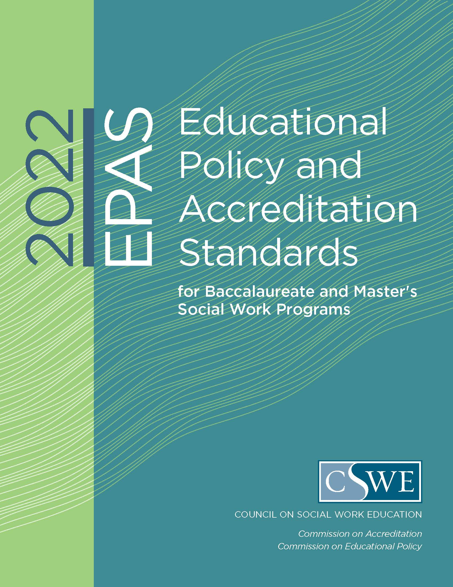
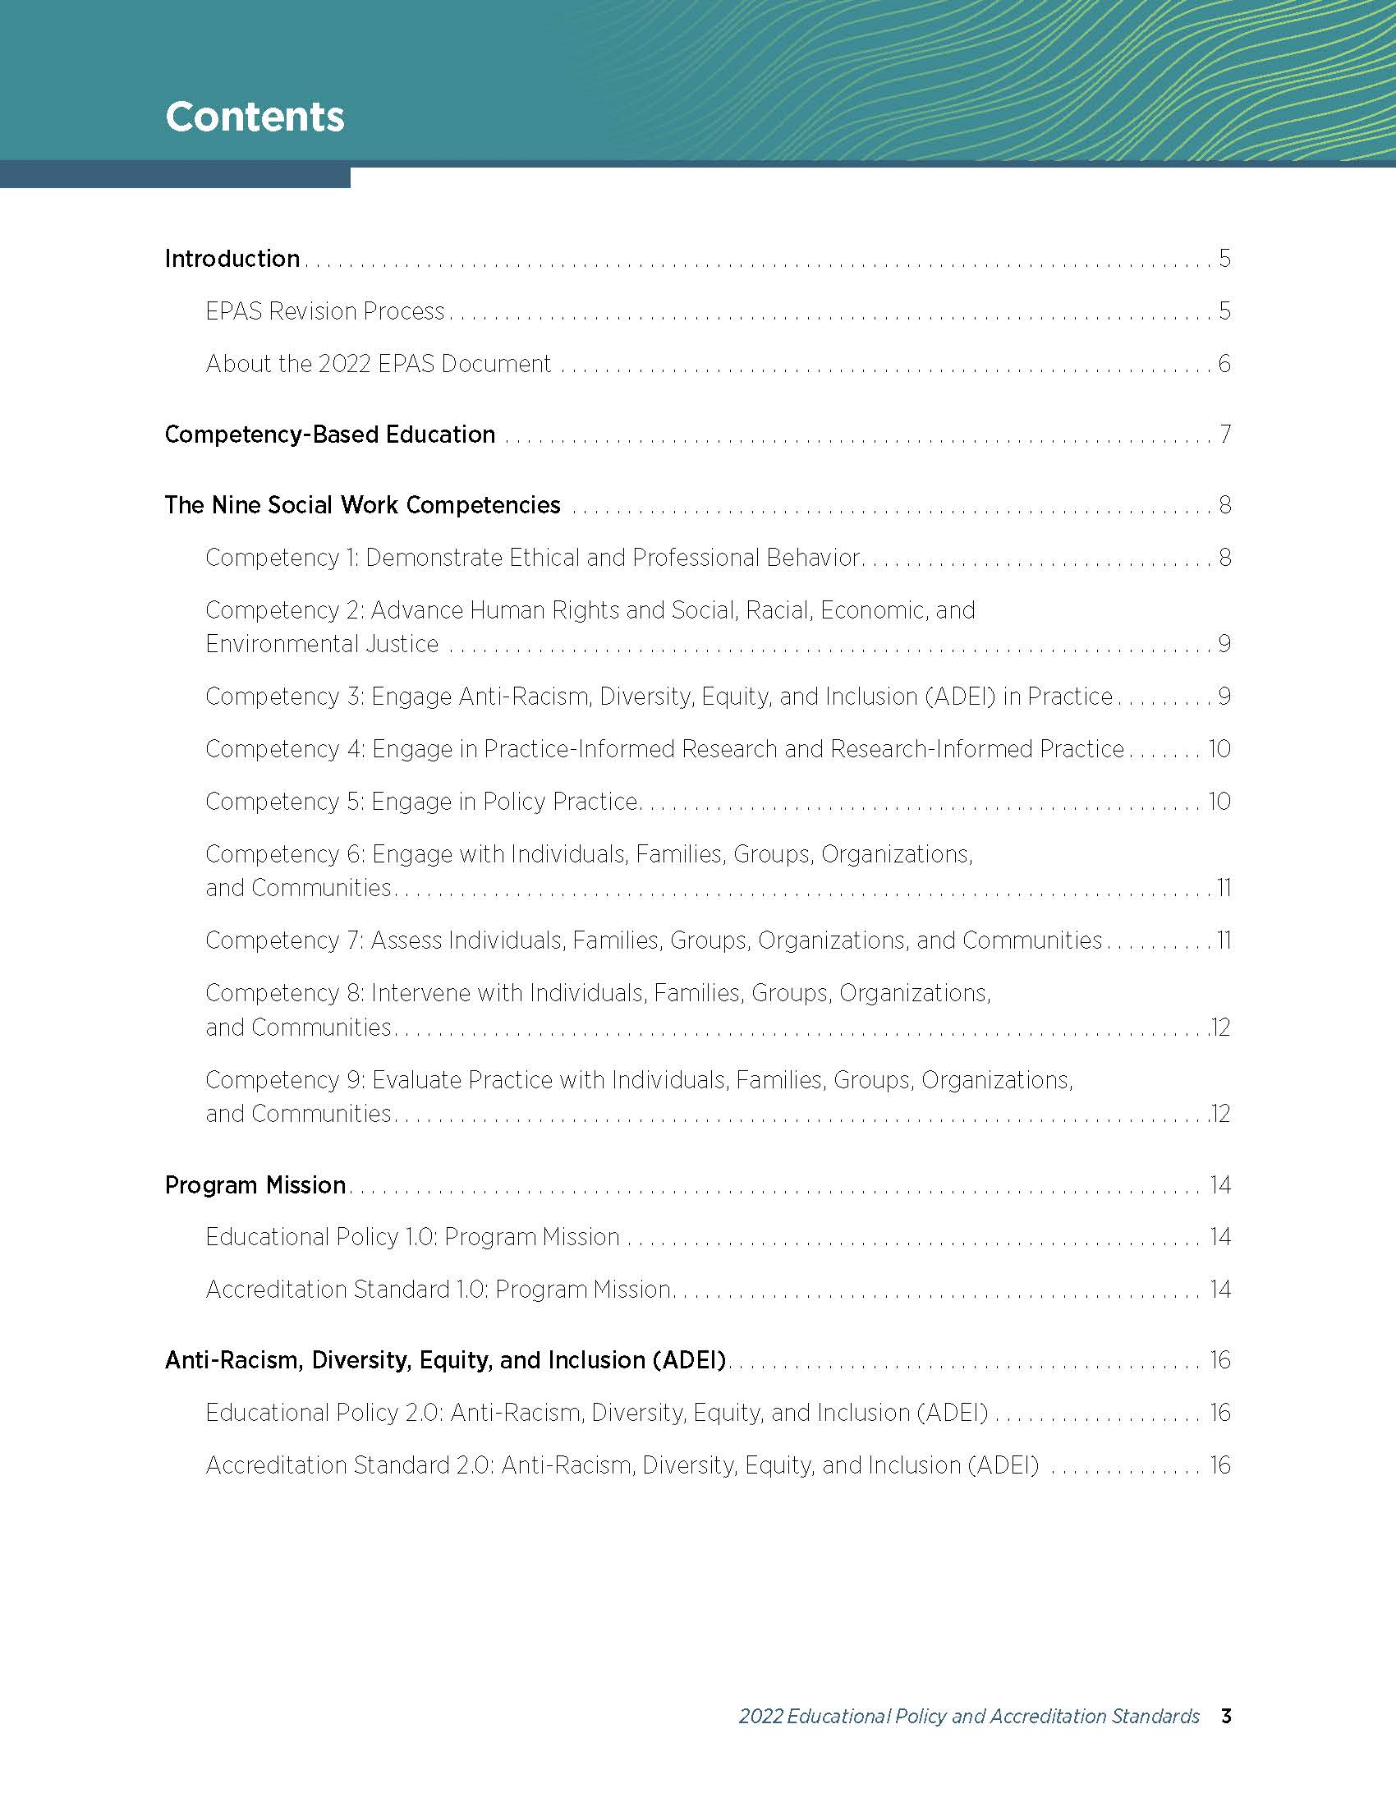
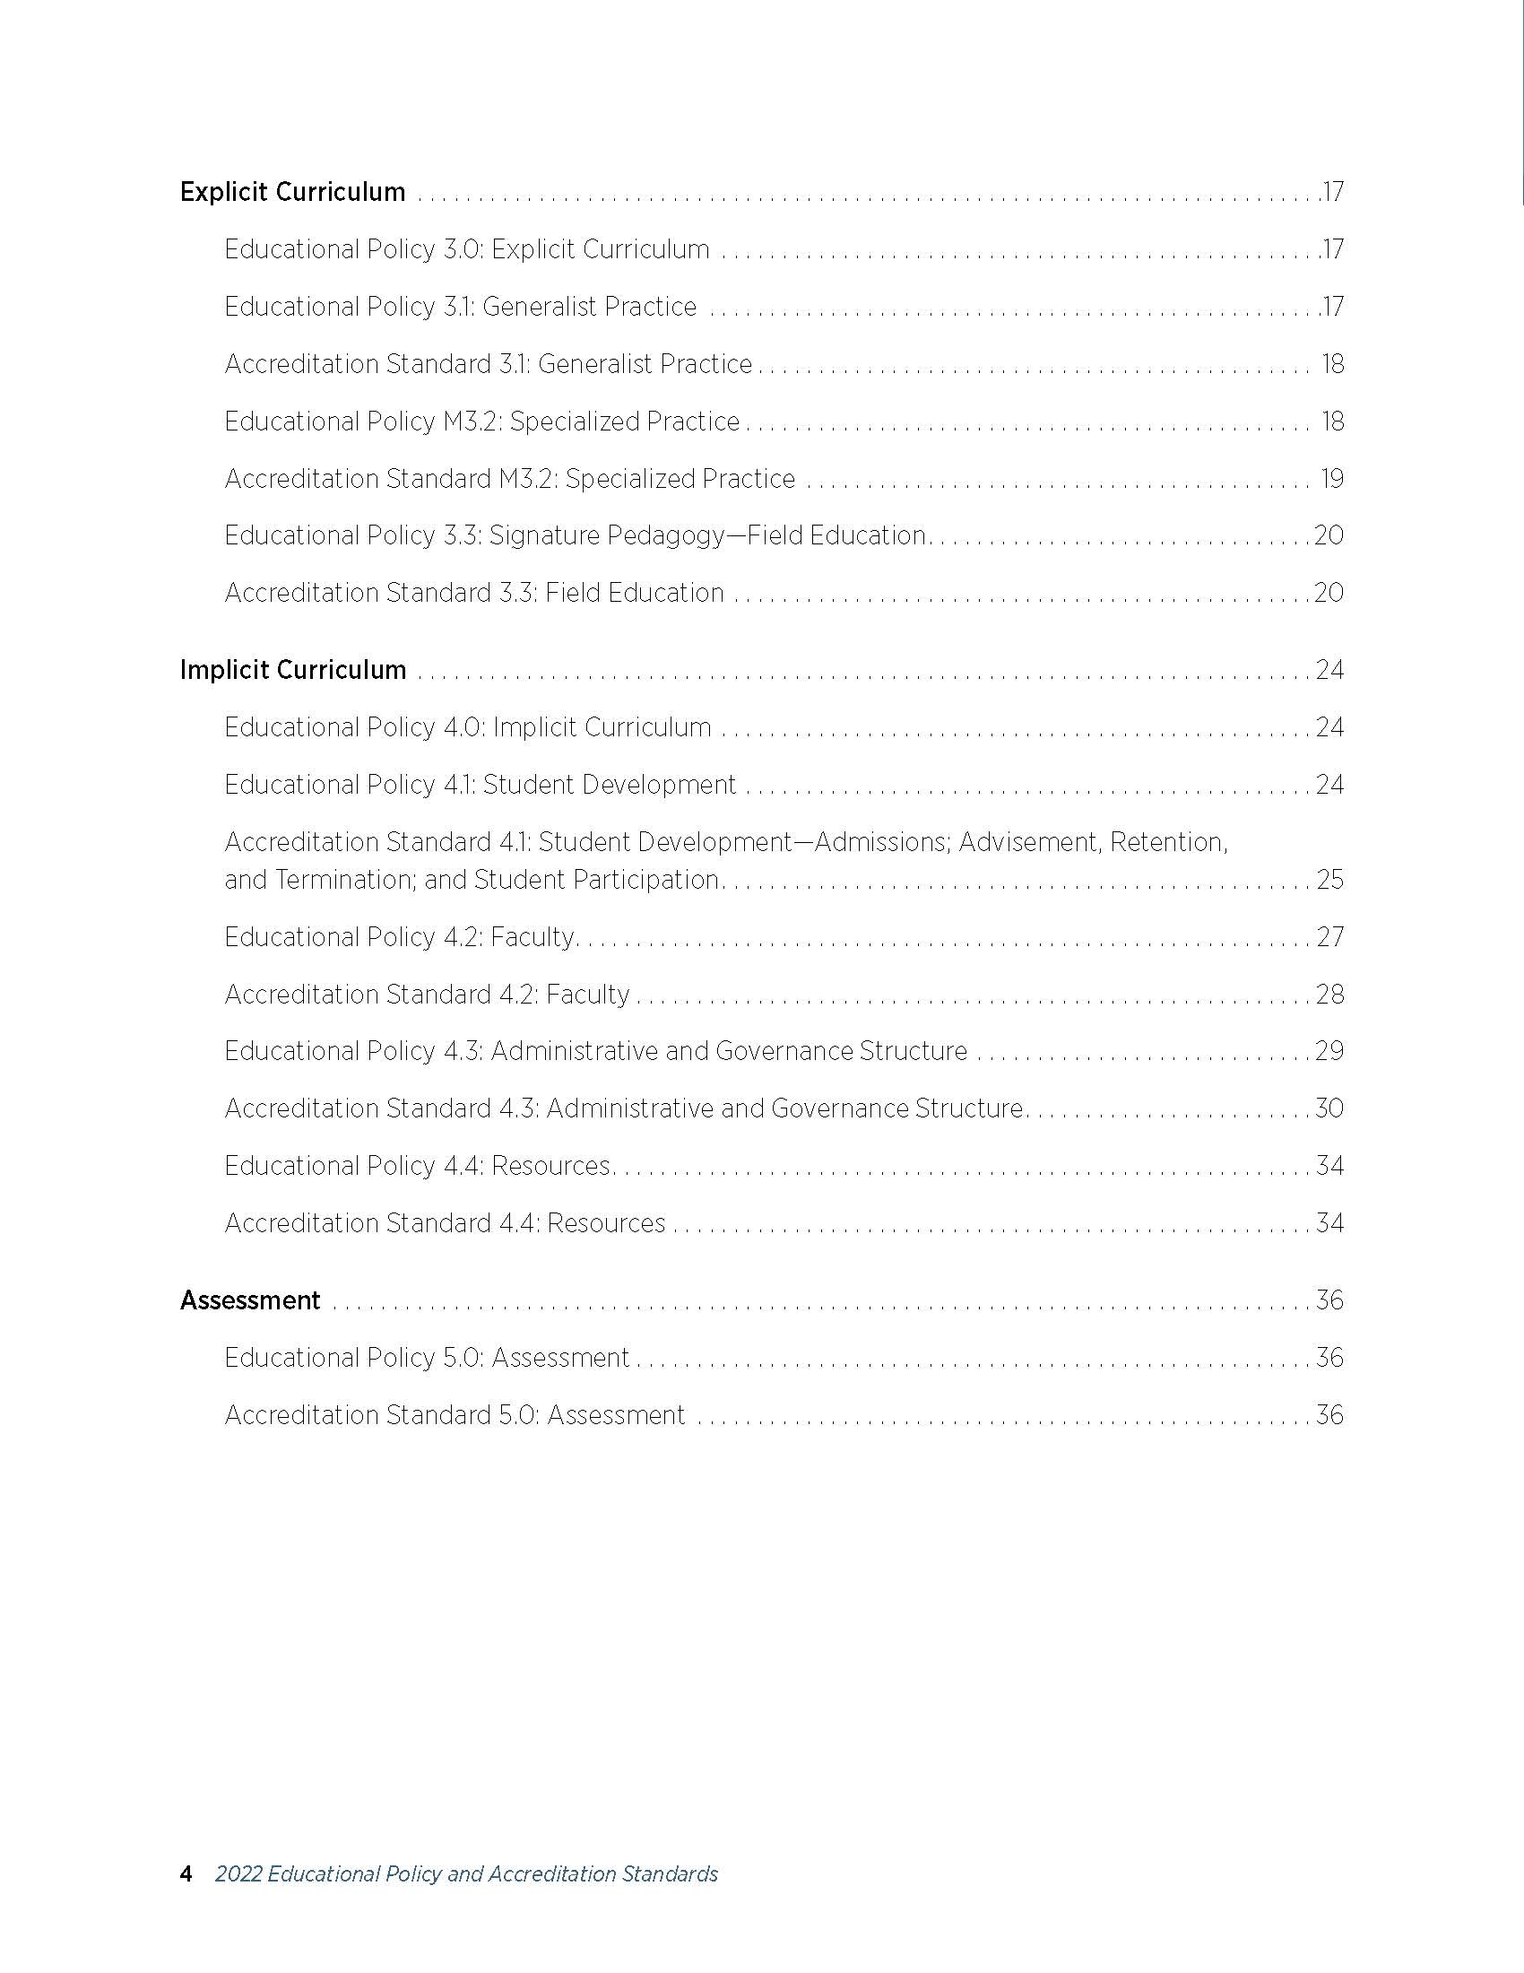
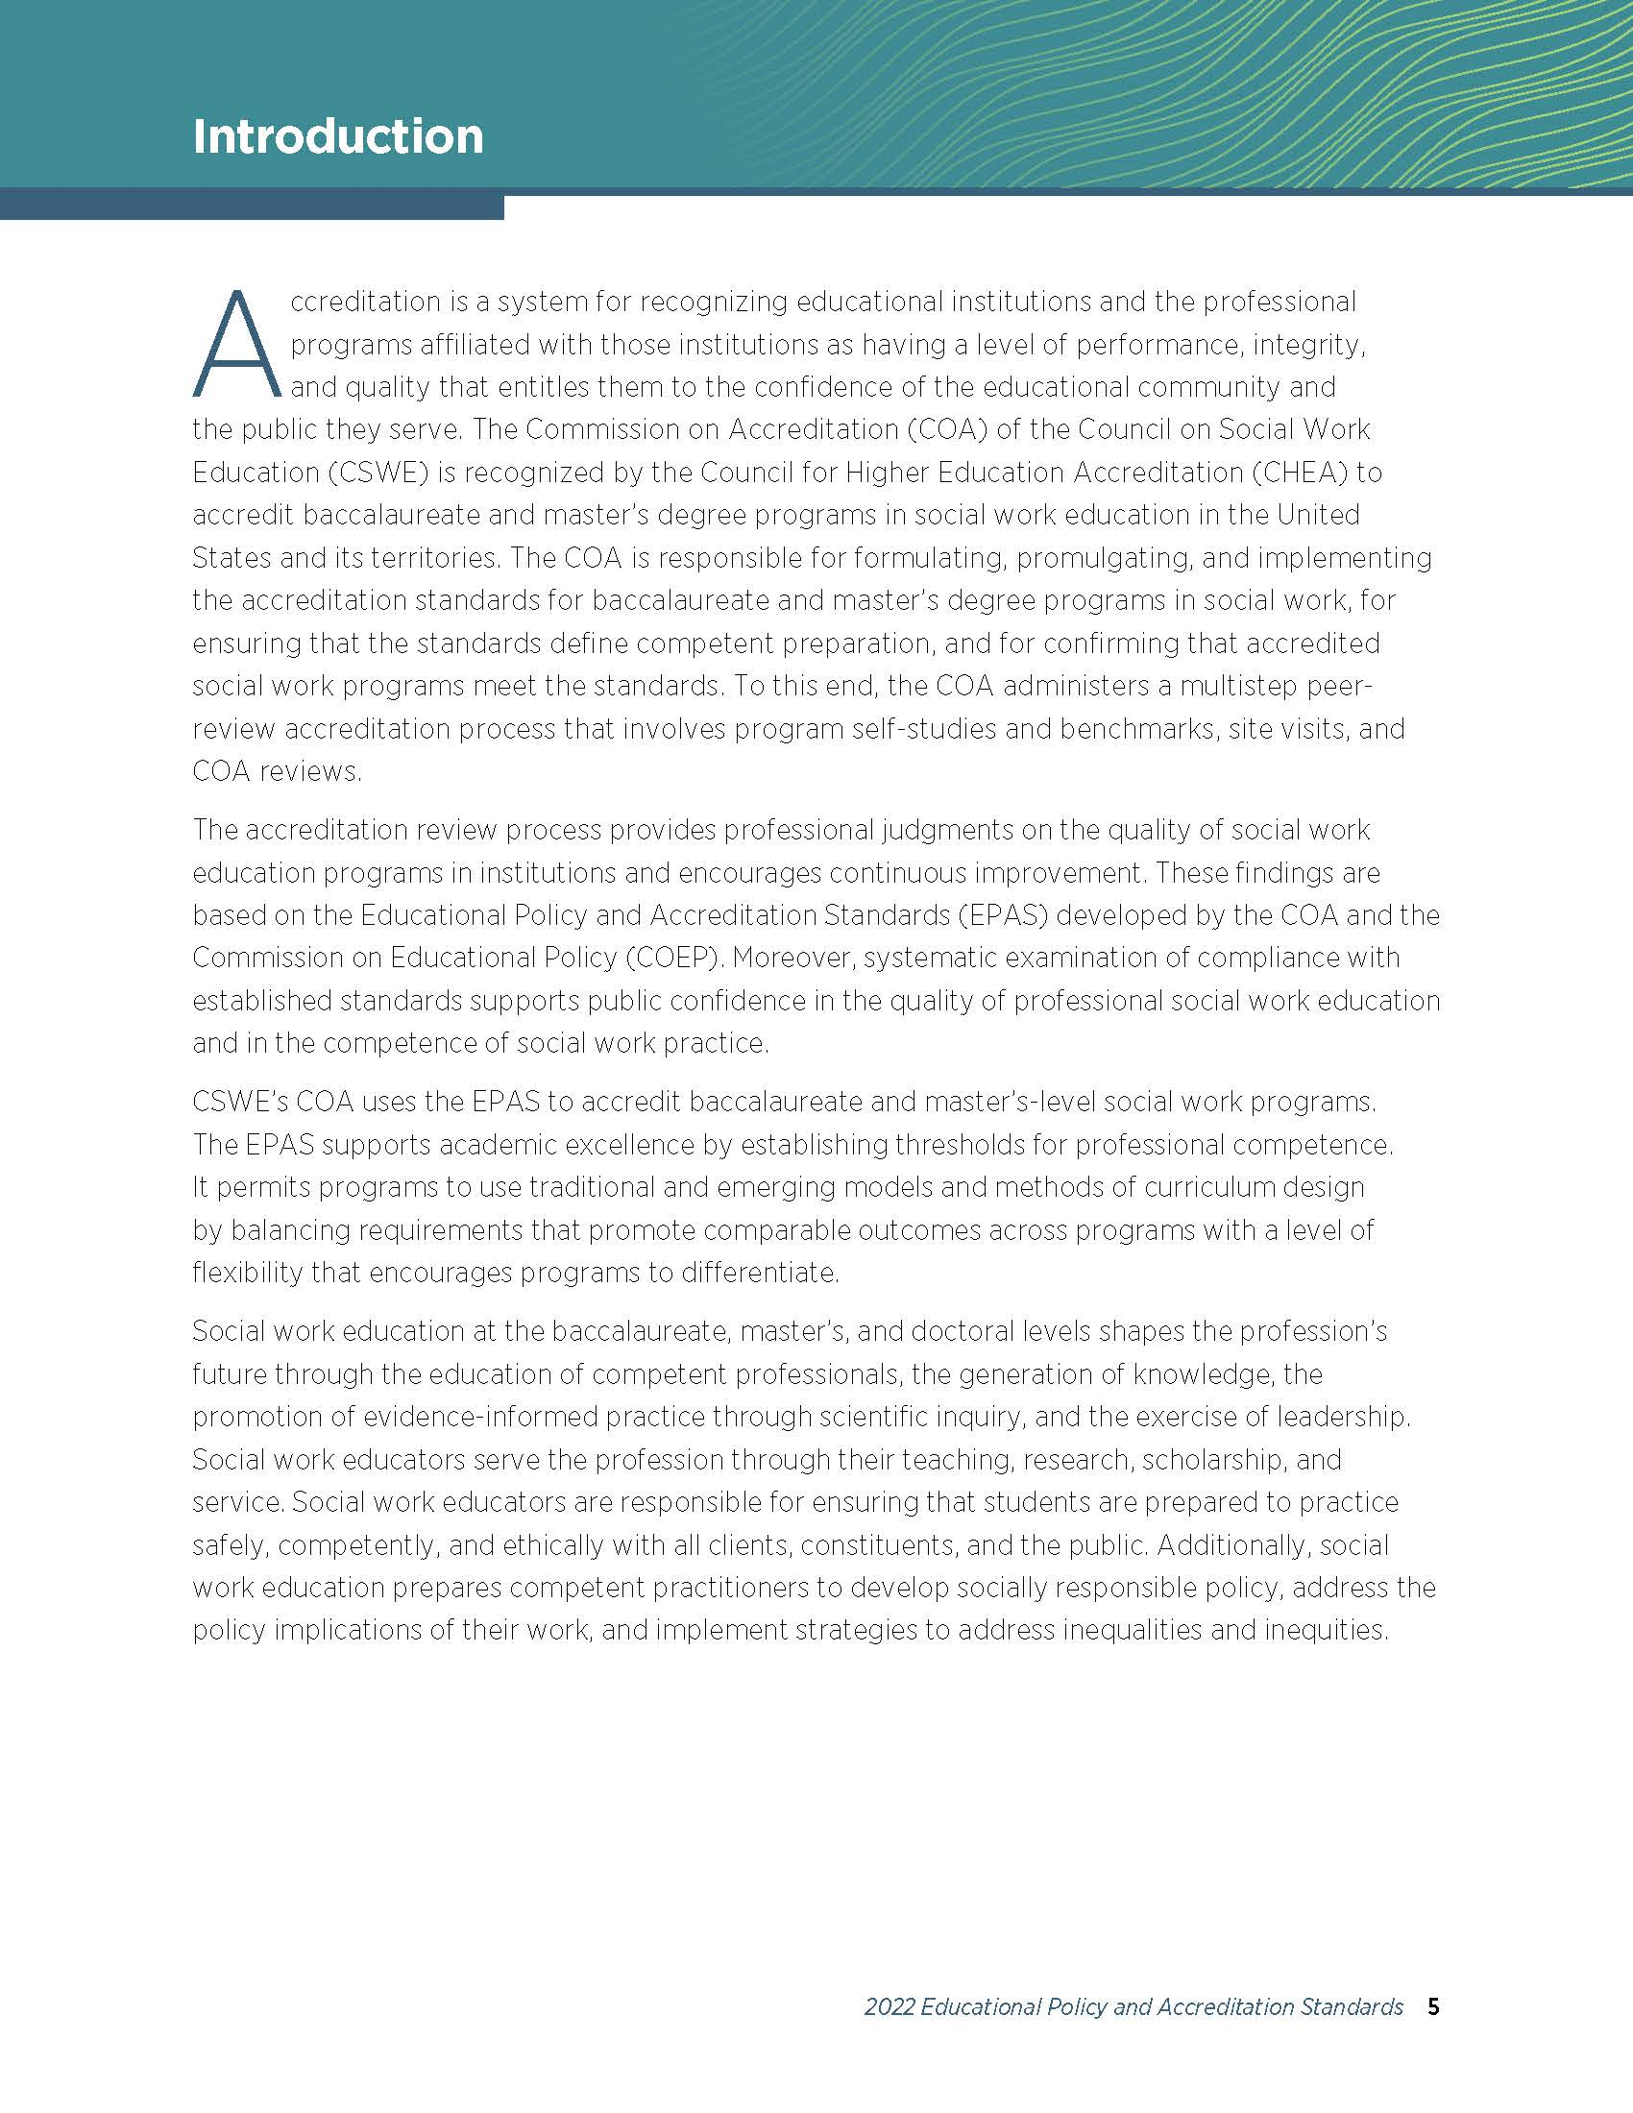
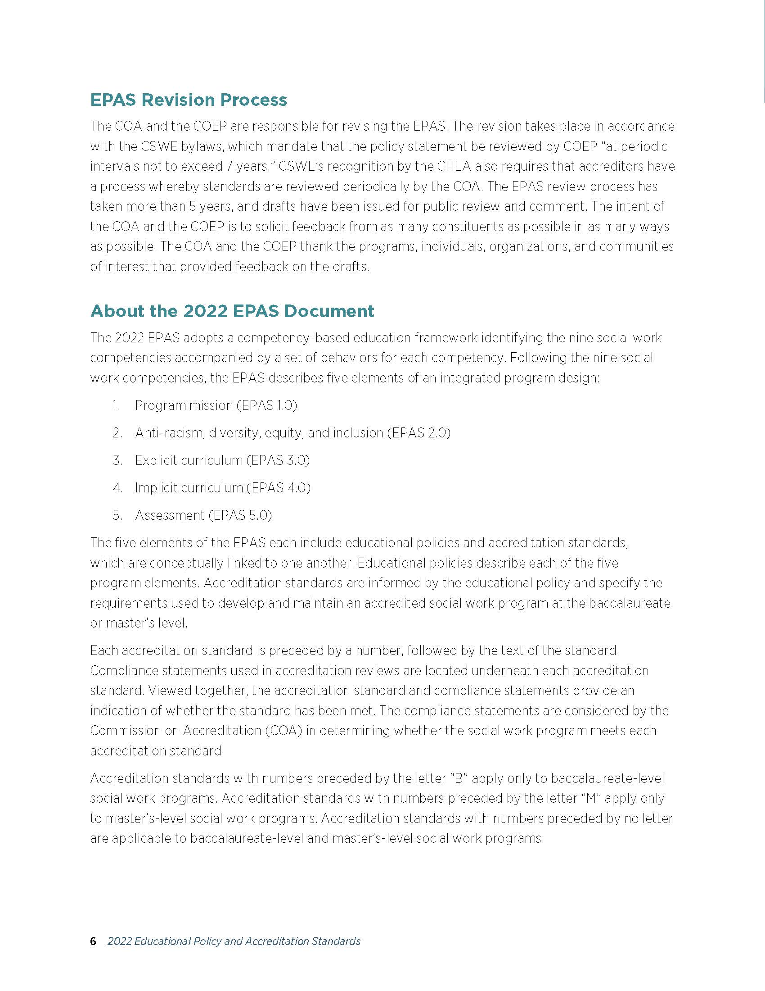
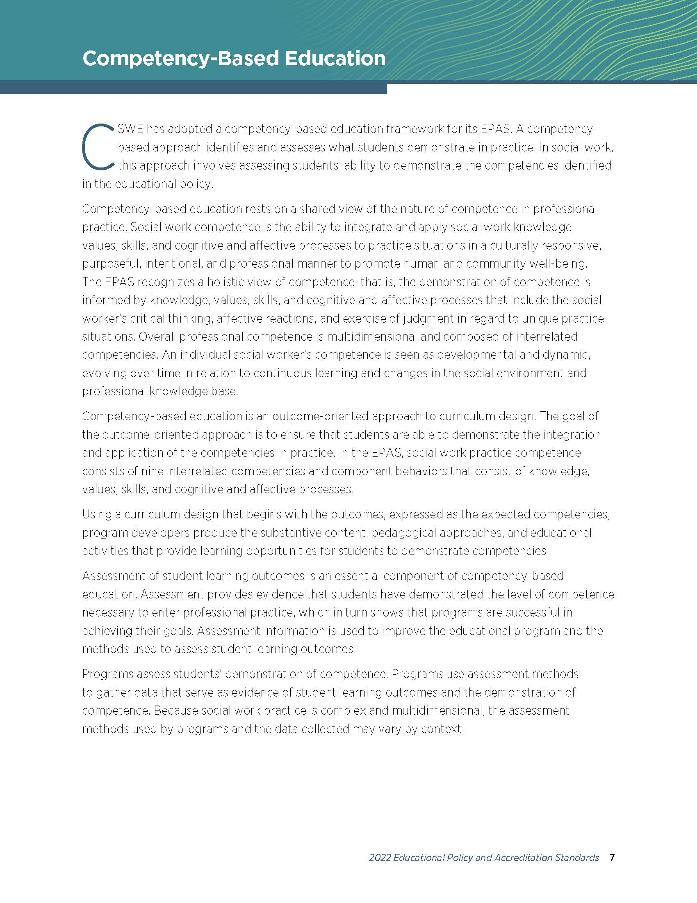

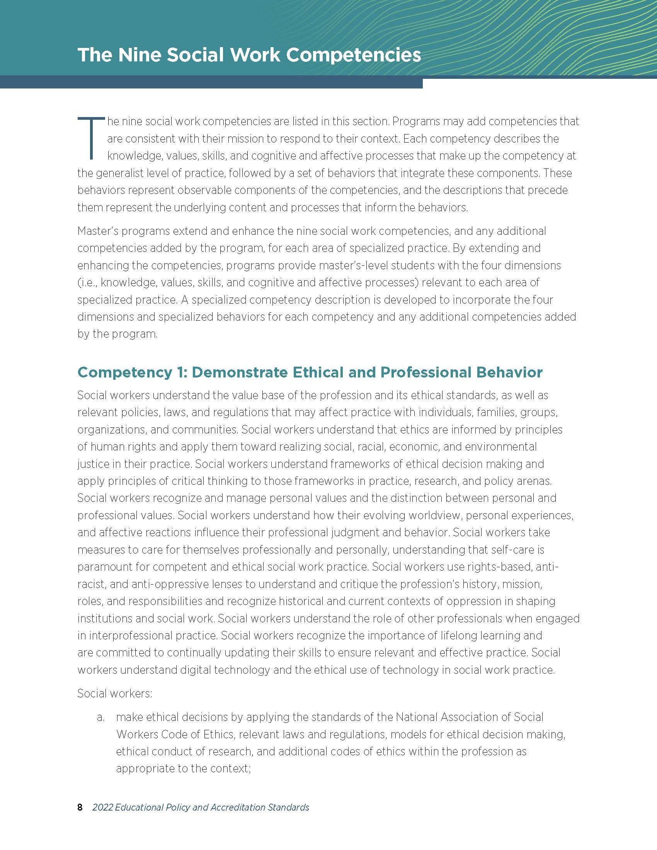
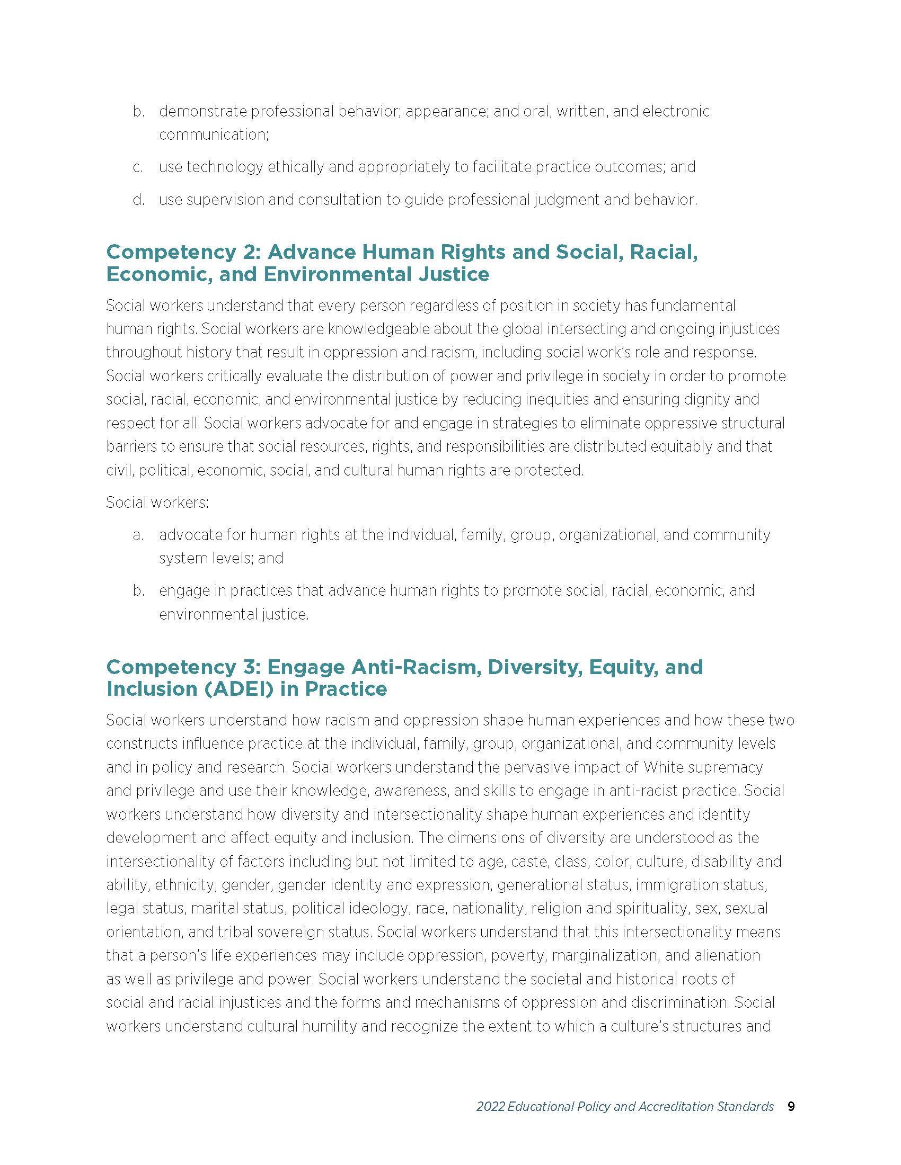
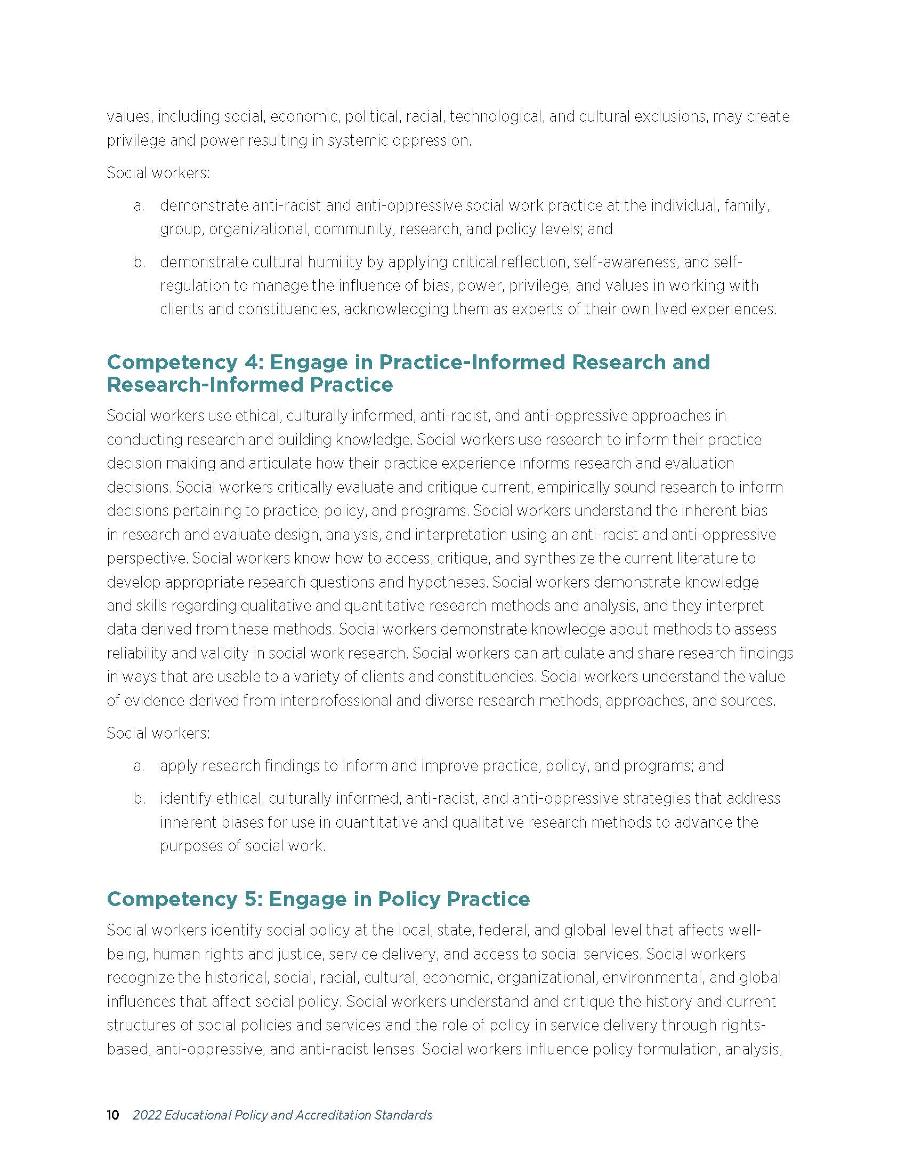
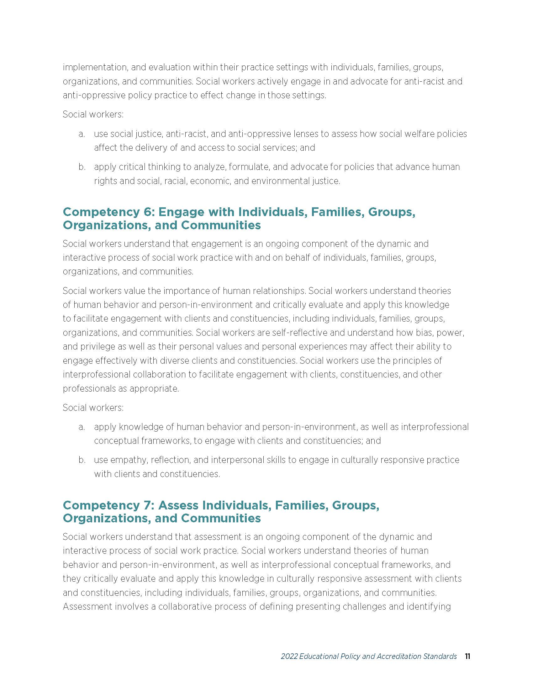
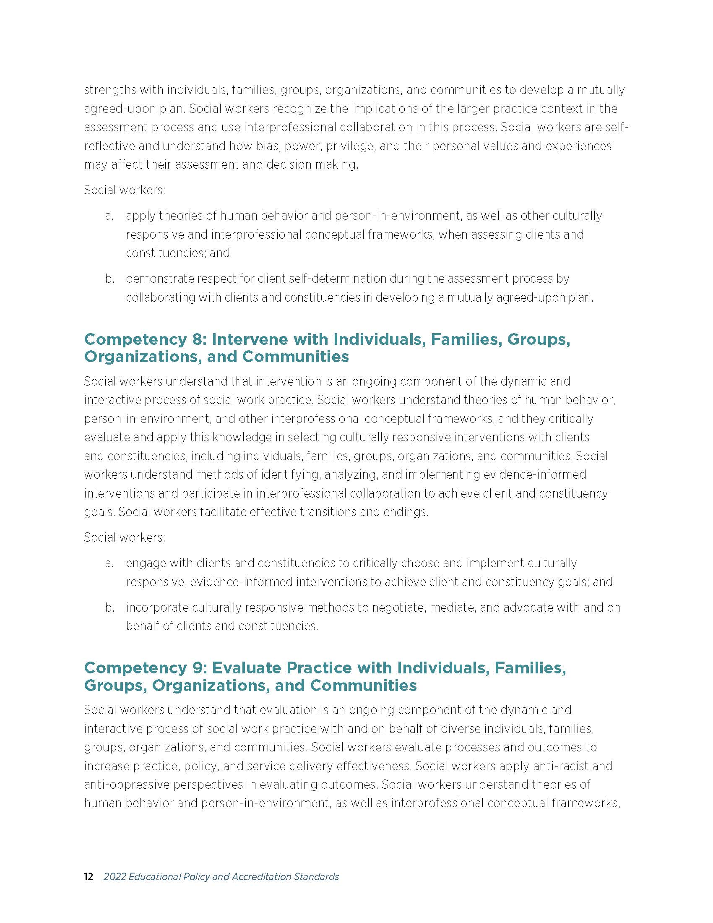
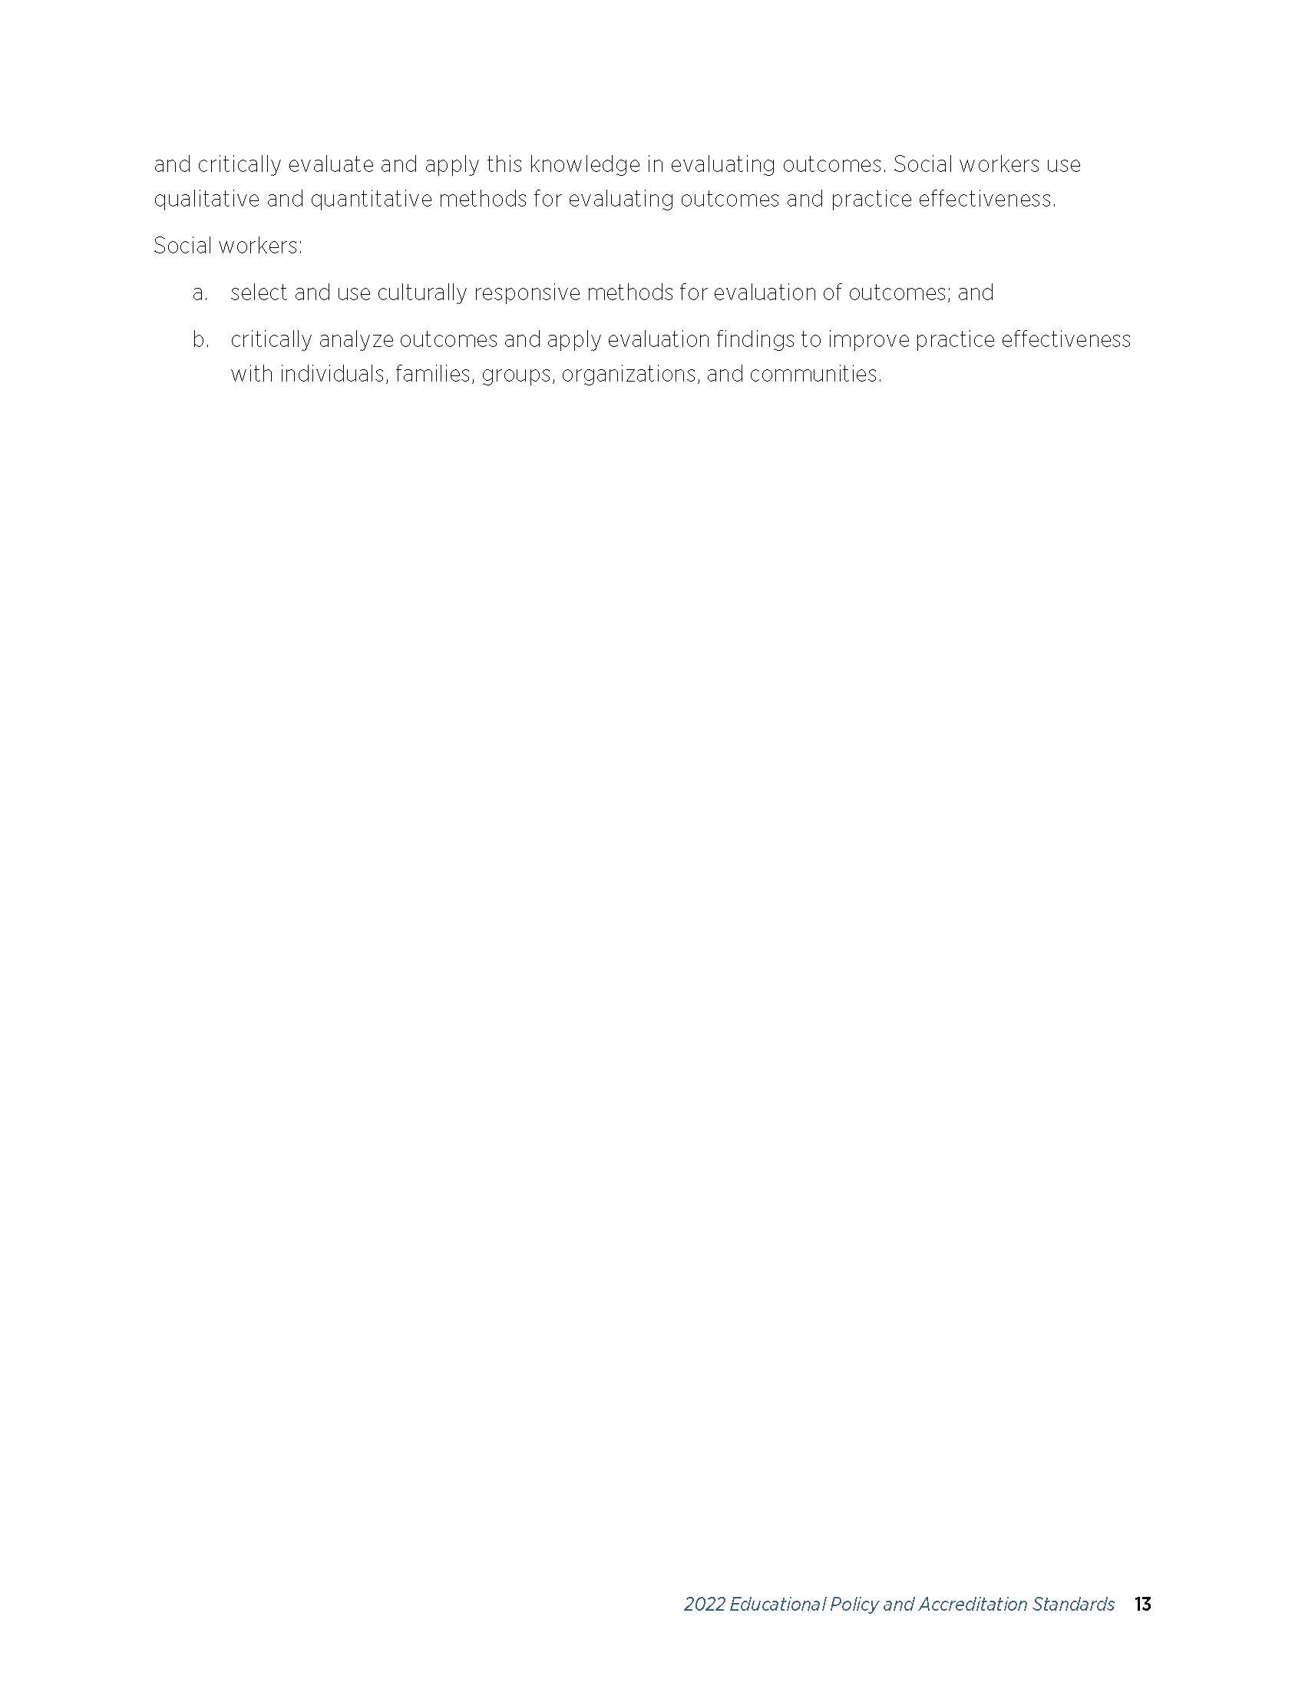
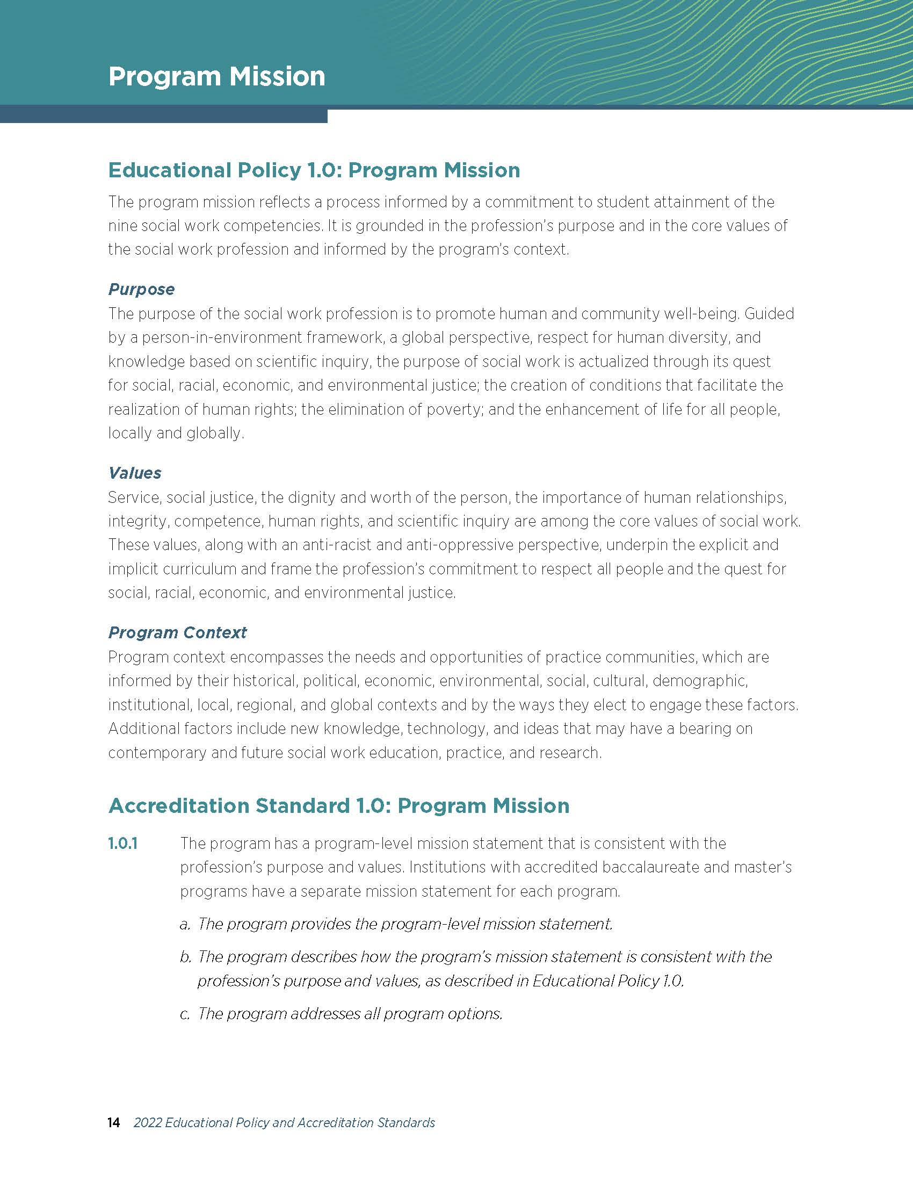
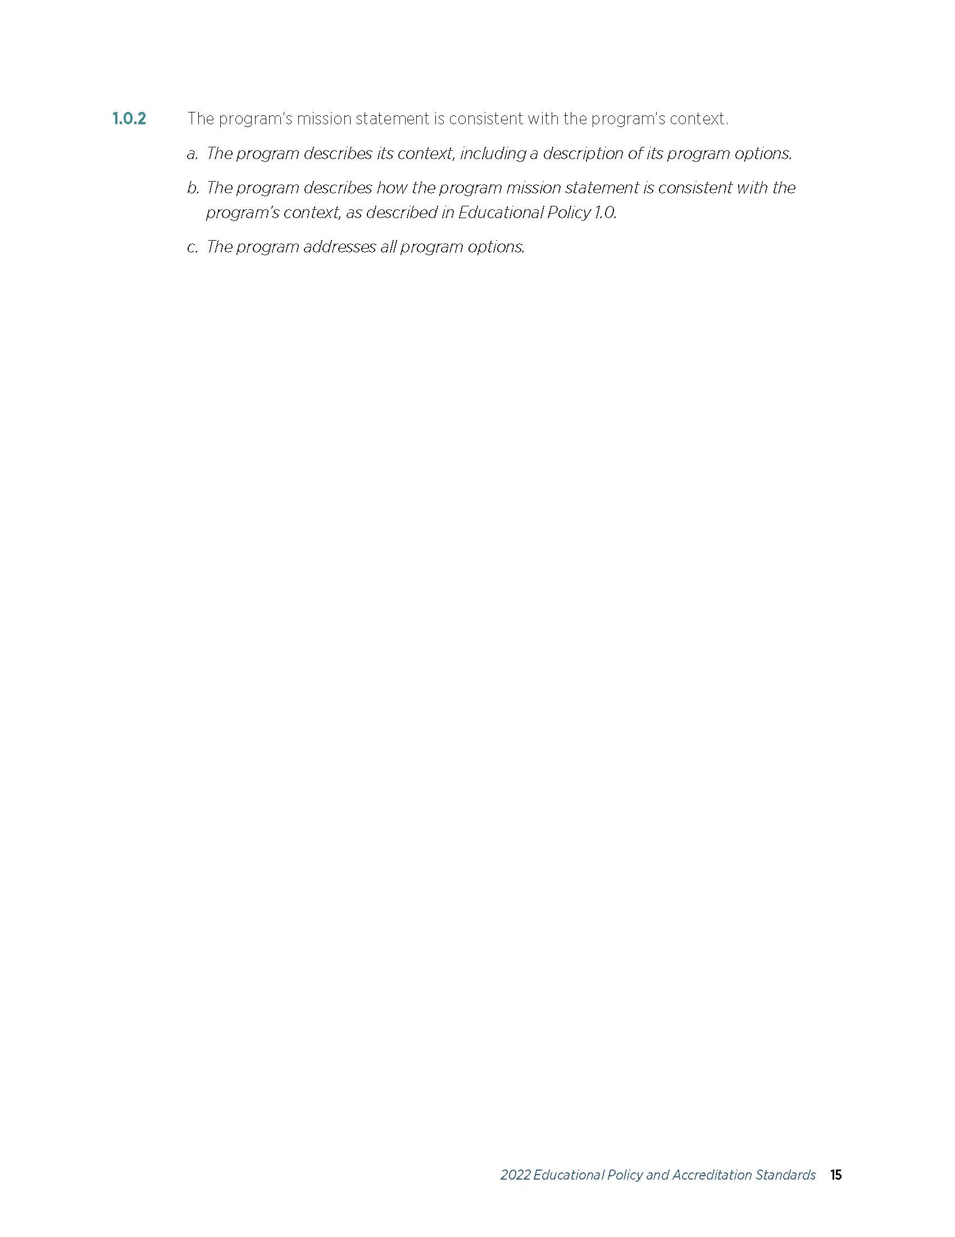
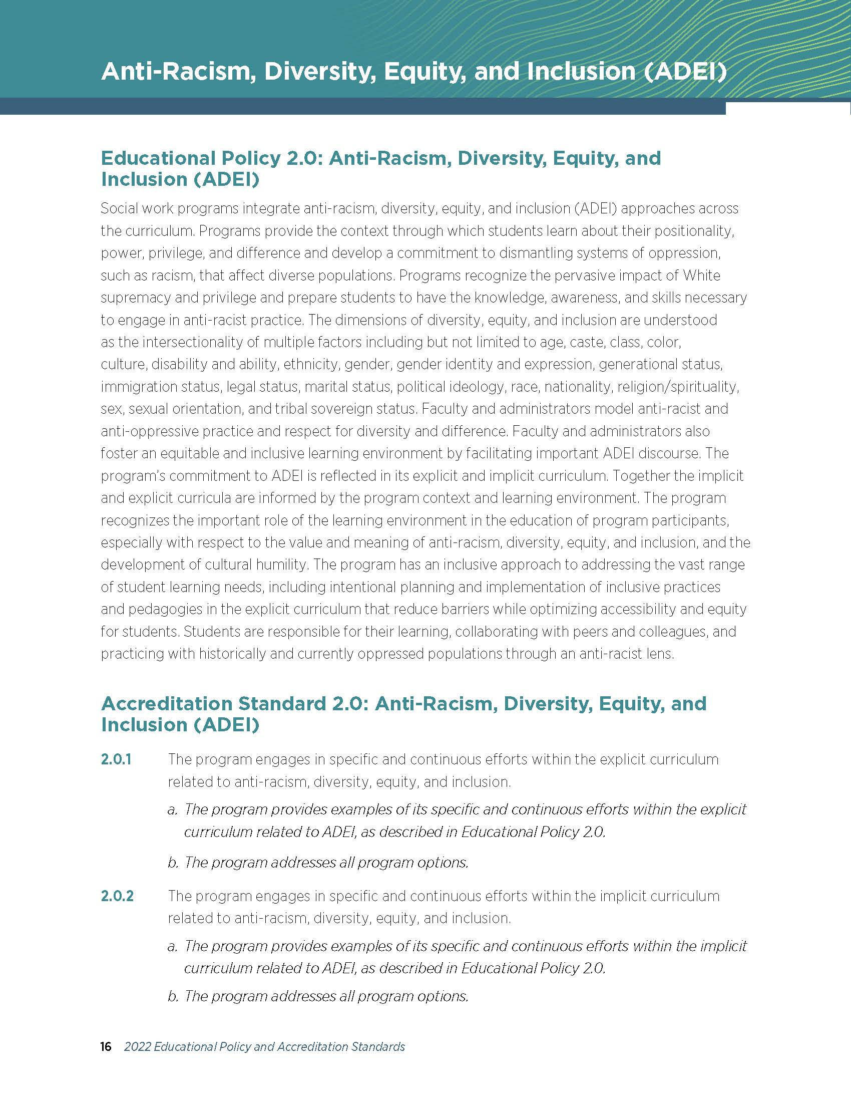
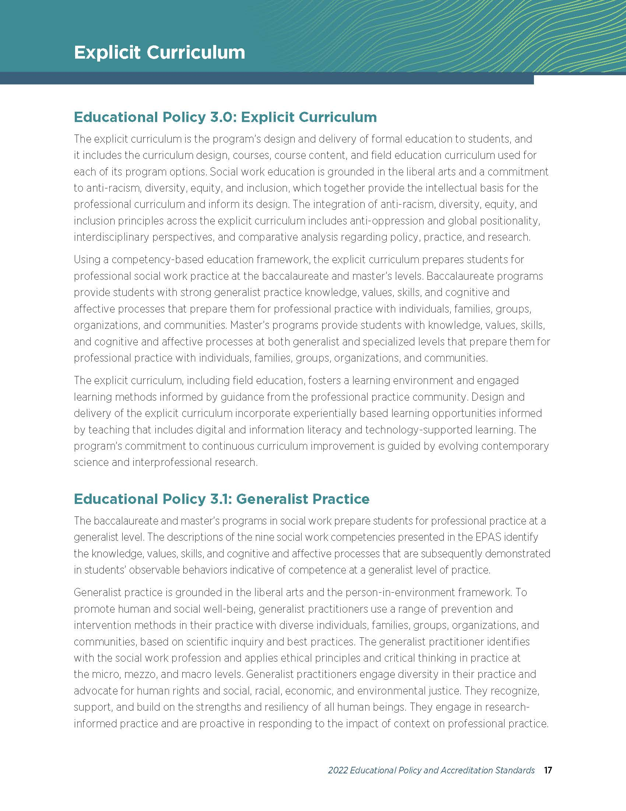
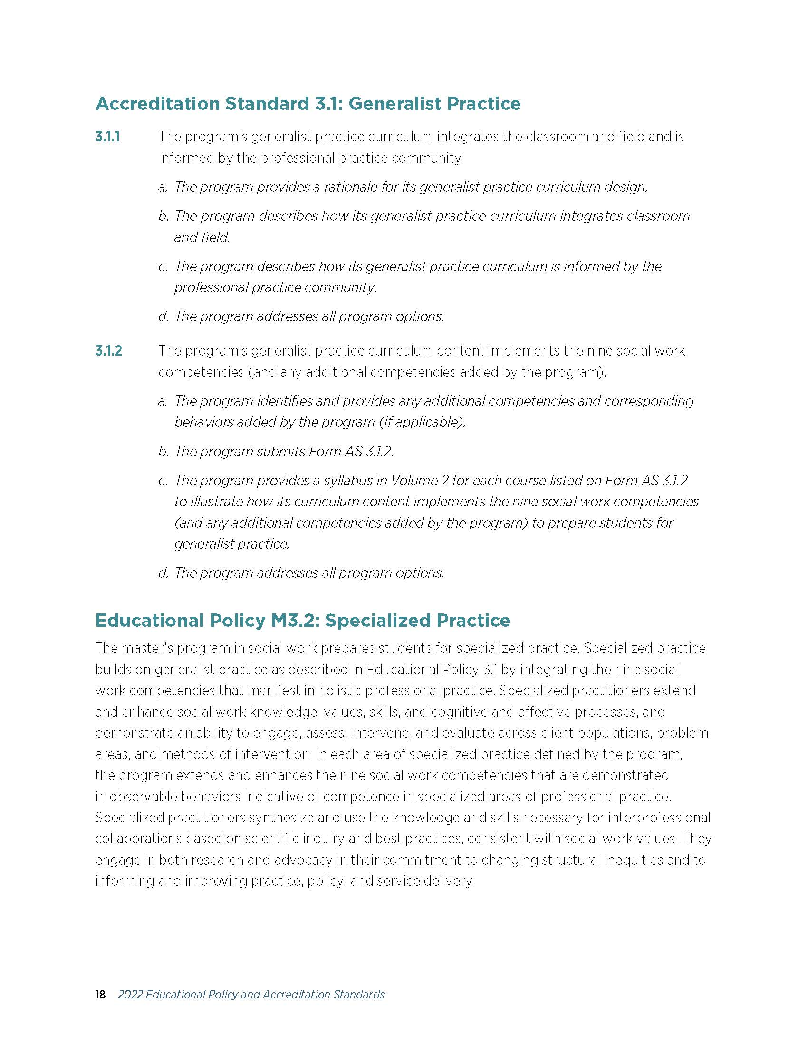
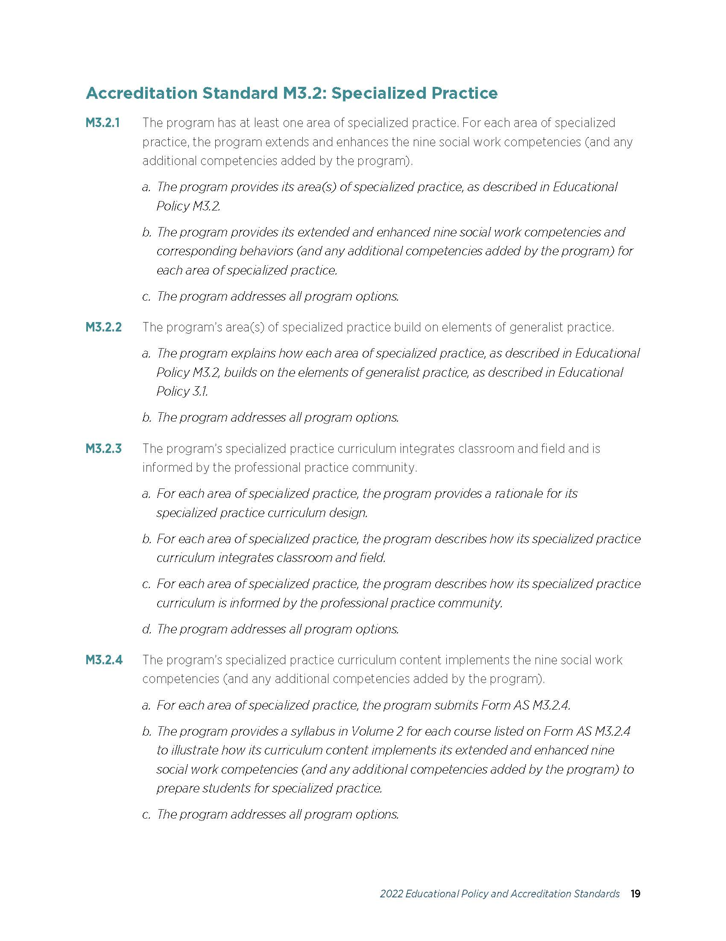
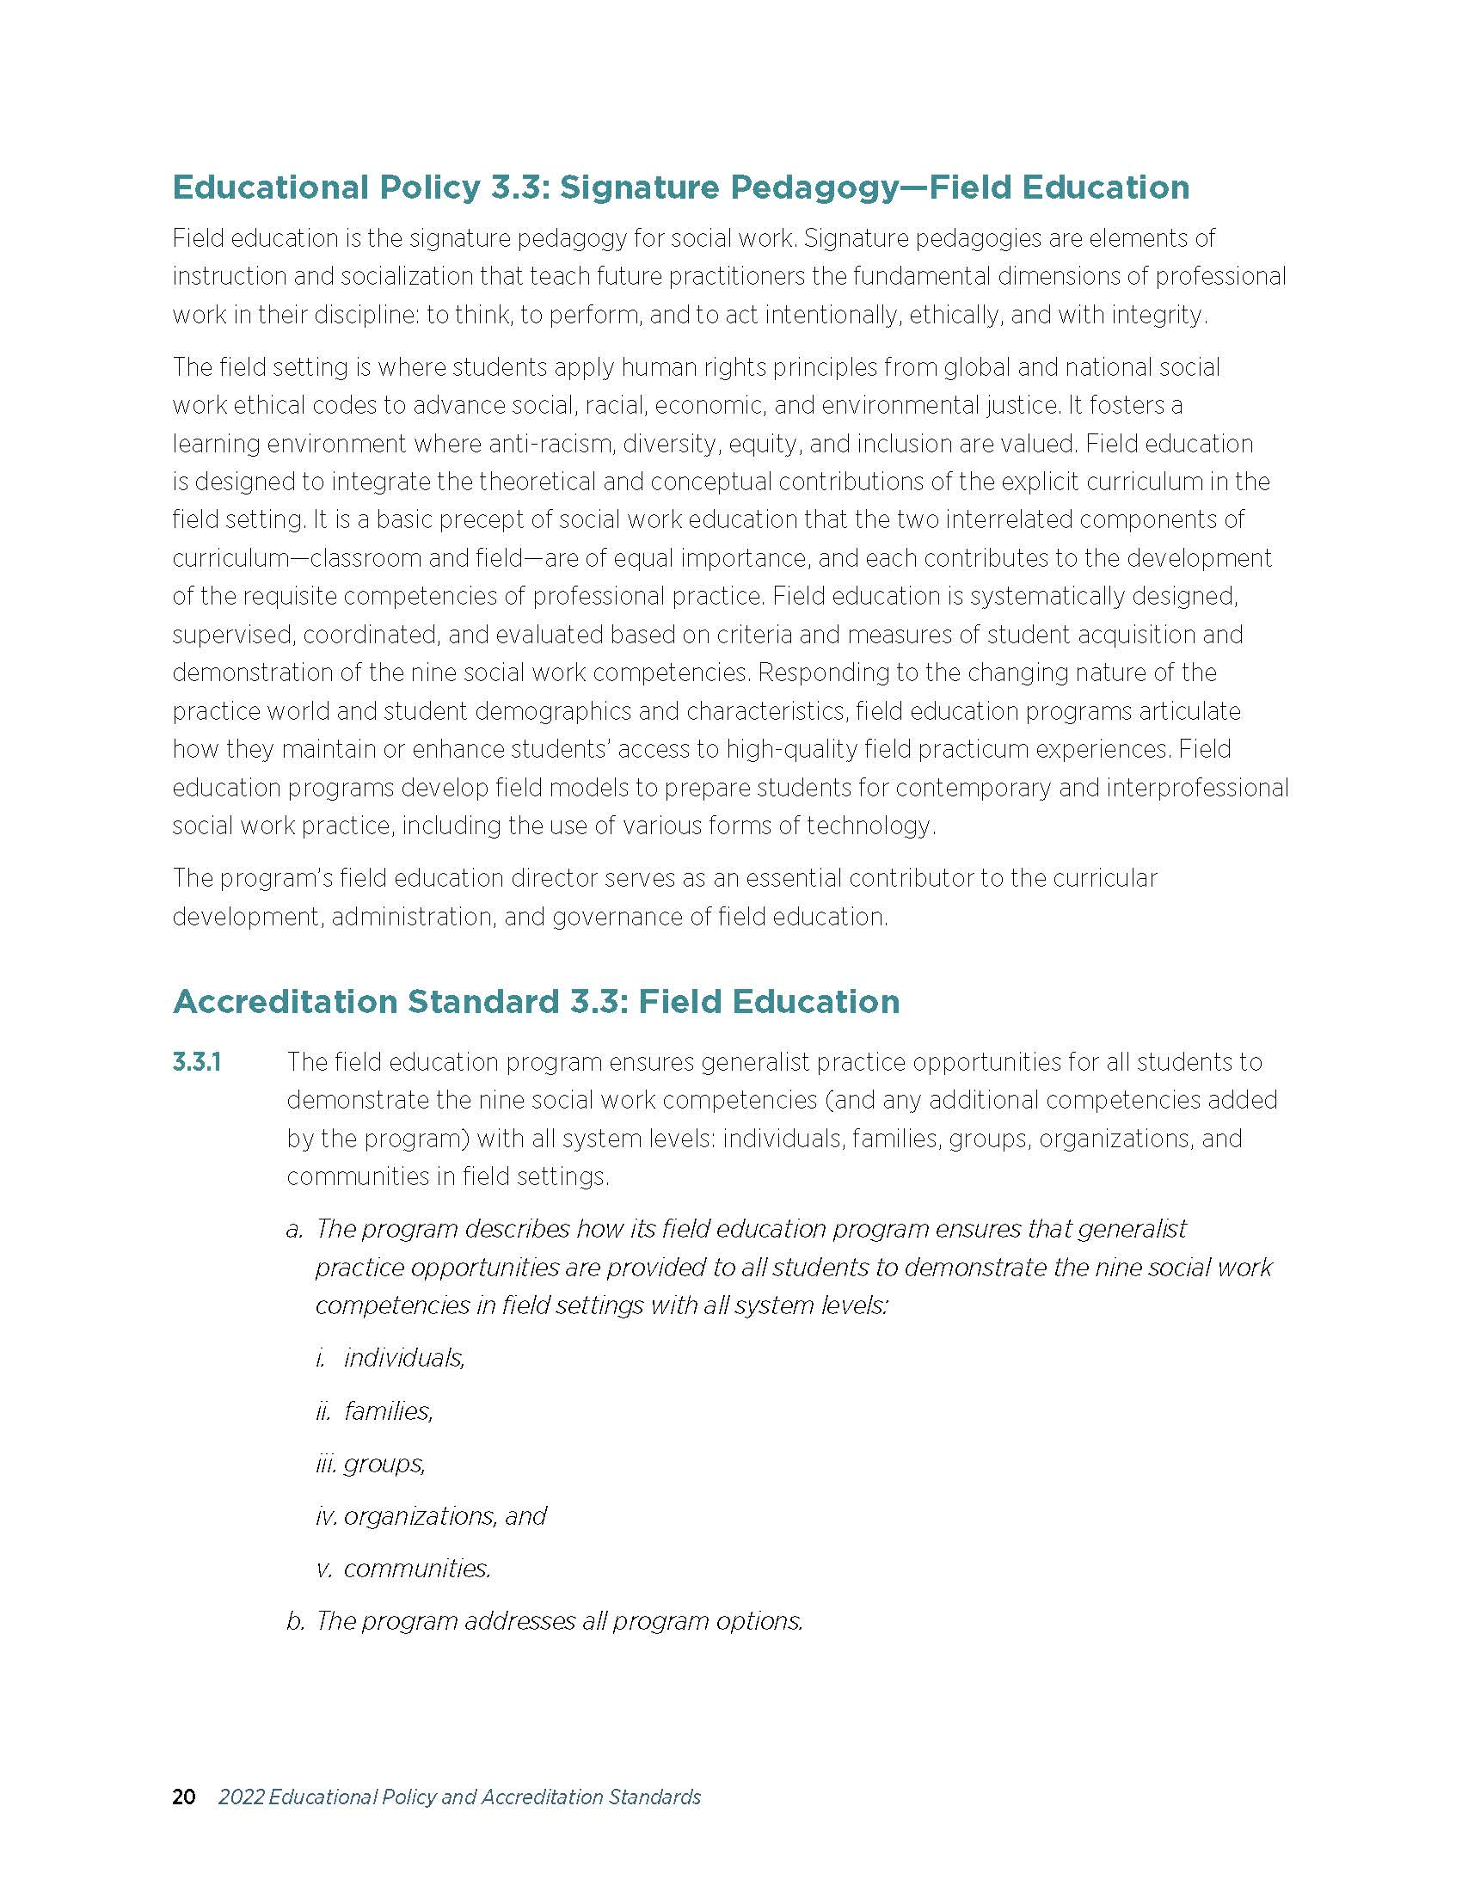
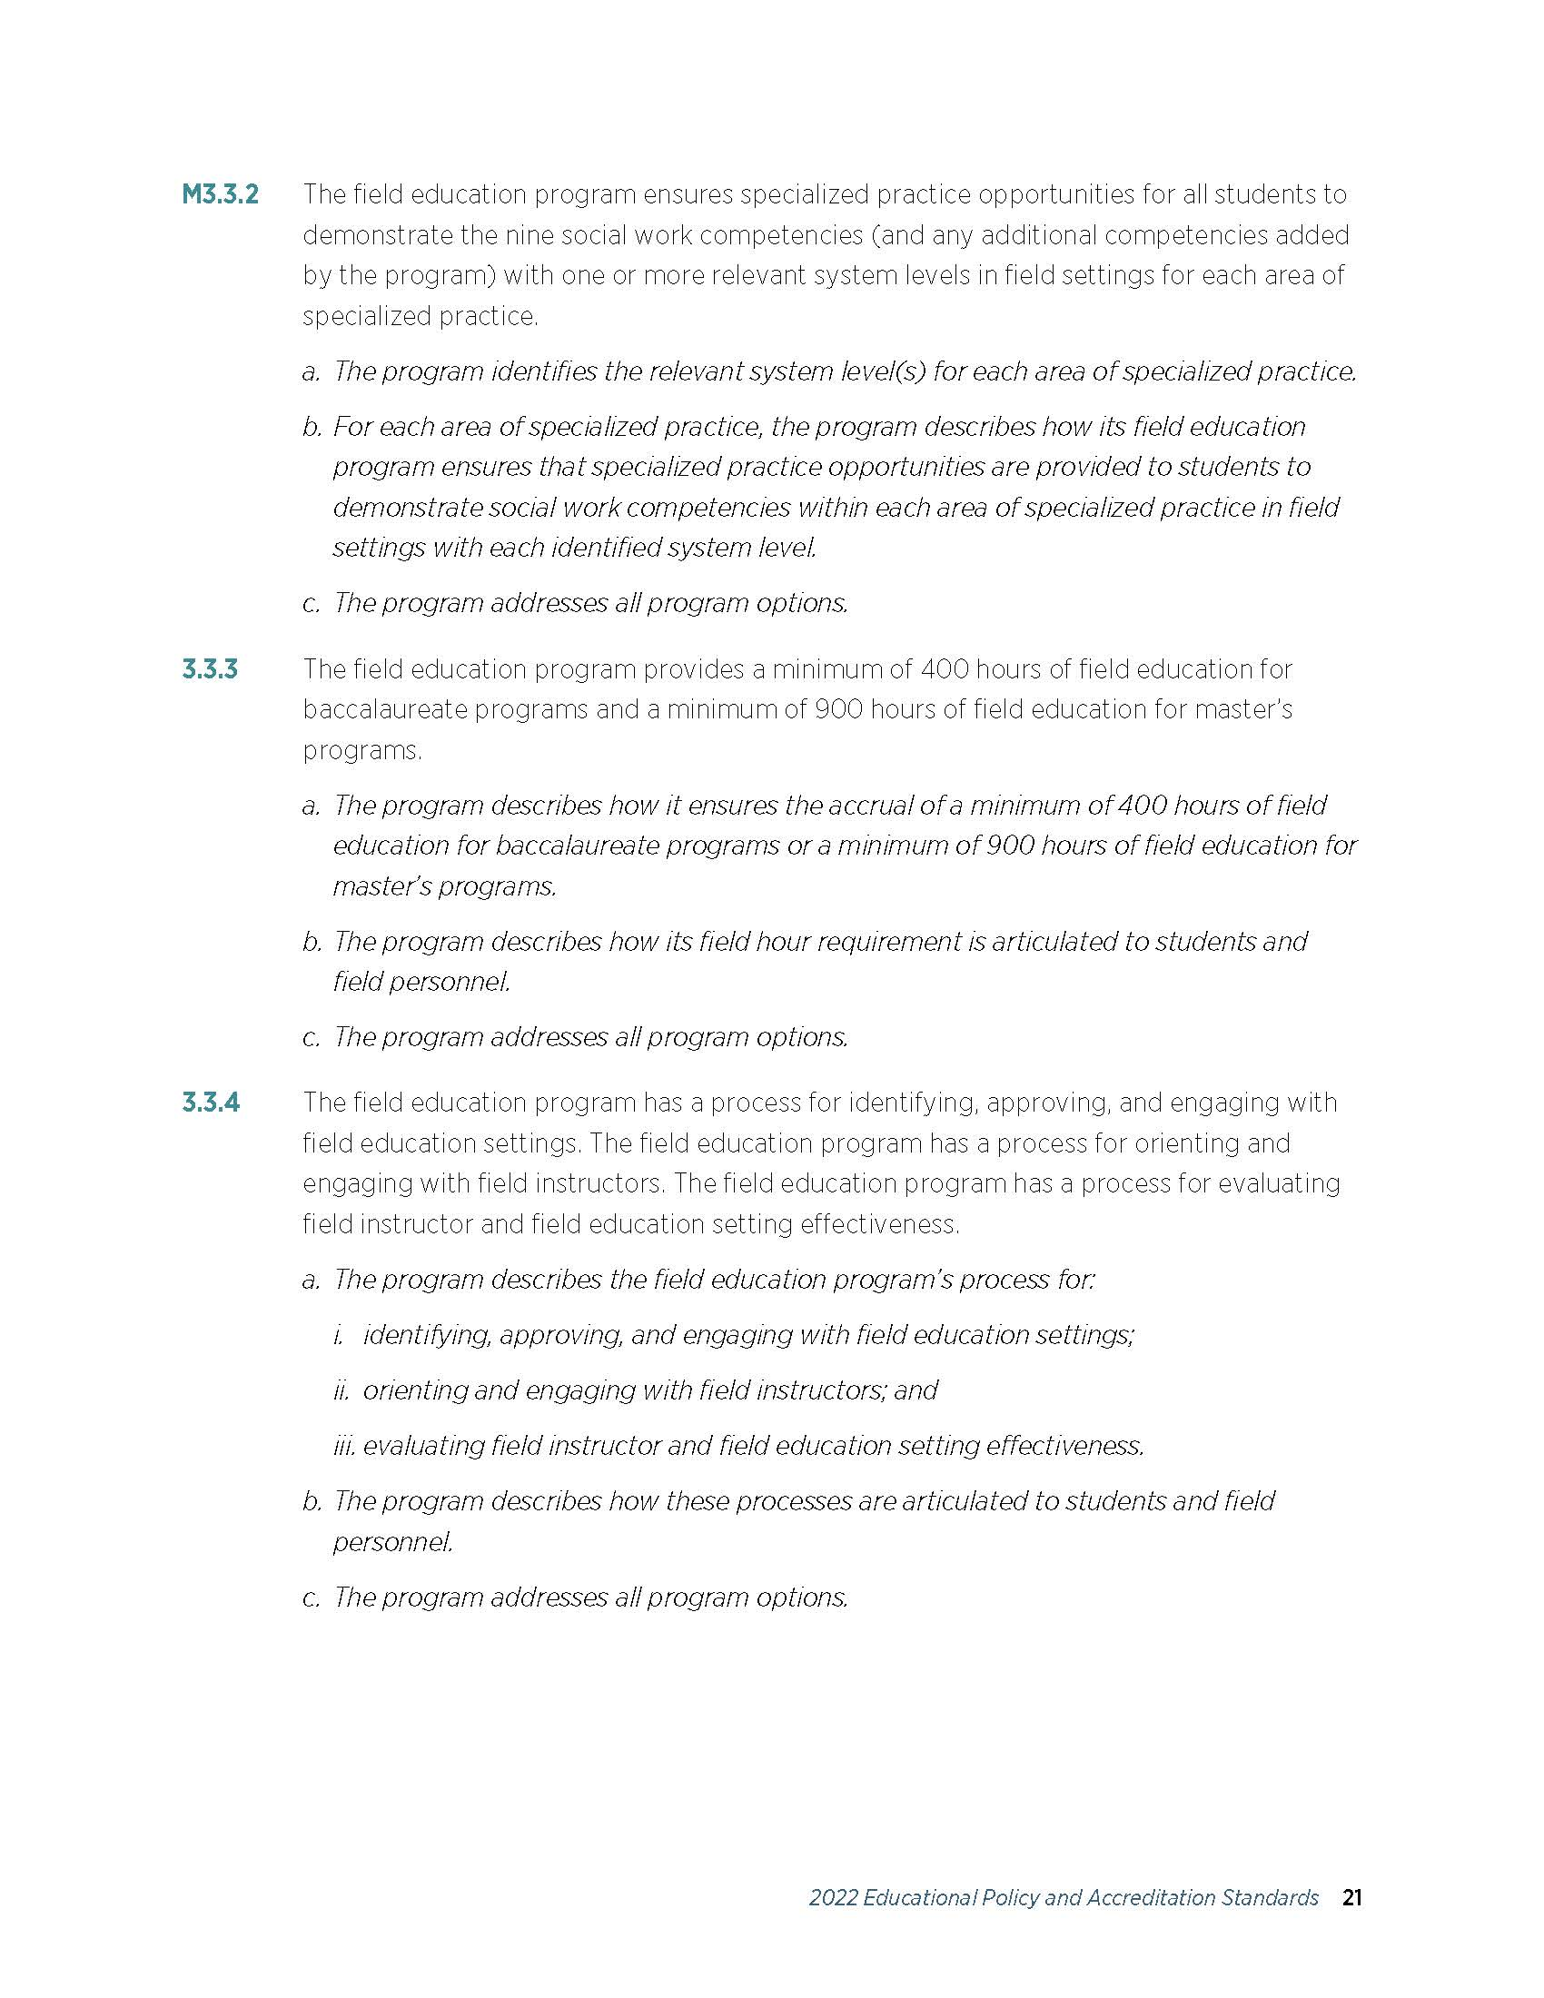
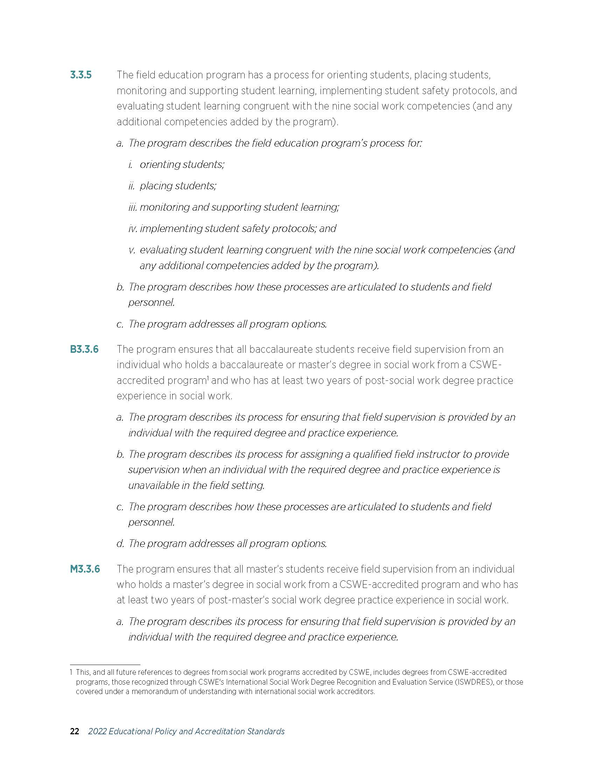
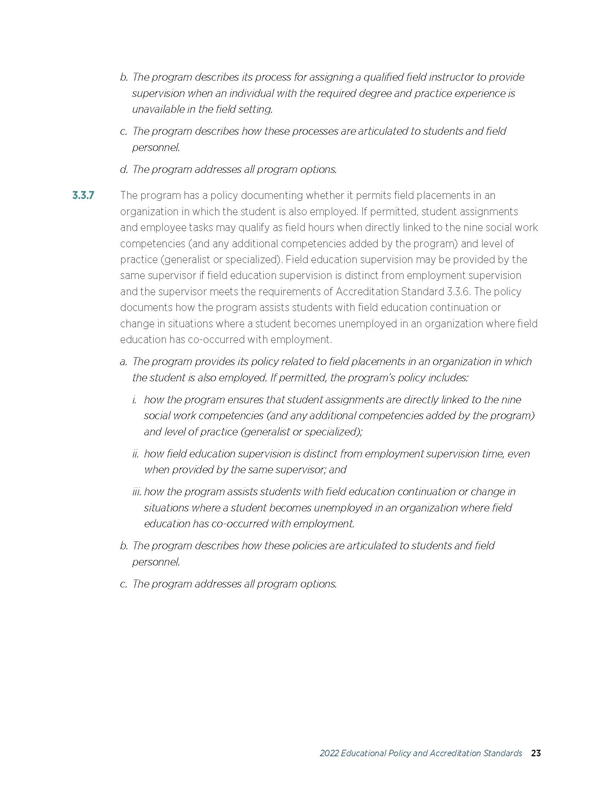
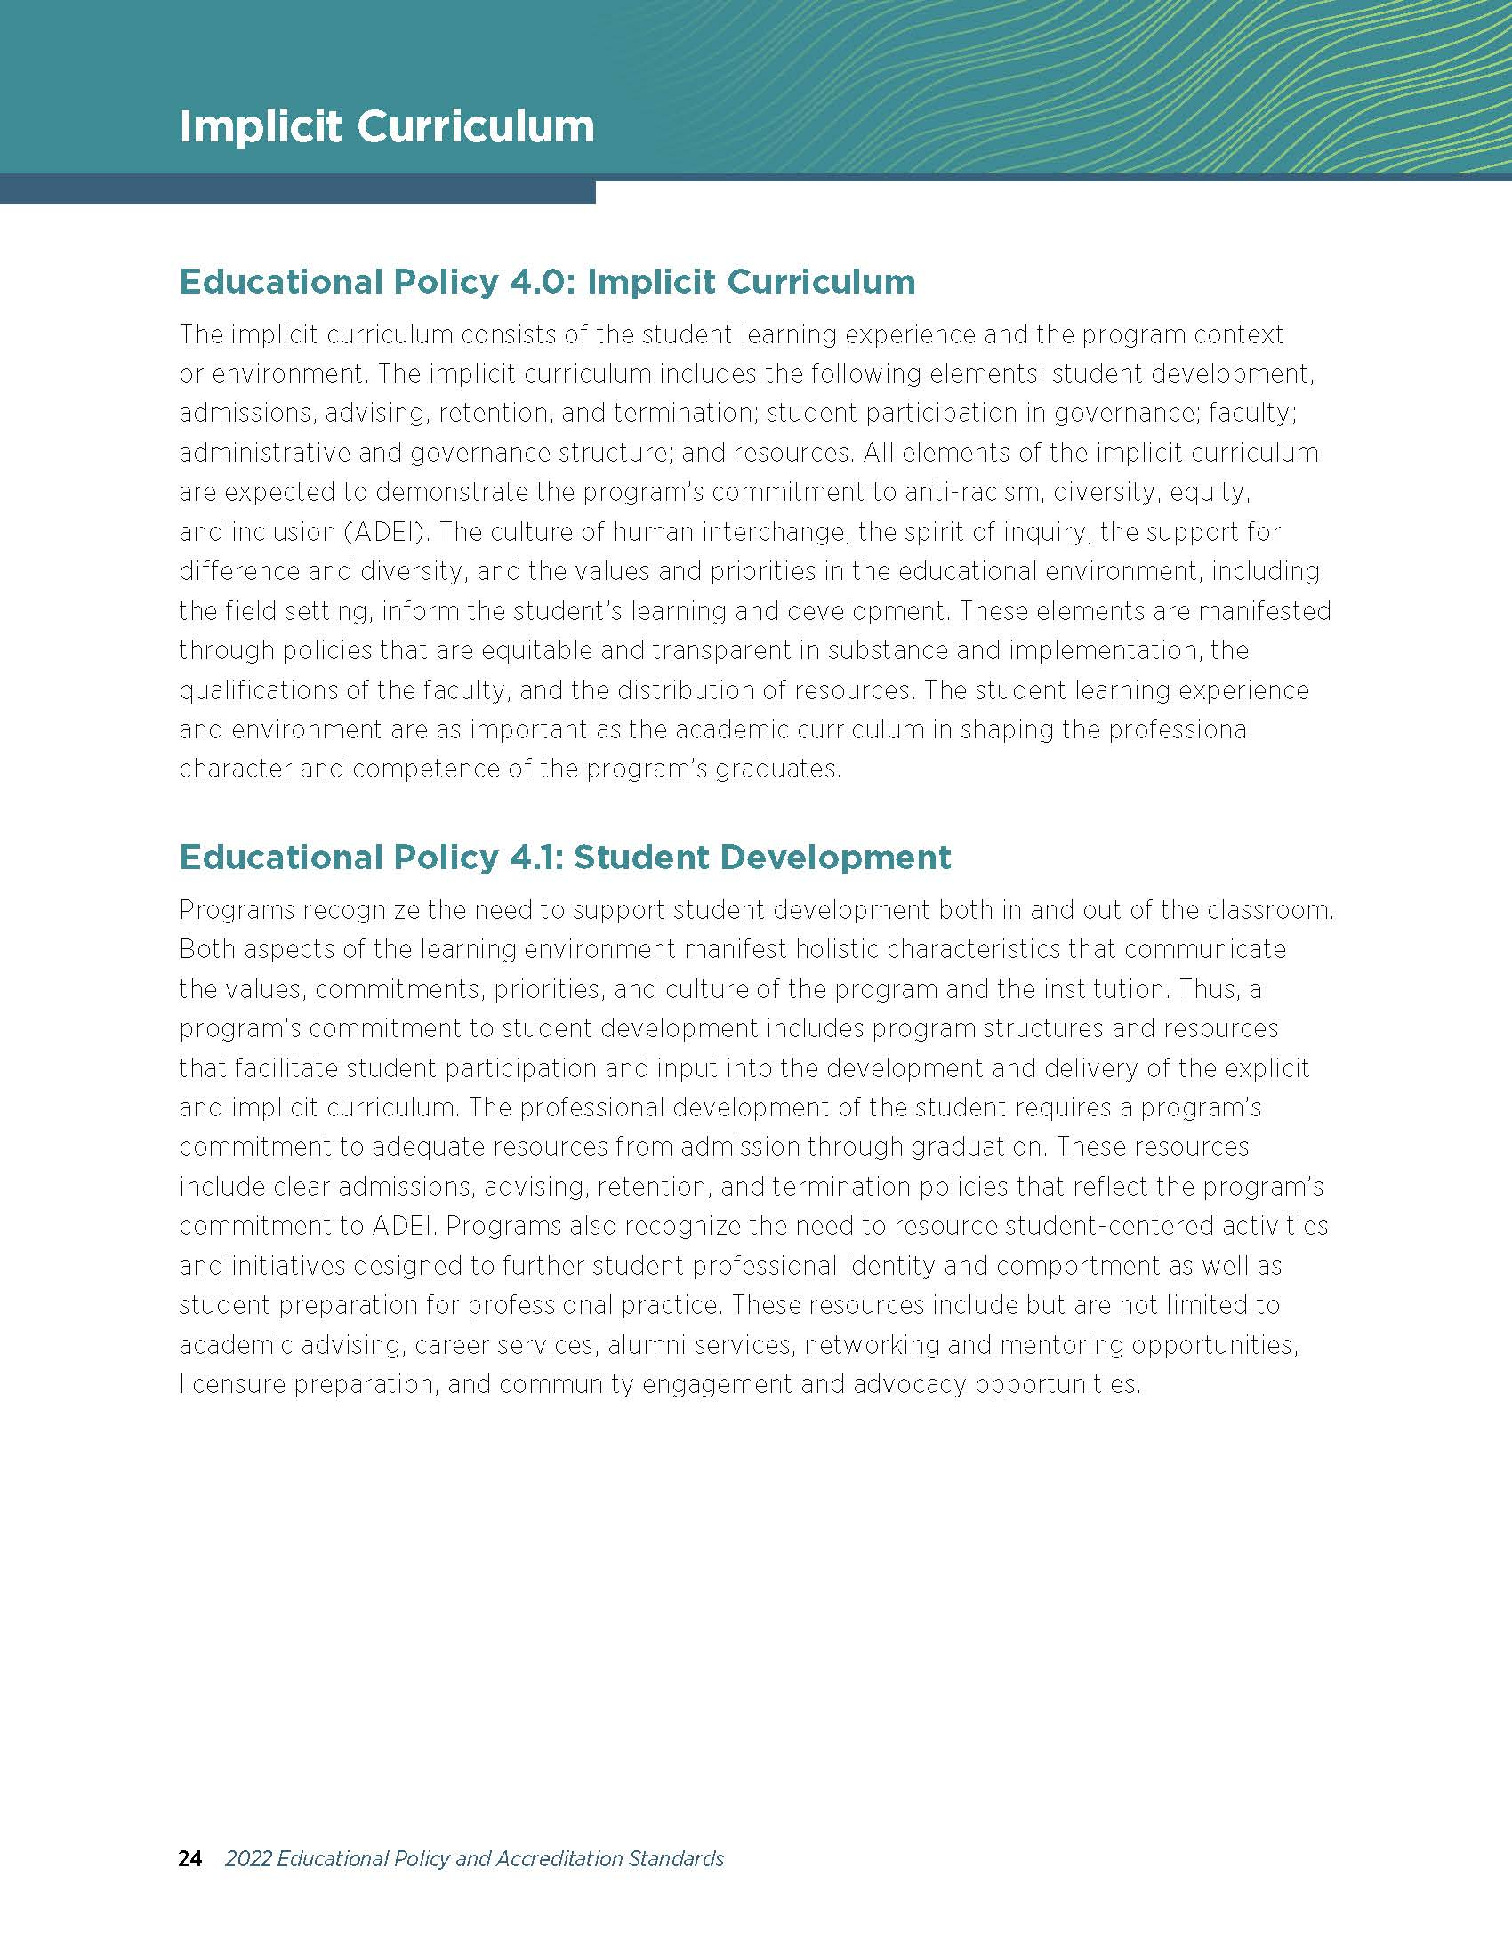
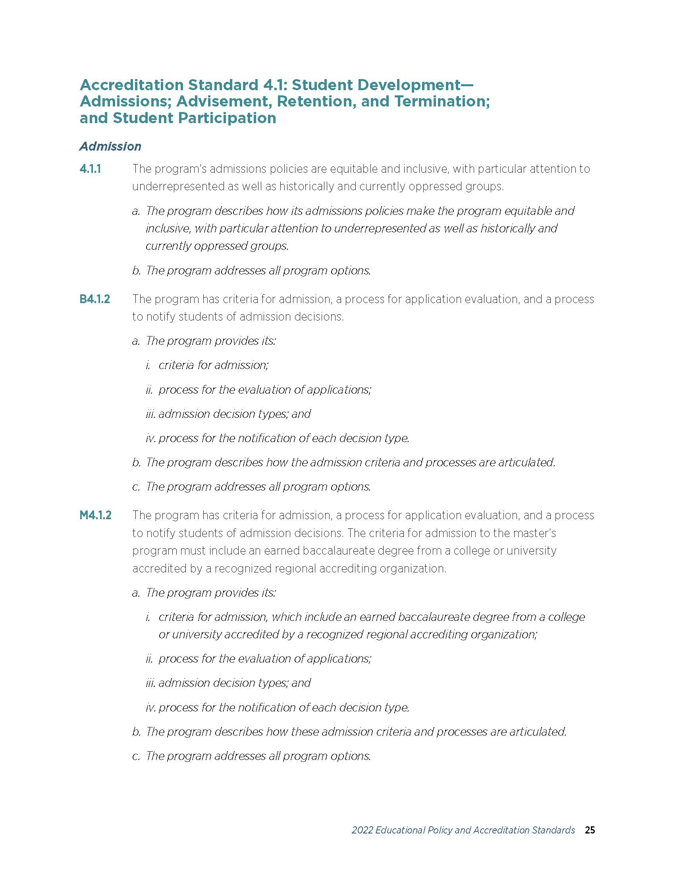
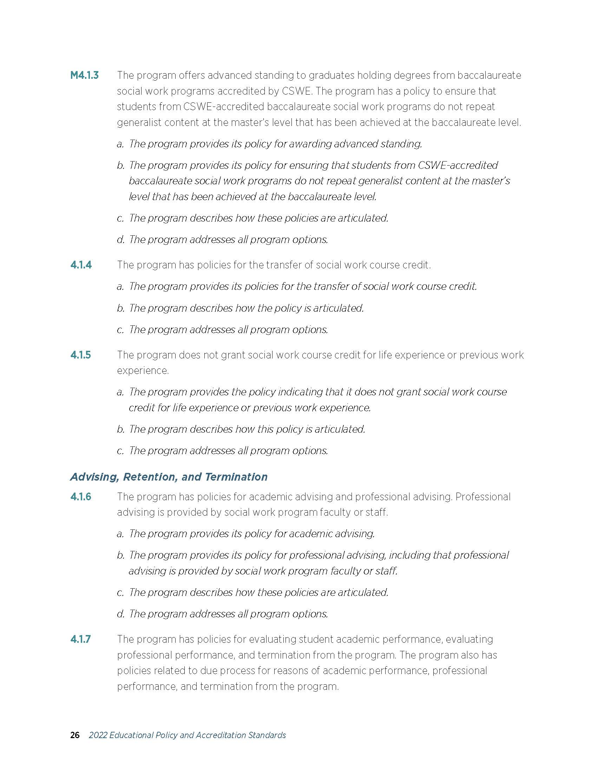
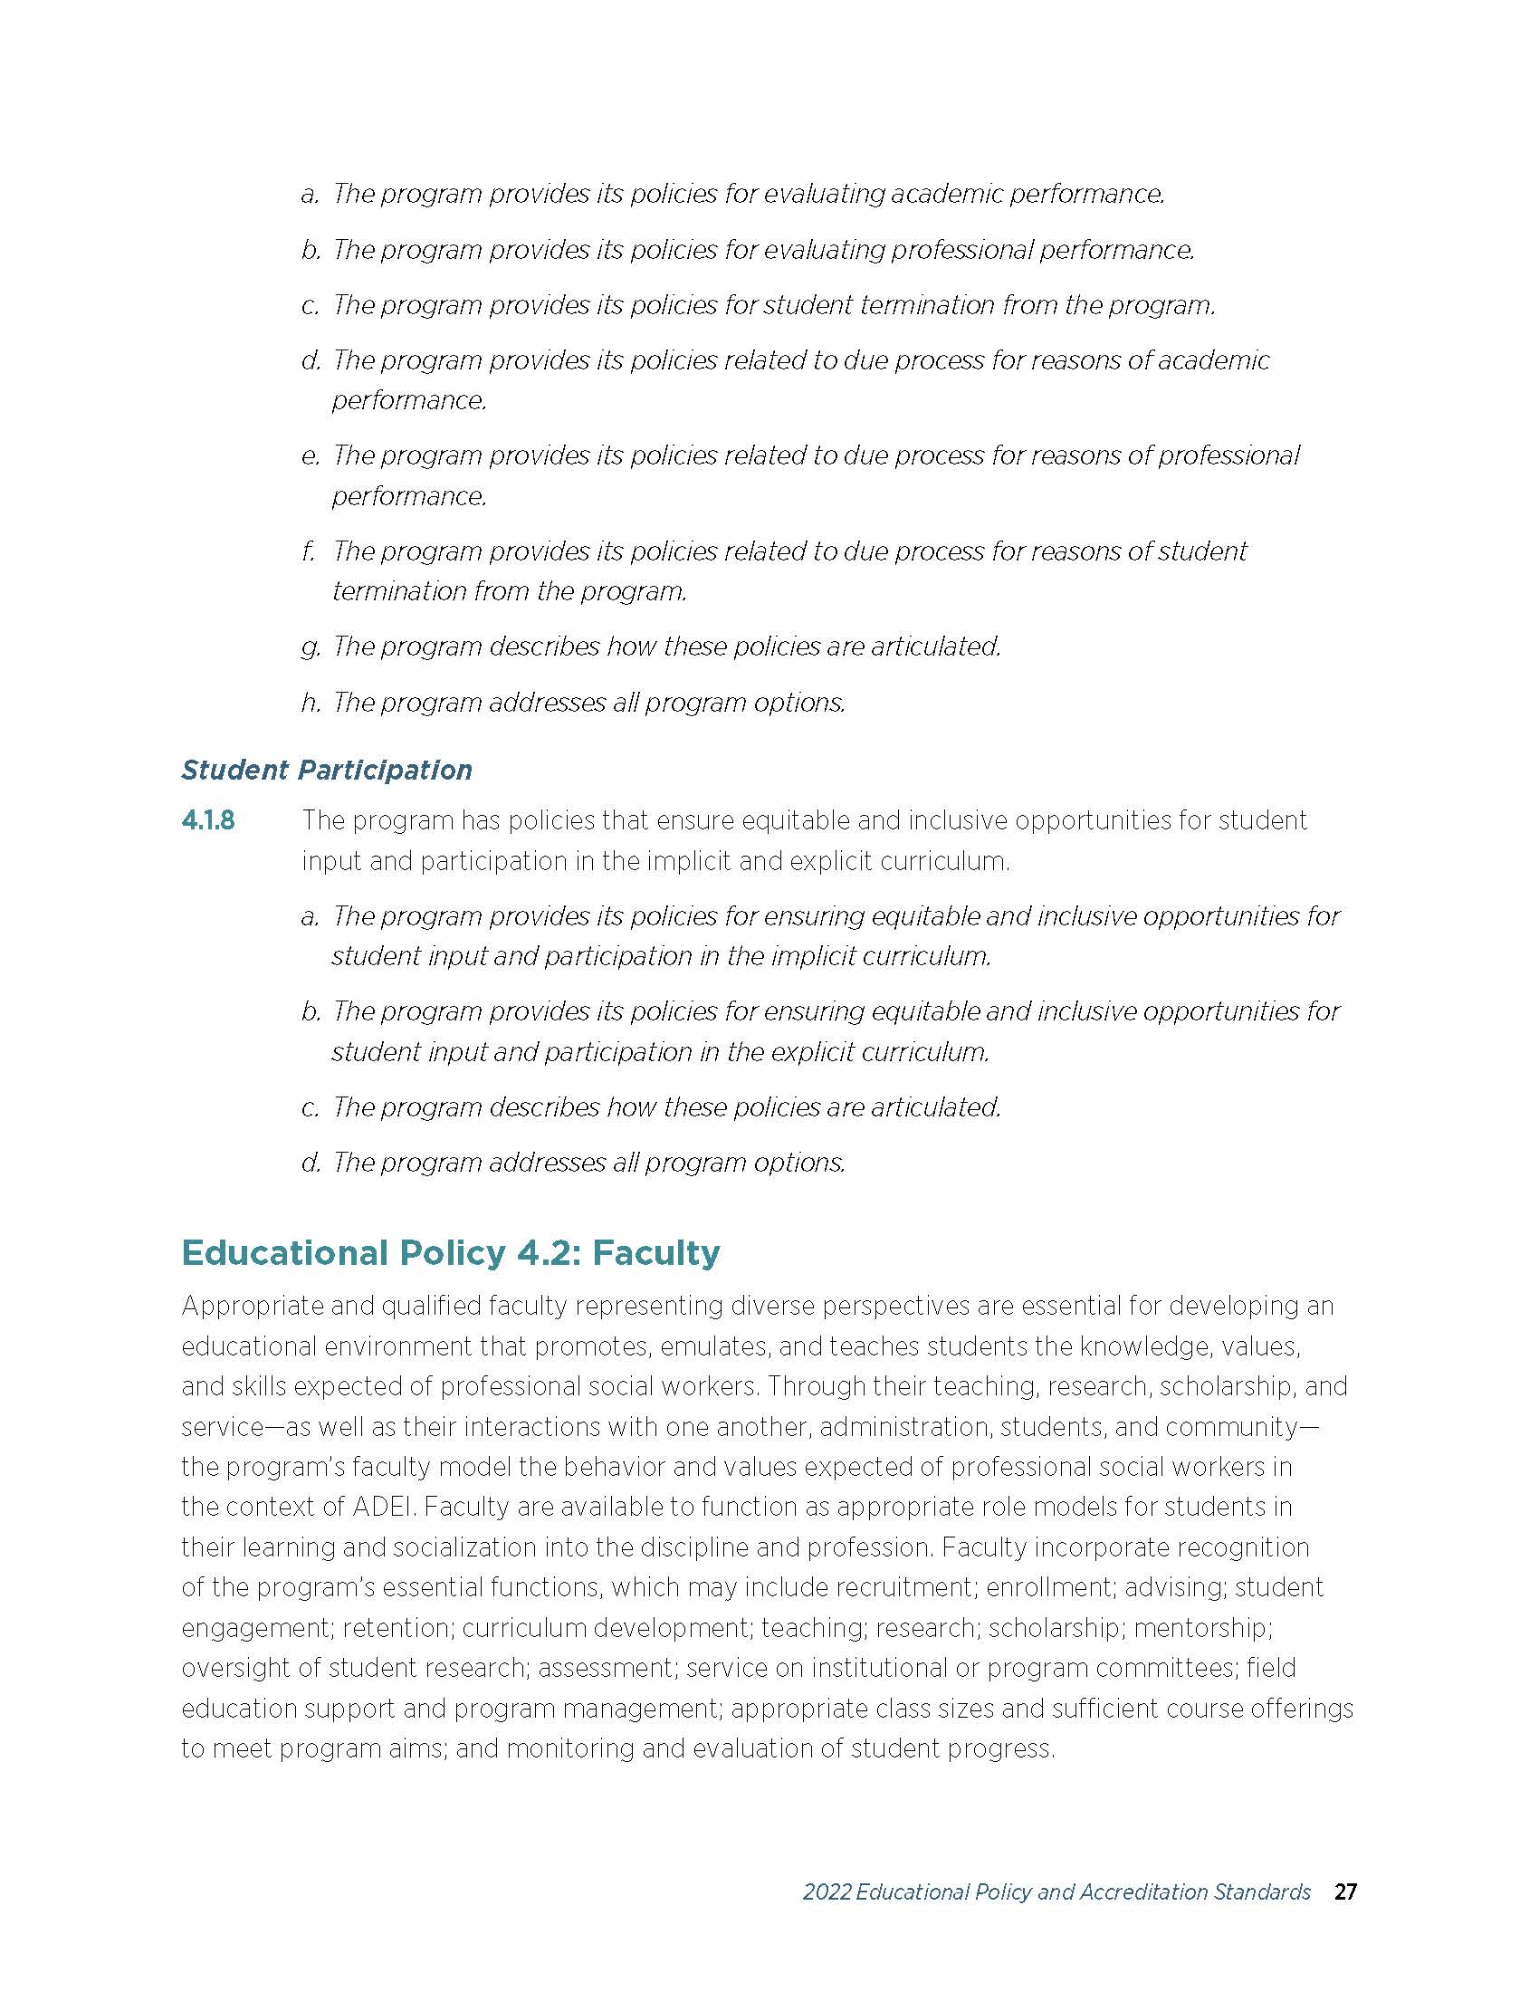
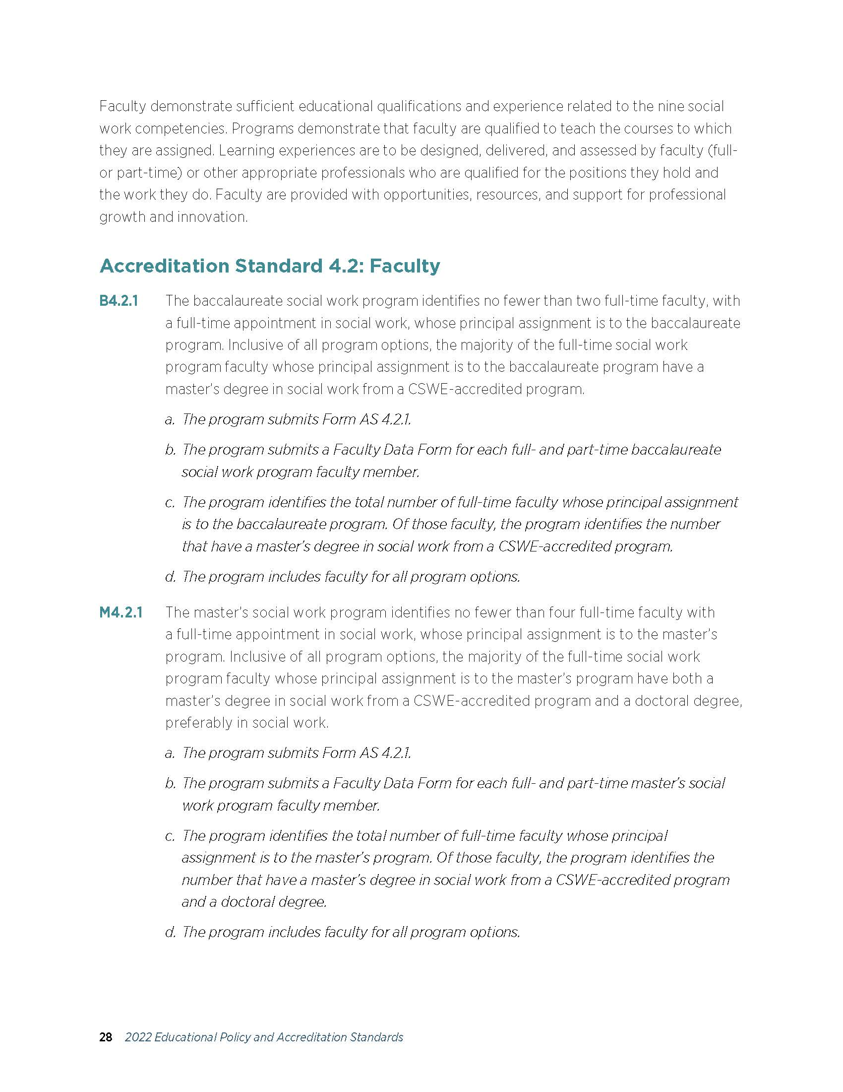
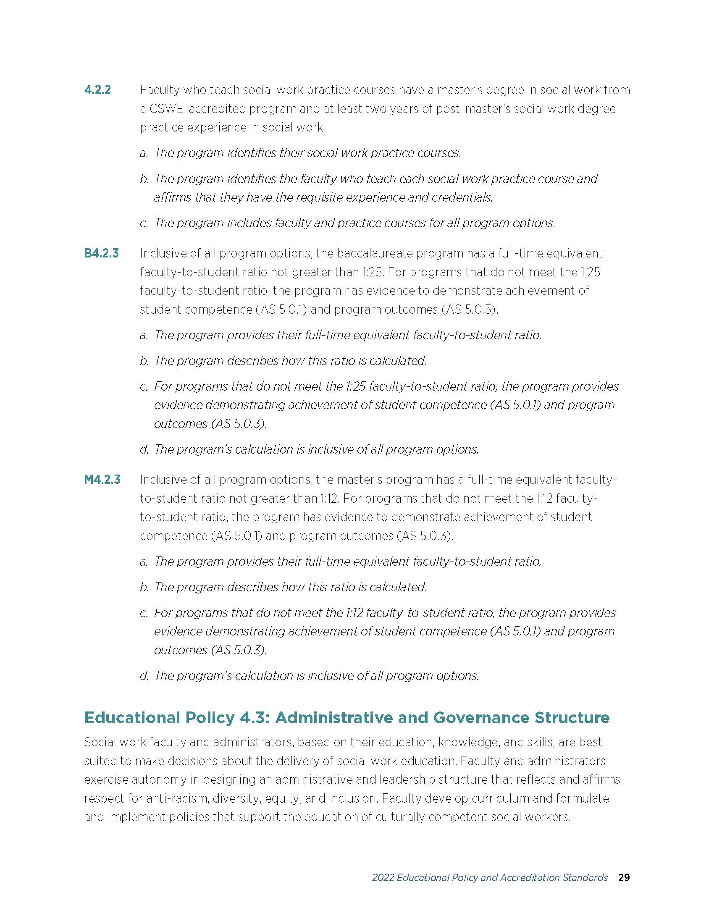
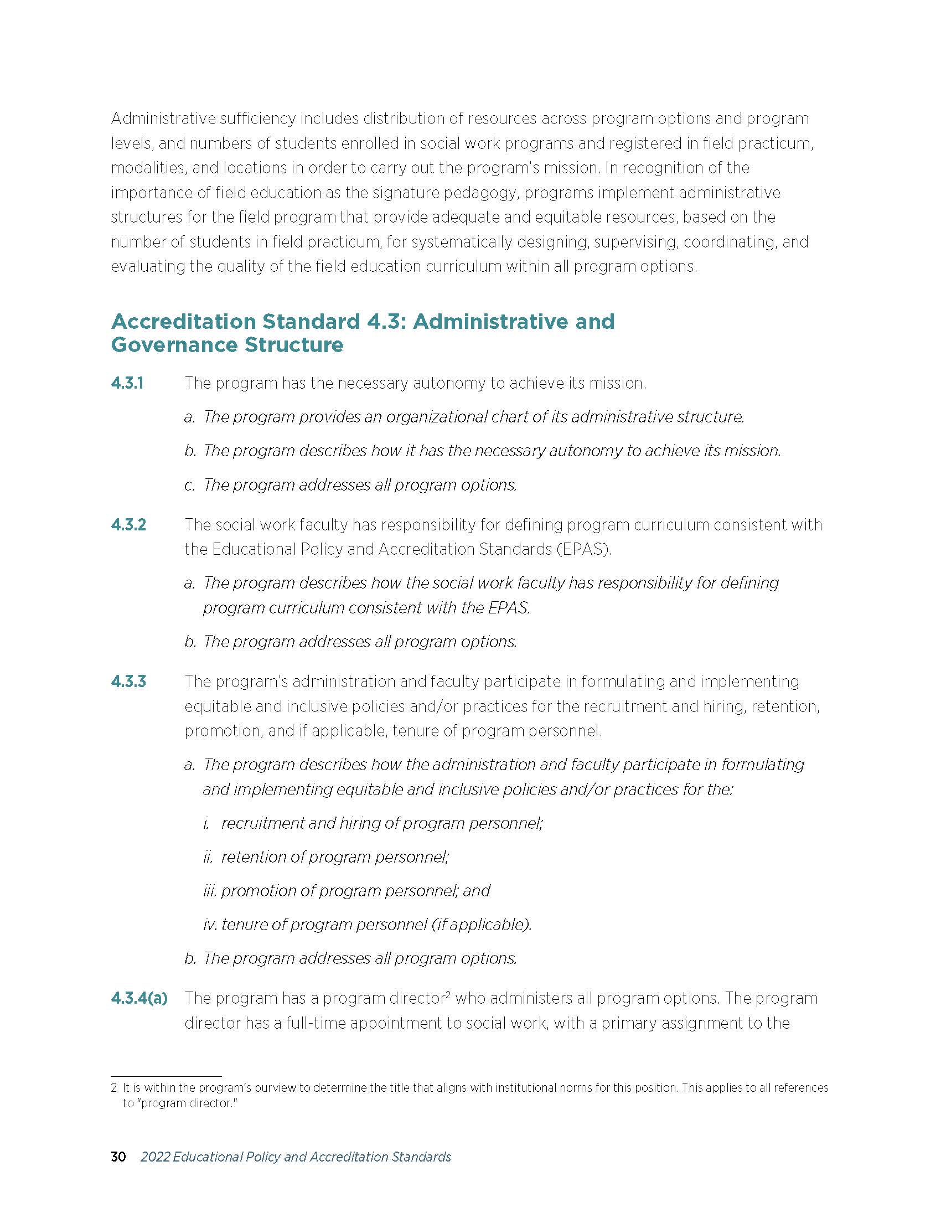
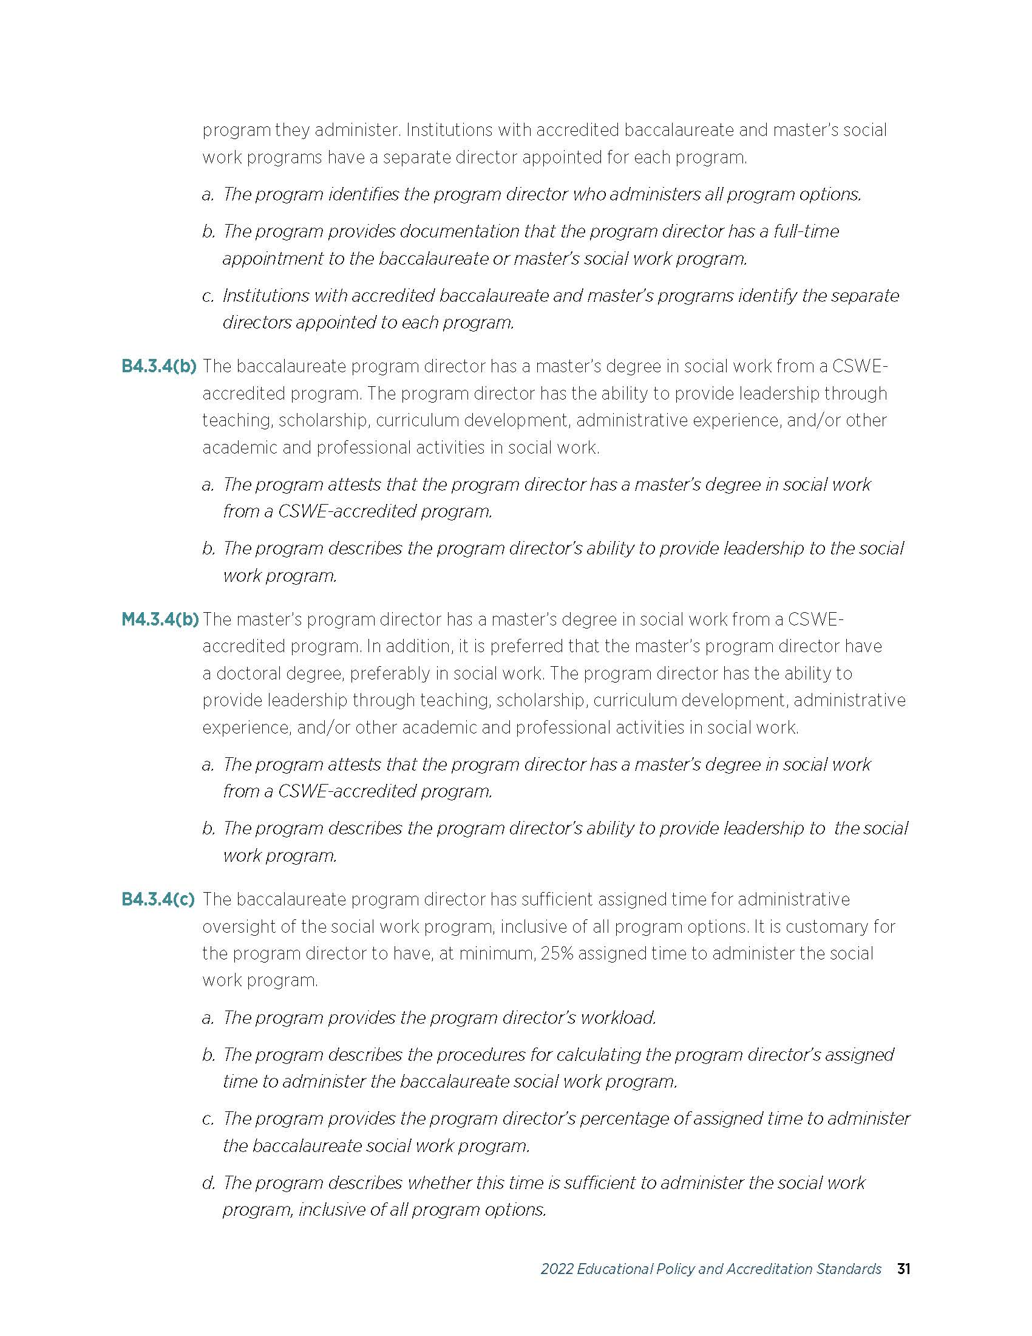
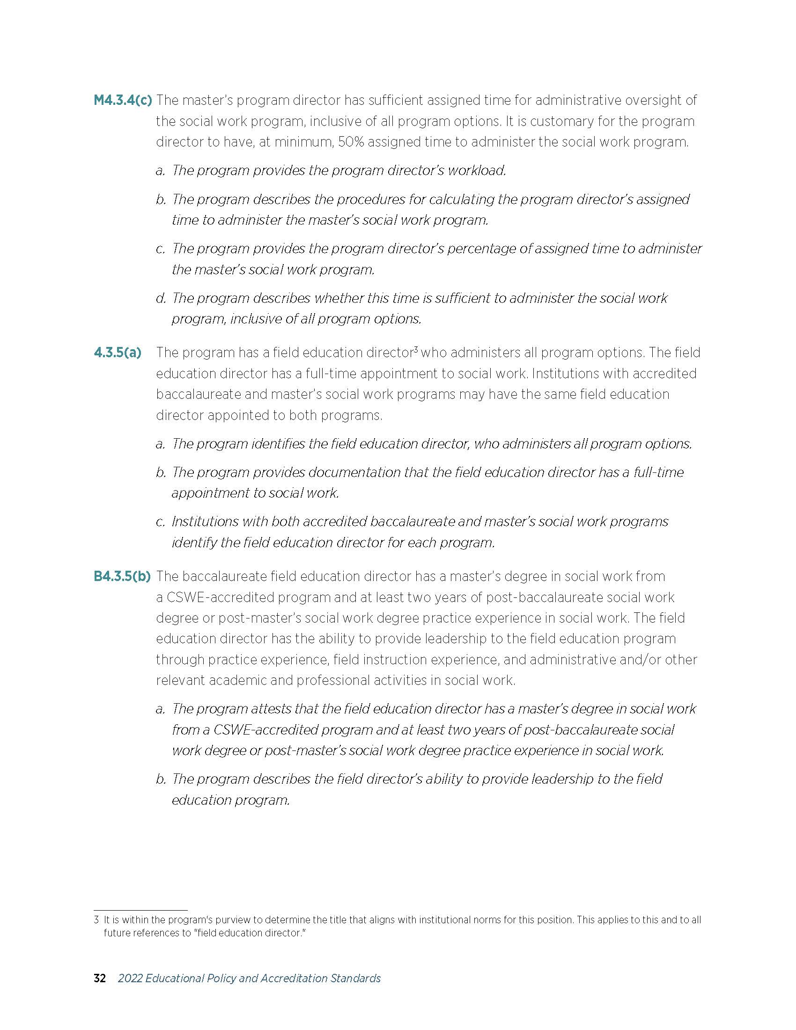
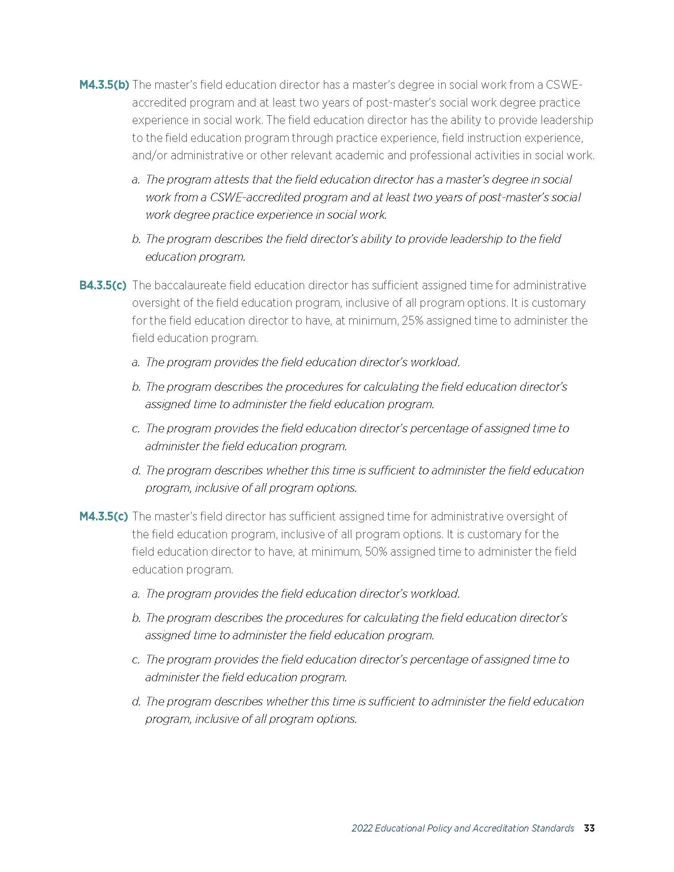
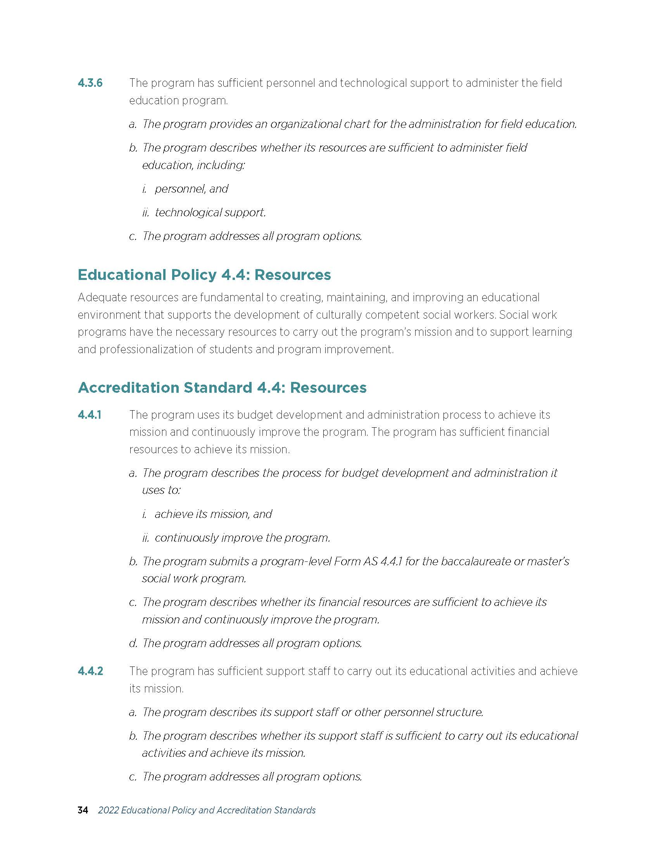
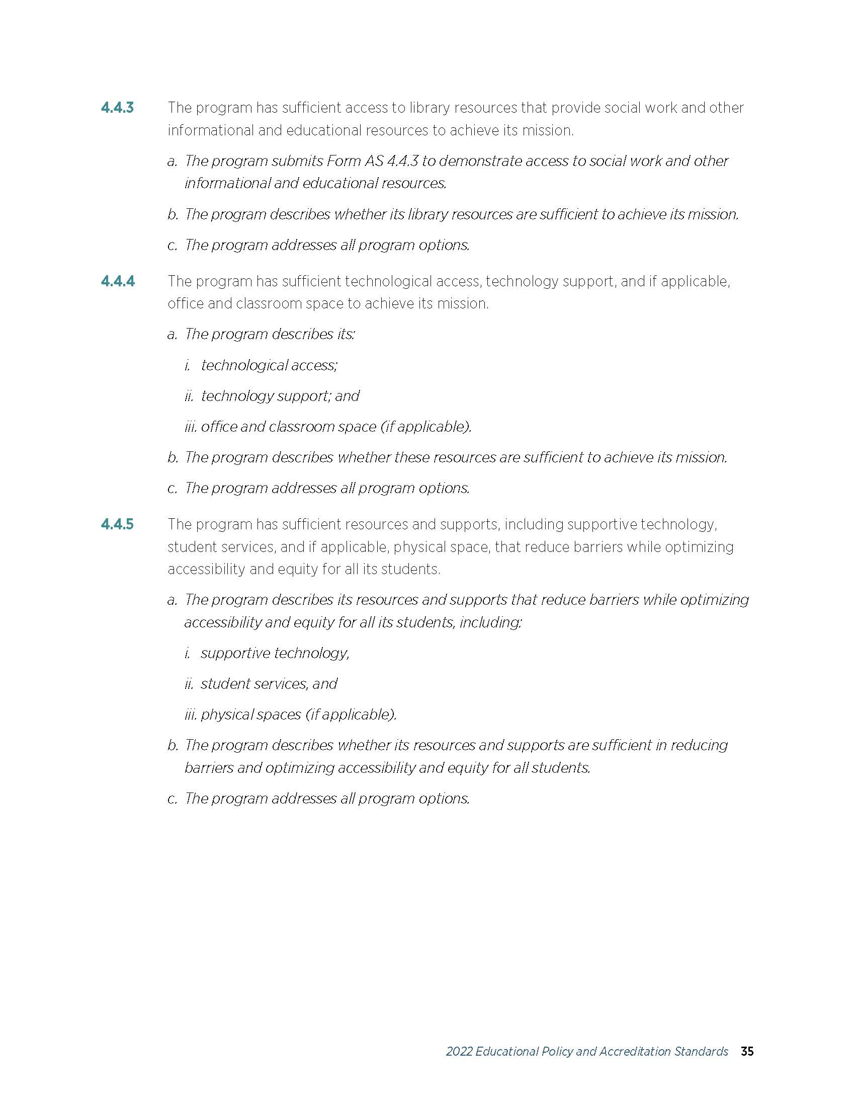
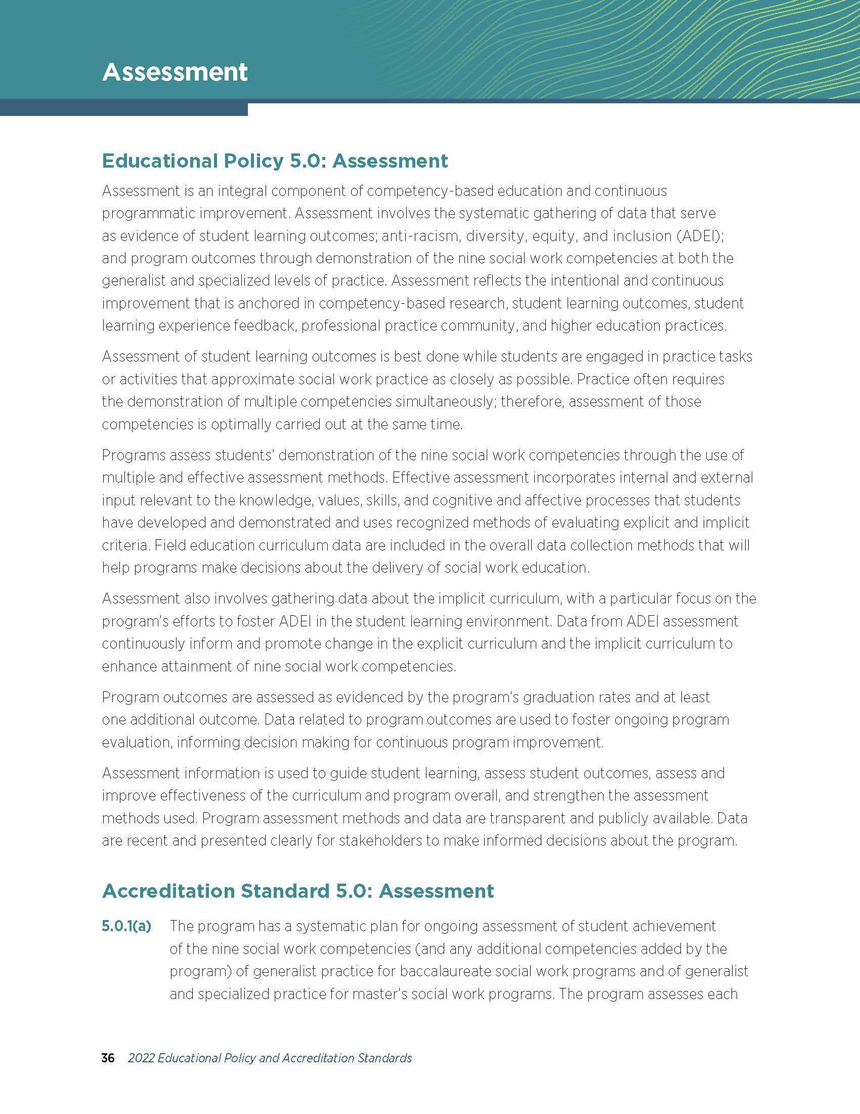
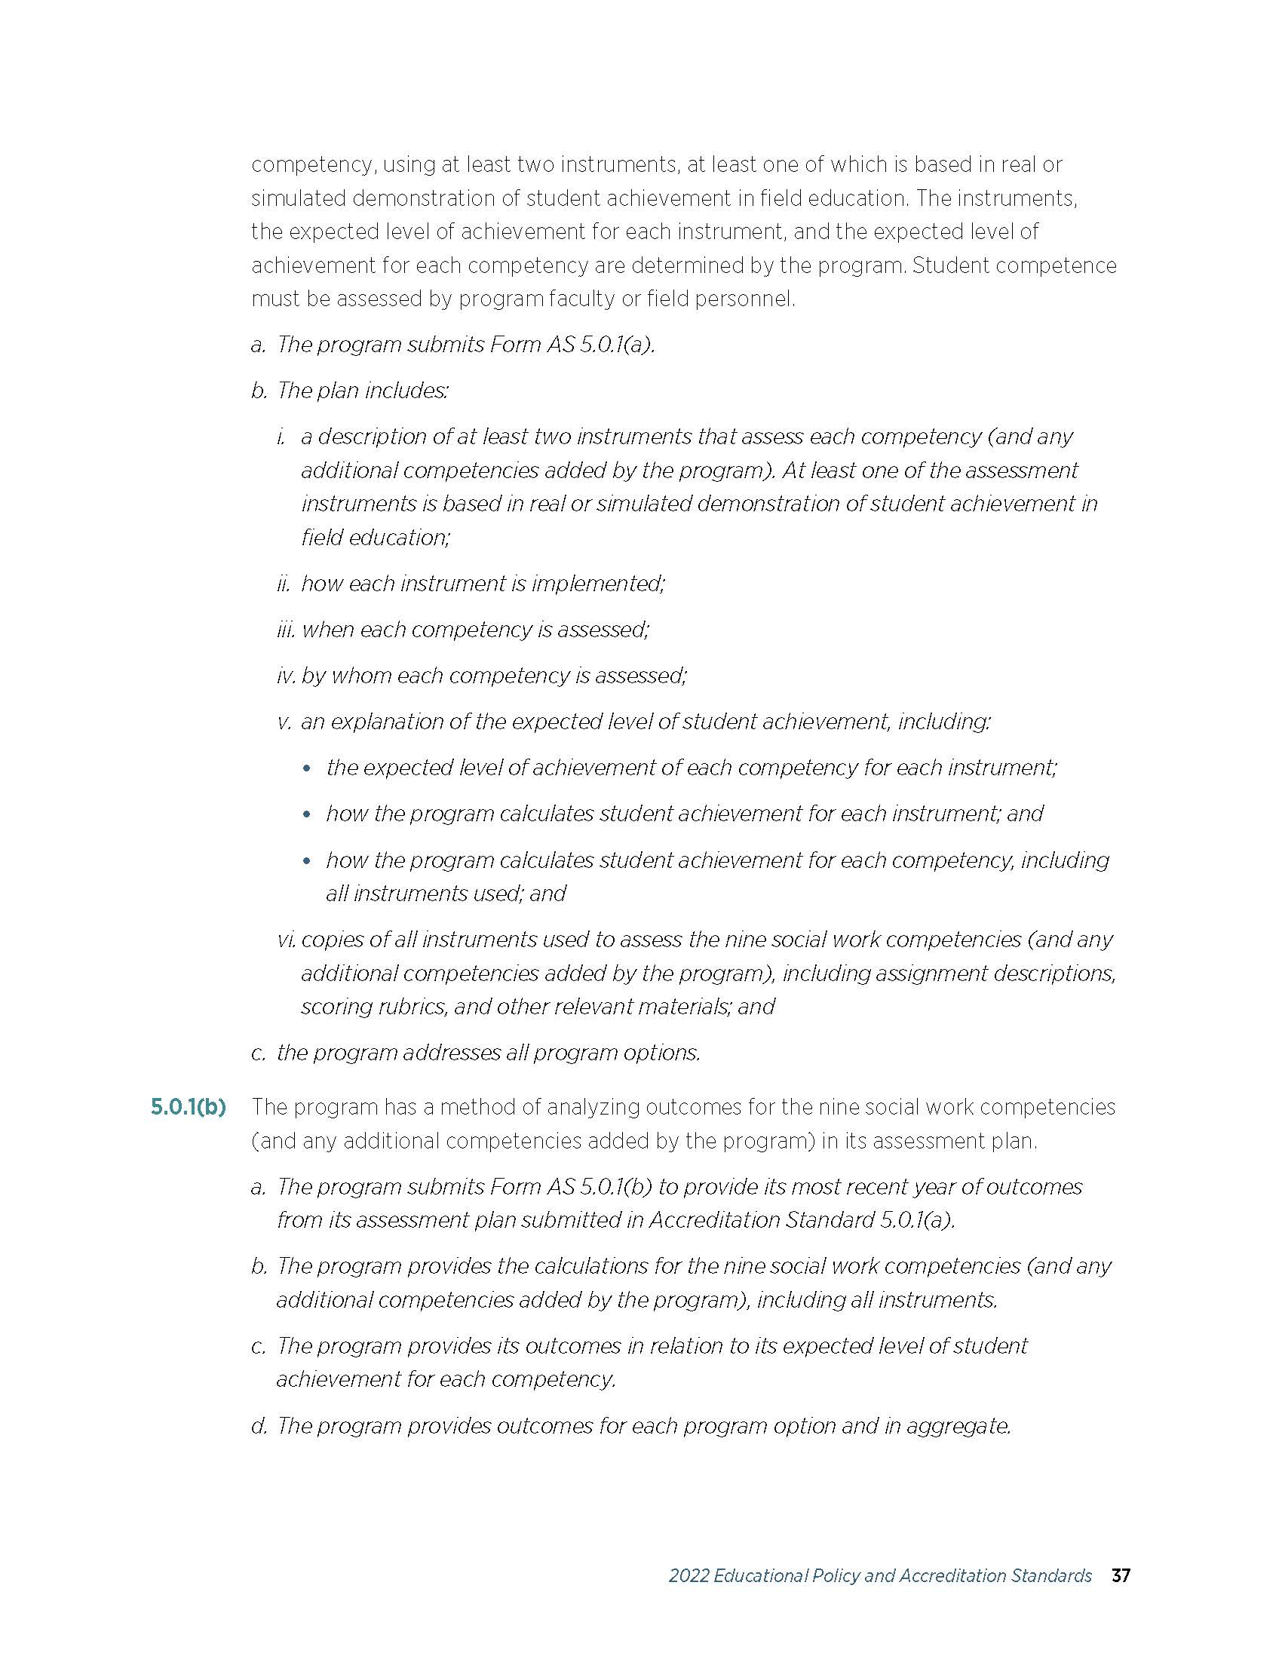
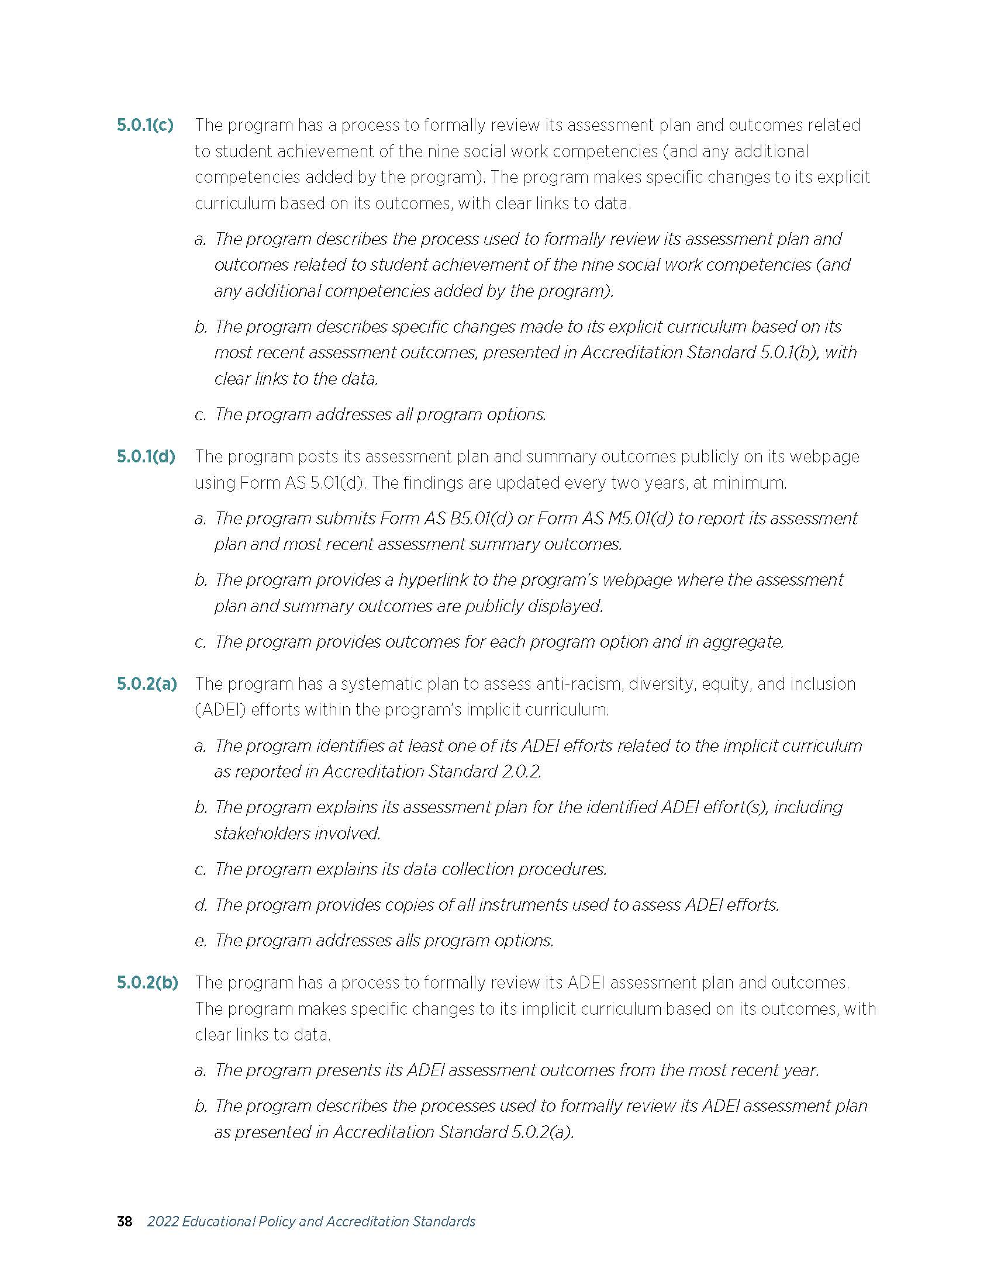
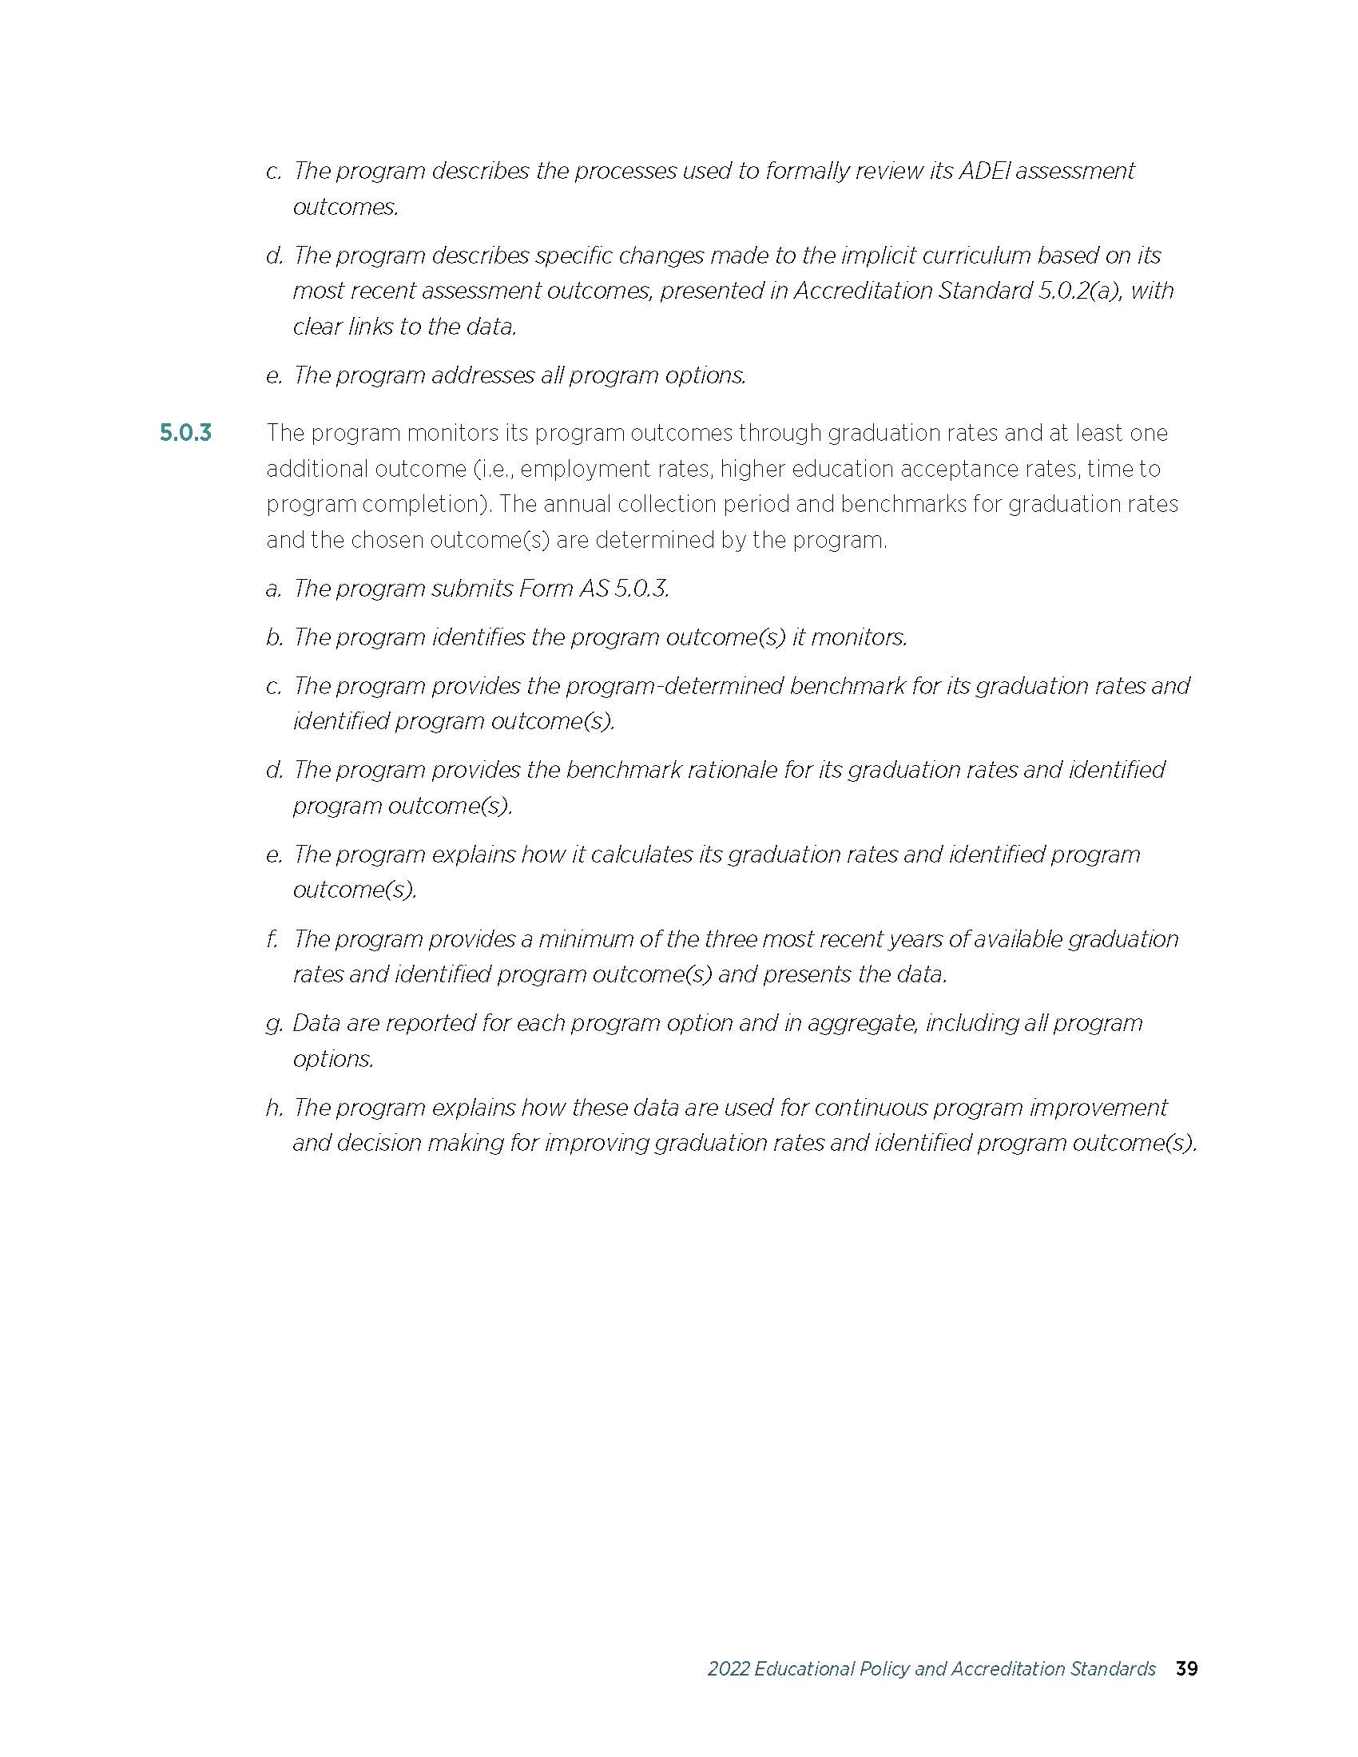

Appendix B: Summary of the NASW Code of Ethics

Summary of Ethical Principles1

Value: Service
Ethical Principle: Social Workers' primary goal is to help people in need and to address social problems.

Value: Social Justice
Ethical Principle: Social Workers challenge social injustice.

Value: Dignity and Worth of the Person
Ethical Principle: Social Workers respect the inherent dignity and worth of the person.

Value: Importance of Human Relationship
Ethical Principle: Social Workers recognize the central importance of human relationships.

Value: Integrity
Ethical Principle: Social Workers behave in a trustworthy manner.

Value: Competence
Ethical Principle: Social Workers practice within their areas of competence and develop and enhance their professional expertise.

100100

1 A complete copy of the NASW Code of Ethics is available online at: https://www.socialworkers.org/pubs/code/default.asp

Appendix C: BSW Forms and Information

Social Work Requirements for Students

BSW Requirement Sheet Sample Course Schedule Program of Study Plan Certification of Clearance to Register Form

Application for the Professional Program Ambassador Application
FAQs

BSW Requirement Sheet – 2023 Catalog (example only; please use DegreeWorks)

Name CWID # Overall GPA SW GPA UA GPA Writing Exam Passed Admission to Program Advisor
Area I (6) | English Composition (101/102) | 6
Area II (12) Humanities/Fine Arts FR/SO | Fine Arts | 3
 | COM 123 or COM 122  Humanities or Fine Arts or Literature | 3-6
 | Literature * | 3-6
Area III (11)  Natural Science/ Mathematics FR/SO | BSC 108 or 109 w/Lab  Natural Science w/Lab | 8
 | Mathematics 110 or higher | 3
Area IV (15) History/Social & Behavioral Sciences FR/SO  At least 12 hours must have the HI/SB designation | PY 101 | 3
 | SOC 101 | 3
 | HY 101, 102, 117, or 118 * | 3-6
 | Two courses in two different departments: ANT 100, 102, 103, 225; AAST 201;  BUI 102; COM 220  EC 110, 111; GY 105, 110;  PSC 101, 211, 370; SOC 202 | 6
Pre-Professional  (31) – JR | UA Free Electives | 11-15
 | Foreign Language (Not Computer Science) | 4-8
 | Statistics (BER 345, PY 211,  ST 260, CJ 381, SOC 301) ++ | 3
 | PY 358 or SW 415+  PY 372 or SOC 205 | 6
 | SW 100 (SW 105- honors program), SW 200 (SW 205- honors program), SW 351 (SW 355-honors program) | 9
 | SW 101 | 3
 | SW 310 | 3
Social Work (48) JR/SR | SW 401 (SW 405-honors program), SW 410, SW 411** | 9
 | SW 440, SW 441, SW 442** | 9
 | SW 444 | 1
 | SW 420 (SW 425- honors program) ++, SW 443, SW 490 | 15
 | Two SW electives | 6
Honors Requirements (Honors program Only) | Refer to Honors Block in Degree Works | 21
 | Totals | > 120
A grade of ‘C-’ or better must be earned in all required courses: BSC 108 or 109, COM 122 or 123, PY 101, SOC 101, PY 358, PY 372 or SOC 205, statistics, and all Social Work (SW) courses.
* Must have a 6-hour sequence in either literature or history. History courses must be from the same history sequence (HY 101 and 102 or HY 117 and 118).
** Admission to the Professional Program is required prior to enrolling in 400-level courses. Distance learning students completing SW 440, SW 441, and SW 442 must also register for in-person skills labs.
+ SW 415 also counts as a social work elective.
++ Statistics must be taken prior to SW 420 (Research)

BSW 2nd Degree Requirement Sheet – 2023

Name Student # Overall GPA SW GPA UA GPA Writing Exam Admission to Program Advisor

 | BSC 108 or 109 | 4
 | PY 101, SOC 101 | 6
 | COM 123 or COM 122 | 3
 | Two courses in two different departments: ANT 100, 102, 103, 225; AAST 201, BUI 102, COM 220, EC 110, 111; GY 105, 110; PSC 101, 211, 370, SOC 220 | 3
General Education Courses  (28 hours) |  | 3
 | PY 372 or SOC 205 | 3
 | PY 358 or SW 415 | 3
 | Statistics** | 3
 | SW 101 | 3
 | SW 310 | 3
 | SW 100/105, SW 200/205, SW 351/355 | 9
 | SW 401/405, SW 410*, SW 411 | 9
Social Work (48) | SW 440, SW 441, SW 442 | 9
 | SW 444 | 1
 | SW 420/425**, SW 443/445, SW 490 | 15
 | Two SW electives | 6

Total 76
Effective for students seeking a second bachelor’s degree Hours completed toward degree
Remaining hours

This sheet is for informational purposes only. Some classes require prerequisites. Please refer to the Undergraduate Catalog for details

Sample Course Schedule

Fall Semester |  | Spring Semester |  | Summer Sessions
Course | Hours | Course | Hours | Course | Hours
 |  | Freshman Year
EN 101 | 3 | EN 102 or EN 103 | 3
SW 101 | 3 | Core Math | 3
SOC 101 | 3 | HY 101,102, 117, or 118 | 3
Foreign Language | 3-4 | Foreign Language | 3-4
SW 100/105 | 3 | PY 101 | 3
 | 15-16 | Sophomore Year | 15-16
Fine Arts | 3 | Literature | 3
Social Behavioral (from | approved list) 3 | COM 122 or 123 | 3
SW 200/205 | 3 | SOC 205 or PY 372 | 3
Core BSC with lab | 4 | SW 351/355 | 3
SW 310 | 3 | Core Natural Science (with lab) | 4
 | 16 | Junior Year | 16
Statistics | 3 | Social Behavioral (from approved list) | 3
SW Elective | 3 | SW 411 | 3
SW 410 | 3 | SW 441 | 3
SW 401/405 | 3 | SW 442 | 3
SW 440 | 3 | SW 444 | 1
 | 15 | SW 420/425  Senior Year | 3  16
SW 490 | 9 | PY 358 or SW 415 | 4
SW 443 | 3 | HY or LIT sequence | 3
 |  | SW Elective | 3
 |  | Free electives | 2-5
 | 12 |  | 12-15

The University of Alabama School of Social Work BSW Program (use DegreeWorks)
Program of Study Plan for , CWID , PHONE Date: Advisor:
(Fall Professional Program Admission)
Fall |  | Spring |  | Interim
 |  |  |  | Summer
Hours |  | Hours |  | Hours
Fall |  | Spring Apply for Prof Prog |  | Interim
 |  |  |  | Summer
Hours |  | Hours |  | Hours
Fall |  | Spring |  | Interim
SW 410 | 3 | SW 444 | 1
SW 440(W) | 3 | SW 411 | 3 | Summer
SW 401/405 (W) | 3 | SW 441 | 3
 |  | SW 442 | 3
 |  | SW 420/425 | 3
Hours 9 |  | Hours 13 |  | Hours
Fall |  | Spring |  | Interim
SW 443 | 3
SW 490 | 9 |  |  | Summer
Hours 12 |  | Hours |  | Hours

*A minimum of 120 hours is required; no more than 60 hours from a 2-year college will be credited.

The University of Alabama School of Social Work BSW Program (use DegreeWorks) Program of Study Plan for , CWID , PHONE Date: Advisor:

(Part-time Professional Program-Fall Admission)
Fall |  | Spring |  | Interim
 |  |  |  | Summer
Hours |  | Hours |  | Hours
Fall |  | Spring Apply for Prof Prog |  | Interim
 |  |  |  | Summer
Hours |  | Hours |  | Hours
Fall |  | Spring |  | Interim
SW 410 | 3 | SW 401/405 (W) | 3
SW 440(W) | 3 | SW 411 | 3 | Summer
 |  | SW 444 | 1 | SW 441 | 3
 |  |  |  | SW 442 | 3
Hours 6 |  | Hours 7 |  | Hours 6
Fall |  | Spring |  | Interim
SW 443 | 3
SW 490 | 9 |  |  | Summer
SW 420/425** | 3
Hours 15 |  | Hours |  | Hours

*A minimum of 120 hours is required; no more than 60 hours from a 2-year college will be credited.
** Sw 420 can be taken at any time during the Professional Program but must be taken before or with SW 490. Statistics is a prerequisite for SW 420.

The University of Alabama School of Social Work BSW Program (use DegreeWorks) Program of Study Plan for , CWID , PHONE Date: Advisor:
(Spring Professional Program Admission)
Fall |  | Spring |  | Interim
 |  |  |  | Summer
Hours |  | Hours |  | Hours
Fall |  | Spring Apply for Prof Prog |  | Interim
 |  |  |  | Summer
Hours |  | Hours |  | Hours
Fall |  | Spring |  | Interim
 |  | SW 401/405 (W) | 3
 |  | SW 440 (W) | 3 | Summer
 |  | SW 410 | 3 | SW 411 | 3
 |  | SW 444 | 1 | SW 441 | 3
 |  | SW 420/425 3 |  | SW 442 | 3
Hours |  | Hours 13 |  | Hours 9
Fall |  | Spring |  | Interim
SW 443 | 3
SW 490 | 9 |  |  | Summer
Hours 12 |  | Hours |  | Hours

*A minimum of 120 hours is required; no more than 60 hours from a 2-year college will be credited.
The University of Alabama School of Social Work BSW Program
BSW Professional Program
Application for Admission - Preliminary Checklist

This form us for informational purposes only. The official application will be filled out through Qualtrics
First, read about the Professional Program in the BSW Student Handbook. The student will then receive an email from the Program Director requesting that student to fill out the Qualtrics checklist, write essays, and complete the field statement.

NOTE: The courses listed below must be passed with a grade of C- or higher.
For the first 9 statements, you will either choose “passed”, “am enrolled in”, or “have not enrolled in” depending on whether you have completed the course in question.

- I passed/ am enrolled/ have not enrolled in BSC 108, BSC 109, BSC 114/115 or BSC 116/117.
- I passed/ am enrolled/ have not enrolled in PY 101.
- I passed/ am enrolled/ have not enrolled in SOC 101.
- I passed/ am enrolled/ have not enrolled in SW 100 or SW 105.
- I passed/ am enrolled/ have not enrolled in SW 200 or SW 205.
- I passed/ am enrolled/ have not enrolled in SW 351 or SW 355
- I passed/ am enrolled/ have not enrolled in SW 101
- I passed/ am enrolled/ have not enrolled in SW 310
- I have completed/ am enrolled/ have not enrolled in the core Math requirement (MA 110 or 112)
- If not enrolled, have you passed Math 100? Yes No
- I have completed at least 45 hours toward my BSW degree. Yes No
- I will have completed at least 54 credit hours toward my BSW degree by the time I begin the professional BSW program. Yes No
- My overall GPA is at least a 2.25. Yes No
- My overall GPA is ______ Date __________
- My SW GPA is at least 2.5. Yes No
- My SW GPA is _________ Date__________
- If I have completed any college-level academic work at any institution other that UA, I have submitted ALL of my transcripts to the UA Registrar’s Office. Yes No
- I understand that my field placement will require me to learn in an agency 32 hours/week, typically during office hours (M-F/ 8am-5pm) for an entire semester. Main campus students will be placed in Tuscaloosa, Birmingham, or a 60-mile radius of Tuscaloosa (or in Washington, DC or internationally). Distance learning students will be placed within 60 miles of their location in the state of Alabama (or in Washington, DC or internationally). YES NO
- I have read and agree to abide by the NASW Code of Ethics. Yes No
- I agree to abide by the Capstone Creed (see below).
“As a member of The University of Alabama community, I will pursue knowledge, act with fairness, integrity and respect; promote equity and inclusion; foster individual and civic responsibility; and strive for excellence in all I do.”
Signature: ______________________________________________

- Please review and sign:
Violations of the NASW Code of Ethics or the Capstone Creed may result in dismissal from the Social Work program and the University of Alabama.
Signature: ____________________________ Date: _______________________
Printed Name: ______________________________
CWID: _______________________________

The University of Alabama School of Social Work
BSW Program Application for Admission to the Professional Program
Essay Instructions and Application Cover Page

If you have answered all the items on the application checklist, or if your advisor indicated you should apply, follow the instructions here.
- Provide the information requested in the box below.
- Type three essays using the prompts below and respond to the field statement in a paragraph. Attach these to this cover page. Do not put your name on the essays or field statement paragraph. Each essay must be at least 350 words. In each essay and the field statement, be sure to address each prompt provided. Essays and field statement paragraphs will be evaluated for content and quality of writing.

  - Essay I: Why do you want to enter the Professional Program in social work? What experiences led you to think that social work is an appropriate career goal for you? What special circumstances, if any, should be considered by reviewers of your application?

  - Essay II: Identify a major social justice problem that interests you and discuss it. What do you think might be some of the causes of the problem? Imagine that you are a social worker and describe how you might intervene to address the problem. It is expected that you will use research literature or other credible sources to support your assertions. Cite and reference your sources according to APA style guidelines. Information about APA style guidelines can be found at https://owl.purdue.edu/owl/research_and_citation/apa_style/apa_formatting_and_style_guide/general_format.html.

  - Essay III: What is the NASW Code of Ethics and what is its purpose? Discuss one of the principles or standards in the Code of Ethics, explaining how you would apply it as a social worker who works with clients. If you use language from the Code of Ethics, be sure to cite and reference your source according to APA styles guidelines.

  - Field Statement: Field placements are completed during the fall semester of your senior year after you have taken most of your Professional Program courses. Students typically complete 32 hours per week in a social service agency for the entire semester (Total of 450 clock hours in agency). You will be required to be in field a minimum of 16 hours per week during normal business hours/days (M-F/8:00 am -5:00 pm). Main Campus students will be placed in Tuscaloosa, Birmingham or 60-mile radius of Tuscaloosa. Distance Learning students will be placed in one of the following geographic locations including the county in which the city is located: Huntsville, Birmingham, Tuscaloosa, Montgomery, and Mobile.

In a paragraph explain how you plan to accommodate field requirements into your personal, family, and/or professional responsibilities.

- Submit your application through the Qualtrics link that is provided to you.

Name CWID#

Local Address Phone Email
List all colleges and universities, other than UA, that you have attended

Signature Date

THE CAPSTONE CREED

The Capstone Creed is a statement of UA student values developed by the Student Leadership Council. The Capstone Creed is the pledge made at convocation by each incoming freshman class at the start of the academic year.
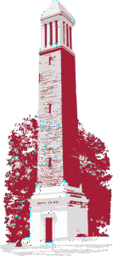
Denny Chimes

“As a member of The University of Alabama community, I will pursue knowledge, act with fairness, integrity and respect; promote equity and inclusion; foster individual and civic responsibility; and strive for excellence in all I do.”

BSW AMBASSADOR APPLICATION

Name: CWID#:

# of SW credit hours completed: Semesters at UA:

SW GPA: UA GPA:

List of individuals who will provide letters of recommendations:

1.
2.
3.
4.

STATEMENT OF INTEREST IN THE AMBASSADOR PROGRAM

Signature Date

Appendix D: Academic Bankruptcy

The following specific guidelines apply to any petition for Academic Bankruptcy:

- Academic Bankruptcy is never granted for a semester in which the student is currently enrolled or has just completed.
- Petitions must be filed prior to graduation.
- Only one (1) petition for Academic Bankruptcy shall be granted during the student’s academic program, and relief shall be limited to one semester’s work.
- If the petition is approved, the grades for all courses taken during the semester will be recorded as “W” (withdrawn).
The procedure followed is:
  - The student writes a petition containing the following documents:
    - A statement of the circumstances which were responsible for the poor academic performance;
    - Supporting evidence outlining the dates and places the problem began to develop, how problems affected academic performance, the help that was sought and received, and how the problems were resolved; and
    - Evidence supportive of all claims made in the petition.

  - The student submits the petition to his/her advisor.
  - The advisor renders an initial decision on the petition, and then forwards the petition with his/her signature to the Program Director for recommendation to the Dean. If Academic Bankruptcy is granted, the Office of Student Services will see that all grades for the term are changed to “W” and the student’s record carries the notation “retroactive withdrawal granted.”

Petitions for Academic Bankruptcy are held in strictest confidence. Petitions should be as specific and detailed as possible.

Appendix E: The University of Alabama Academic Misconduct Disciplinary Policy

This policy was revised and became effective in November 2021. It is available online: https://catalog.ua.edu/undergraduate/about/academic-regulations/student-expectations/academic-misconduct-policy/

- General Policy
All students in attendance at The University of Alabama are expected to abide by The Capstone Creed, in which students pledge, among other things, to pursue knowledge, act with fairness, integrity and respect, foster individual and civic responsibility, and strive for excellence in all that they do. All students are also required to adhere to the Academic Honor Pledge, and shall not, at any time, be involved with acts of academic misconduct, such as cheating, plagiarism, fabrication, or misrepresentation. Students are absolutely prohibited from engaging in academic misconduct as defined herein.
Academic Honor Code
- All students in attendance at The University of Alabama are expected to be honorable and observe standards of conduct appropriate to a community of scholars. The University of Alabama expects from its students a higher standard of conduct than the minimum required to avoid discipline. When enrolled at The University of Alabama, students are expected to abide by the Academic Honor pledge. Additionally, at the discretion of the course instructor, each student will be expected to sign an Honor Pledge.
- The Academic Honor Pledge reads as follows: “I promise or affirm that I will not at any time be involved with cheating, plagiarism, fabrication, or misrepresentation while enrolled as a student at The University of Alabama. I have read the Academic Honor Code, and I understand that violation of this code will subject me to charges under the Academic Misconduct Policy and result in penalties as severe as suspension or up to expulsion from the University.
The University is committed to providing its students notice of academic misconduct charges and an opportunity to be heard prior to finding a student responsible and imposing a fair and equitable penalty. This Policy identifies types of academic misconduct and possible penalties and sets forth the process that will be followed when addressing accusations of academic misconduct. Except in divisions that have an alternate academic misconduct policy that has been approved by the Provost or except in instances in which a college is dealing with multiple students accused of academic misconduct in a course and the Provost has approved alternate procedures, academic misconduct cases shall be resolved as set forth below.

- Types of Academic Misconduct

Academic misconduct by students includes all acts of dishonesty in any academic-related matter and any knowing or intentional help, attempt to help, or conspiracy to help another student commit an act of academic dishonesty. Academic dishonesty includes, but is not limited to, each of the following acts when performed in any type of academic or academic-related matter, exercise, or activity:
- Cheating: using, attempting to use or assisting in the use of unauthorized materials, information, study aids, or computer-related information.
- Plagiarism: representing words, data, pictures, figures, works, ideas, computer programs or outputs, or any other work generated by someone else, as one's own.
  - Self-Plagiarism: resubmitting your own previously submitted work without proper citation and permission from the current instructor to whom the original work is subsequently submitted.
- Fabrication: presenting as genuine any invented or falsified citation, data or material.
- Misrepresentation: falsifying, altering, or misstating the contents of documents or other materials related to academic matters, including schedules, prerequisites, and transcripts.

- Penalties for Academic Misconduct

Range of Penalties: Penalties for academic misconduct can range from a reprimand to a penalty as severe as suspension or expulsion for egregious acts and/or multiple offenses.

- First Offense Penalties: For a student’s first offense, typical penalties might include, but are not limited to, the student’s grade on an assignment or test being lowered (even to a zero) or the student’s grade being lowered in the course in which the misconduct occurred. If a student is accused of multiple acts of misconduct where the accusations have not been resolved at the college level (and are therefore not considered “second offenses” as defined below), penalties may be more severe than is typical in first offenses and may include a suspension. A suspension normally requires a minimum of one major semester (fall or spring).
- Second Offense Penalties: Second offense penalties presume that a first offense has been resolved (i.e., a college has made a finding of responsibility prior to the second academic misconduct act). A penalty of suspension is generally mandated for a finding of responsibility on second offenses. The length of the suspension for a second offense generally ranges from one major semester (fall or spring) to one academic year.
Discretion in Imposing Penalties: Academic deans have the authority and discretion to impose a full range of penalties for both first and second offenses. Academic misconduct monitors are authorized to impose penalties up to but not including suspension and may impose penalties of suspension only if authority to do so has been delegated to them by their academic dean. In determining a penalty, the dean or misconduct monitor may take into consideration mitigating factors, such as a student’s admission of academic misconduct in a timely fashion and/or other behavior consistent with acceptance of responsibility.
Suspensions: In cases that involve suspension as a penalty, the college in which the misconduct occurred will place a hold on the student’s record to prevent further enrollment, and the Office of the University Registrar will facilitate a drop of any existing future enrollment. The college in which the offense occurred should notify the student’s home college of the length of the suspension at the time of suspension.
Expulsions: For egregious acts and/or multiple offenses, a penalty of expulsion may be appropriate. A student permanently expelled is prohibited from reapplying to the University in the future or from earning a degree from any of its colleges or schools. If a disciplinary action results in a recommendation that expulsion is the appropriate sanction, then the matter shall be referred to the Office of Academic Affairs. The Provost and Vice President for Academic Affairs shall review the sanction and shall make the final decision to expel after consultation with the President of the University. Because a decision to expel a student is made after consultation with the President, a student has no right to request a review of the sanction of expulsion.
Timing of Penalties Being Imposed: Penalties are not imposed until the time for filing an appeal has expired and no timely appeal was filed or after a decision on a timely appeal has been reached and no further appeals may be filed.
- Resolution of Academic Misconduct by the Academic Misconduct Monitor

Each academic dean appoints an academic misconduct monitor (hereinafter “monitor”) to resolve an accusation(s) of academic misconduct. The monitor must have had previous classroom experience as an instructor of record at the university level. The monitor is charged with taking reasonable steps to gather evidence regarding the accusation, notifying the student of the academic misconduct accusation, giving the student an opportunity to be heard, resolving the accusation and, where appropriate, imposing a fair and equitable penalty. The monitor may identify a designee to act on their behalf. In all cases, a designee must satisfy the qualifications and act with the authority of a monitor. This section generally describes the process the monitor will follow in resolving an academic misconduct accusation.

If there is a conflict of interest with the monitor handling and/or resolving the particular matter (i.e., the monitor is also the course instructor making the accusation of misconduct), the dean will either select a substitute academic misconduct monitor to follow the process below or may choose to escalate the matter to the dean for the initial meeting. In that instance, if the dean decides the matter pursuant to this Section IV, then there will be no appeal to the dean’s office; any appeal will be limited to the basis for an appeal to the Office for Academic Affairs discussed below.

- Responsibility of Course Instructor to Report Acts of Academic Misconduct
A course instructor or any other person(s) who has reasonable cause to believe a student has engaged in an act of academic misconduct shall report the matter in a timely manner to the monitor of the division within which the alleged misconduct occurred. In most cases, the monitor should receive the report within three weeks of the student’s alleged act of misconduct. The instructor will take no other action in the matter until a final decision has been reached and time for any appeal exhausted. When suspected incidents of academic misconduct occur in settings other than an academic division, the matter will be reported to and processed through the divisional academic misconduct monitor where oversight of the course occurs.

The course instructor should submit all evidence to the monitor for review. If any electronic device is confiscated by an instructor as part of the package of evidence presented to the monitor, the device will be returned promptly once pertinent information related to the accusation has been documented.

- Academic Misconduct Monitor’s Response and Resolution

- Initial Responsibilities of Monitor
After a course instructor reports alleged academic misconduct by a student to the monitor, the monitor may discuss the circumstances involved with the course instructor and/or other appropriate person(s) and will review any pertinent materials in order to determine if a reasonable basis exists for believing that academic misconduct may have occurred. If the monitor concludes that there is a reasonable basis for believing an act of academic misconduct may have occurred, the monitor will determine if the matter is a second offense, will place appropriate holds, and will attempt to notify the student, in writing, of the accusation and of the student’s need to promptly schedule a conference with the monitor to discuss next steps.

a. Determining if an Accusation Represents a Second Offense
Once the monitor concludes that a reasonable basis exists that an act of academic misconduct may have occurred, the monitor will determine if there are any prior academic misconduct findings for that student. If the student has previously been found responsible for academic misconduct, then the monitor will proceed with determining whether the student is responsible, but the monitor will not determine the penalty. Determination of the penalty for second offenses is reserved for the academic dean.

For second offense cases that are in progress at the beginning of a semester, a student will be allowed to enroll and continue through completion of the semester, even if the penalty for the accusation is suspension. If an academic misconduct case is underway during a student’s final semester, the awarding of the degree will depend upon the resolution of the case, and, if applicable, penalties imposed.

  - Preventing Student from Dropping Course and Assigning Incomplete Grade
Once the monitor concludes that a reasonable basis exists that an act of academic misconduct may have occurred, the monitor will promptly place a hold on the student’s academic record, indicating the student cannot drop the course in which the alleged misconduct occurred. When such an accusation is made prior to the last day to withdraw from a class with a W grade, the student will not be allowed to drop the course in which the academic misconduct is alleged to have occurred until the misconduct resolution process is complete. If the student is found not responsible for the misconduct after the deadline to withdraw from the class with a W grade, the student will have five (5) business days from the date of the monitor’s written notice to notify the monitor that they wish to drop that course. If the student is found responsible for misconduct by the monitor, the student will not be allowed to drop the course at any time.

If the accusation of misconduct is made prior to the end of classes for the term, the Office of the University Registrar will be notified to assign an “Incomplete” (I) grade so that the student may not withdraw from the term. If classes have ended for the term and the matter has not been finally resolved, the monitor will advise the instructor to assign the “Incomplete” (I) with the submission of final grades. The “Incomplete” (I) grade will be replaced with the student’s earned grade (after application of any penalty imposed) once the proceedings set forth in this Policy are final.

  - Written Notification to the Student
The monitor will provide written notification to the student of the accusation of academic misconduct, identifying the type of academic misconduct that is alleged to have occurred and the course in which the alleged misconduct occurred. The notification will provide a link to this Policy, recommend that the student review this Policy, and require the student to promptly contact the monitor to schedule a conference with the monitor to discuss the allegations.

Anytime written notification to the student is required in this Policy, it generally will occur via the student’s UA e-mail. A text may be sent to the student’s personal cell phone advising that an email has been sent, or the student may be notified by other ways deemed appropriate by the University.

- When a Student Fails to Respond in a Timely Fashion to the Monitor’s Request to Meet
  - Monitor’s Responsibility to Make a Timely Finding
If the student does not respond to the request to meet with the monitor within five (5) business days of the communication from the monitor, the monitor will send a second communication to the student. If the student fails to schedule a meeting with the monitor within five (5) business days from the date of the second communication, the monitor will proceed with reviewing the evidence and determining if a preponderance of evidence exists that a violation of this Policy occurred. The monitor will thereafter provide written notice to the student of their finding, with copies to the instructor and other involved parties. The monitor will also indicate in that written notification what, if any, penalty is being imposed.

If the monitor makes a finding of responsibility and imposes a penalty as a result thereof, the student will have five (5) business days from the date of the monitor’s notice to request a meeting with the monitor for further review. If the student fails to request a meeting with the monitor within this five (5) day period, the student will be deemed to have waived their opportunity to meet with the monitor and/or to present evidence to the monitor. At that point, the monitor’s finding of responsibility will stand, and the penalty will be imposed.

  - Student’s Limited Appeal to Set Aside Monitor’s Finding
If a monitor makes a finding of responsibility against a student who has failed to meet with the monitor in a timely fashion and requests to do so, the student may seek to set aside the monitor’s finding by appealing to the dean within five (5) business days of the penalty being imposed. However, the grounds upon which a student may bring an appeal in these circumstances are limited to mistake, inadvertence, or excusable neglect on the part of the student that caused the student to ignore or otherwise not respond to the monitor’s communications. If the dean determines, in their discretion, that a preponderance of evidence exists that the student’s failure to respond was due to mistake, inadvertence, or excusable neglect, then the dean may accept the case for appeal, and the matter will be resolved by the dean. (See Section V).​

- Student’s Conference with Monitor
The conference with the student and monitor can be held in person or electronically/virtually if the student or other involved parties are not available for an in-person meeting or if the monitor deems it appropriate. The monitor may invite the course instructor and/or other appropriate persons to join the conference. At the start of the conference, the student will be informed again of the accusation of academic misconduct, the type of academic misconduct that is alleged to have occurred, and the course in which the alleged misconduct occurred. The student will also be given a copy of this Policy and be asked to acknowledge receipt of the Policy.

a. Student’s Rights in Conference​
At the conference, the monitor will advise the student of the following:

- The student is not required to make any statement regarding the matter under investigation.
- The student may make a voluntary statement if they choose.
- The student has a right to present any evidence, supporting witnesses, and other information to the monitor.
- The student has a right to be advised and accompanied by any one person of the student’s choosing. This adviser, who may be an attorney, may privately consult with and advise the student but may not question witnesses, make statements, or otherwise directly participate in the conference. Any fees charged by the adviser are the sole responsibility of the student. The monitor may remove or dismiss a support person/adviser who becomes disruptive or does not abide by the limitations on their participation. These limitations on an advisor accompanying a student to a conference with the monitor apply equally to advisors who accompany students to appeal meetings that are discussed in Section V with the dean and in Section VI with representatives from the Office for Academic Affairs.
- Students admitted to the University are required to meet the provisions in the English Language Proficiency Policy and must understand and speak the English language sufficiently to participate in class discussions, write multiple-page essays, read and understand assigned textbooks and course materials and comprehend lectures. If a student requests an interpreter and appropriate University officials determine that a language interpreter is either required or in the best interests of the parties, then the University will select and schedule the language interpreter.
- With the rights listed in items 3 and 4 above, the student is entitled to request a recess in the conference for one week, or more at the sole discretion of the monitor.
b. Possible Findings After Student’s Conference with the Monitor

​The monitor will preside over the conference with the student, and the provisions in paragraphs IV.B.3 a) 1. - 5. above apply during the conference. At the conference, the student will be informed of the following three possible findings:

- Dismissal. The matter can be dismissed by the monitor if evidence is presented that leads the monitor to conclude that a preponderance of evidence does not exist that the student engaged in an act of academic misconduct. In that instance, the matter is concluded unless the course instructor files a timely appeal to the dean regarding the monitor’s dismissal. A monitor may also dismiss and send a warning letter.
- Admission of Responsibility. The matter can be concluded by the monitor at the conference level and a penalty imposed if the student makes a voluntary written admission of engaging in an act of academic misconduct. In that instance, the matter is concluded unless either the course instructor or student files a timely appeal to the dean regarding the penalty imposed by the monitor.
- Finding of Responsibility. The matter can be concluded by the monitor at the conference level and a penalty imposed if the monitor concludes that a preponderance of the evidence indicates an act of academic misconduct occurred. In that instance, the matter is concluded unless the student files a timely appeal to the dean regarding the finding of responsibility and/or penalty or the course instructor files an appeal to the dean regarding the penalty imposed by the monitor.
- Written Notification of Finding by Monitor

The student will be given written notice of the monitor’s finding and, if applicable, of the penalty(ies) to be imposed. Copies of this notice will also be sent to the instructor. The monitor may seek the advice of the course instructor prior to assigning a grade penalty. However, the monitor is not obligated to follow the instructor's recommendation, because a penalty is being assigned rather than an evaluation of academic work. If the course instructor does not approve the grade penalty recommendation, the course instructor has the option of filing an appeal to the academic dean (or dean’s designee).

- Appeal to Academic Dean
The dean may identify a designee to act on their behalf. In all cases, a designee must satisfy the qualifications and act with the authority of the dean. In colleges in which a monitor may also serve as a dean’s designee, the dean will ensure that the dean’s designee handling the matter/appeal on behalf of the dean is never the monitor whose decision is being appealed or reviewed.

- Five Days to Appeal Monitor’s Decision to Dean
A monitor’s finding will be forwarded to the academic dean by the monitor if, within five (5) business days from the date of the written notification of the monitor’s finding, either the student or the course instructor notifies the monitor and the dean that they wish to appeal the monitor’s finding of responsibility and/or penalty, including dismissal.

- Decision of Dean & Notification of Decision
​The dean may act alone or in conjunction with a standing divisional committee to review the appeal, but the dean shall make the appeal decision. The academic dean may confer with the course instructor, the student, the monitor and any other appropriate persons to discuss the matter in question. The dean may arrange an individual or group conference to discuss the matter or can act on the evidence already provided in the appeal documents by the course instructor, monitor and student. At the dean’s discretion, conference(s) may be held in person or electronically/virtually.

Notice of the dean's appeal decision will include a statement of any changes to the monitor’s decision and/or penalties imposed. This written notice will be sent to the student with copies to the instructor, other involved parties (with a legitimate need to know and consistent with FERPA), and the monitor. If grade penalties are revised, the dean will notify the appropriate University officials, who will adjust the grade penalty when the decision is deemed final (i.e., when the appeal is concluded or time for appeal has run).

- Time for Appeal to Office for Academic Affairs
The student or the instructor may appeal the dean's decision to the Office for Academic Affairs if the appeal is filed within five (5) business days of the date of the dean's appeal decision. After five (5) business days, appeals are not accepted. If no appeal is filed, the decision of the dean is final, and the penalty, if any, is imposed.

- Appeal to Office of Academic Affairs
The Provost may identify a designee to act on their behalf. In all cases, a designee must satisfy the qualifications and act with the authority of the Provost. Appeals to the Office for Academic Affairs may only be based on substantive grounds such as procedural errors, new evidence, or inconsistencies in penalties assigned. When an appeal is received by the Office for Academic Affairs, the Provost will review the appeal to ensure that these limited substantive grounds have been articulated. If the appeal meets the criteria or is unclear, the Provost may schedule a conference(s) with the student and other concerned parties to discuss the reasons for the appeal. If these meetings result in an agreeable solution to the matter, the appeal process will end.

If no such solution is reached, the Provost will make the decision on whether the appeal should be heard or denied. The appeal will not be granted unless there are substantive grounds, such as those noted above, to support the appeal. If the Provost denies the appeal, the appeal process will end. If the appeal is to be heard, the Provost will convene a panel to resolve the issues that remain.

The panel will consist of a person designated by the Vice President for Student Life, a person designated by the Provost, one student (appointed by the president of the SGA), and one course instructor (appointed by the president of the Faculty Senate). Both the student and the course instructor designees will come from the division holding jurisdiction for resolving the alleged misconduct if it is possible to find such people who have no prior connection with the case. In cases involving graduate students, the faculty and student members of the appeals panel should hold graduate faculty or graduate student status, respectively. The person designated by the Provost will serve as hearing administrator and will coordinate and preside at all meetings conducted to resolve the academic misconduct appeal.

The hearing by a panel is an administrative hearing, and the proceedings will be informal rather than those used in courts of law. The panel may admit any evidence that is of probative value in determining the issues, subject to the panel's judgment as to the relevance, credibility, and weight of the evidence. The panel may ask the parties to produce evidence on specific issues, may examine witnesses, and may call and examine its own witnesses. The party requesting the hearing may be accompanied and advised by any one person of the party’s choosing. This adviser, who may be an attorney, may privately consult with and advise the client but may not question witnesses, make statements, or otherwise directly participate in the conference by discussing the alleged misconduct; only the client may participate in the hearing in this manner. Any fees charged by the adviser are the sole responsibility of the party who invited the adviser. The hearing administrator may remove or dismiss an adviser who becomes disruptive or who does not abide by the participation limits.

The panel will decide each of the issues raised in the appeal. The panel's decision will be final and will conclude the University’s process. A decision contrary to the student's position must be supported by the votes of at least three of the four panel members. The panel will give written notice of its decision(s) to the student, the course instructor, the dean, and the Provost.

Written notice of the panel’s decision to uphold the decision of the dean (or dean’s designee) or to make changes to the findings and/or penalties will be provided to the student with copies to the instructor, dean, and other involved parties.

- ​Records
Disciplinary sanctions, with the exception of University expulsion, shall not be made part of the student’s permanent academic record (official transcript). Records documenting investigations and/or disciplinary actions taken against University students charged with academic misconduct shall be input into a centralized online software system and maintained for as long as required pursuant to the University’s record retention schedule.

Appendix F: Policy on Plagiarism and Falsification of Data

The following is a modification of the Graduate School Policy on Plagiarism and Falsification of Data that was adopted as policy by the BSW Program Committee 1/29/92.
The purpose of this policy statement is to clarify the obligations of students in their use of sources and in their reporting of data, and to establish a procedure for dealing with any violations that might occur.

- The proper use of sources.

Although the details of form vary among the various style manuals, the tradition of differentiating between a writer’s original wording and the wording found in his or her sources is common to them all. Specifically, in making a comment about or in summarizing a work as a whole, quotation marks and specific page numbers are not normally required provided the actual words of the source are not used.

Example: Early vocational theorists (Kitson, 1925; Parsons, 1909) relied heavily on what is known as the trait factor theory.

Here, the writer is providing an original description of the work of Kitson and Parsons. Quotation marks would be inappropriate because the writer has not copied the description or any part of it from any unique source. The works summarized are acknowledged parenthetically with the names of their authors and the dates of their publication according to the conventions of the APA Style Manual. (Researchers who use other style manuals should consult them for the proper forms to use in these circumstances.)

In determining whether a given phrase requires quotation marks, the distinction between a unique source and other sorts of influence is an important one. It is quite likely, for example, that the phrase “trait factor” or even “trait factor theory” was not the original invention of the researcher who summarized Kitson’s and Parson’s work. It is also likely, though, that those phrases are common in the literature being discussed and could have been copied from any number of sources, so that adding quotations and specific page numbers to indicate the original occurrence would probably be impossible and certainly pointless.

When the writer chooses to use the actual words of a unique source, the following conventions must be observed.

  - The words must be copied exactly as they are in the source, except when ellipsis dots or brackets are used to indicate additions, alterations, or deletions.

  - The reference must include not only the year of publication but also the page number as well.

  - The quoted passage must be enclosed in quotation marks if it is short or separately indented if it is long.

As a rule, a quotation of more than three lines is indented. Examples:
In a recent article regarding career counseling research, Oliver (1979) suggested that the “increased interest in career counseling has led to the need for measuring the impact of career counseling” (p. 217). McDermott (1977) made the following recommendation in his doctoral dissertation:

Different methods of career information delivery should be studied to discover which are the most effective; general career information should be studied to determine more precisely the effectiveness of each type of information on career development as measured by career maturity. (p. 5927A)

Notice that quotation marks are not used in block quotations; the indentation signals that the material is quoted.

- Plagiarism
Plagiarism in its purest form involves the copying of entire passages either verbatim or nearly verbatim, with no direct acknowledgment of the source. Outright plagiarism needs no exemplification: researchers who copy from sources without acknowledging them know, or ought to know, that they will be liable to the severest academic penalties and, in some cases, to civil penalties as well.

Sometimes plagiarism is subtly disguised, as it is in the passage below: Example:
Bahr, Chadwick, and Stauss (1979) pointed out that social distance and personal distance tend to be congruent and complementary, but personal-distance rules may emerge to define relationships not covered by social-distance norms. They stated that if a society has social-distance norms forbidding intermarriage but permitting acquaintance with members of an ethnic group, the appropriate personal-distance rules would be developed by the individual to regulate his or her interaction. According to Bogardus (1954), social distance includes personal distance.

In this passage two forms of plagiarism occur. The first is that in not using quotation marks, the writer is indicating that the first paragraph is an original paraphrase of Bahr, Chadwick, and Stauss. It isn’t. In fact, every word except for the two introductory clauses—Bahr, Chadwick, and Stauss (1979) pointed out that, and “They stated that”—was copied directly from p. 220 of the book cited in the notes (American Ethnicity.)

The second paragraph in the example is also a form of plagiarism in that it purports to be the researcher’s summary of Bogardus. It isn’t. The summary appears in American Ethnicity just below the paragraph that was improperly quoted in the first paragraph of the example. Whether the

writer took the trouble to look at Bogardus in the original is irrelevant; consulting the original firsthand would not entitle a researcher to use someone else’s summary of it without proper attribution.

Another form of plagiarism occurs when, instead of quoting a passage directly, a writer attempts to avoid the necessity of using quotation marks by making a few superficial changes in the text.

Example:

Mayr (1982) noted that the essential difference between Lamarck’s and Darwin’s mechanisms of evolution is that for Lamarck the environment and its changes had priority. They produced needs and activities in the organism that caused adaptational variation.

Every word after" that" in the first line was copied verbatim from Mayr, The Growth of Biological Thought, p. 354, except that “essential” was “crucial” in the original, Darwin’s name came before Lamarck’s, and the phrase and “these in turn” in the original of the second sentence was replaced by “that.” In short, the sentence is too close to the original to be considered a paraphrase, and yet it is altered so that it cannot be regarded as a quotation. It is de facto plagiarism, and although writers who commit this impropriety may plead ignorance of the conventions, ignorance of this sort cannot be condoned or excused.

- Avoiding Plagiarism
The best way to avoid plagiarism is to study the conventions carefully with an understanding of their purpose, which is to acknowledge indebtedness to previous scholars for phrases, insights, or information that may have affected the researcher’s approach to the problem at hand. In mature scholarship, quotations serve a purpose that would not be served by paraphrase; they include a technical definition, an authoritative or controversial opinion, an important distinction, a noteworthy phrase, or some other quality that makes them interesting or important for the reader to see in the original form. Paraphrasing is more appropriate than quotation when the research is summarizing an entire document or a lengthy part of it. As a rule of thumb, when researchers are relying so heavily on a particular passage that they must have a copy of it before them as they write, chances are they should quote the passage verbatim and acknowledge it rather than attempt to paraphrase.

Beginning scholars should also be mindful of these other required conventions.

  - When material is quoted, it must be quoted exactly as it appears in the original, mistakes and all; any additions, deletions, or alterations must be clearly signaled by brackets or ellipsis dots as indicated in the style manuals.

  - The acknowledgment of material that is quoted or paraphrased from a single passage in the original must include the page number or numbers on which the original appeared.

  - Data that are not commonly available should never be cited without a clear indication of their source.

  - Terminology or phraseology that is not common in the literature should never be copied without proper acknowledgment.
  - Changing a few words in a source to avoid the necessity of quotation marks is at best amateurish scholarship and at worst outright plagiarism.

In general, researchers should study the appropriate style manual before beginning a research project and consult with faculty as frequently as necessary as they draft their reports.

- Falsification of Data

The national press and specialized academic publications have in recent years reported cases in which researchers have deliberately falsified their data or used data that they knew or should have known were unreliable. Obviously, this practice is unethical in itself, and it erodes public confidence in scientific and scholarly investigation. Researchers themselves must be the primary custodians of their own integrity in these matters, but faculty members must be reasonably cautious about endorsing the work of their students if they have any doubt about its authenticity. It is, of course, important for faculty members and students to establish an atmosphere of mutual trust so that research can be conducted and reported frankly and freely. When violations of this trust are discovered, however, either by supervising faculty or by other knowledgeable persons, they will be regarded as serious academic misconduct and will be treated according to the procedures already in place in each academic division.

Appendix G: Independent Study Policy and Proposal Form

Students in each of the degree programs may complete no more than one Independent Study during the course of study in the respective degree program. The option of an Independent Study is available to allow students to enhance their capacity in independent investigation and learning under the supervision of an instructor with expertise in the area of study. However, there must be a compelling academic necessity that justifies an Independent Study. Students who request approval for an Independent Study must do so with a well-defined plan that is consistent with the requirements of the specific degree program, and there must be evidence of a level of effort that is consistent with regularly offered courses. It is normally expected that a request for Independent Study will not substantially cover content and/or material that is covered in regular courses in the curriculum. Independent Study will not exceed three hours of credit.

A proposal for Independent Study must be focused on a specific area of inquiry and include the following:

- Specific goals and objectives;

- Discussion of the rationale for the project, including how it supports the requirements of the student’s degree program;

- Discussion of the methodology to be followed;

- Selected bibliography of primary sources to be used; and,

- Description of how the project will be monitored and evaluated.

Requests for completing an Independent Study project should be done at the time of registration for the semester or term in which the project is to be completed. The adding of Independent Study after the semester has begun is not permitted. Independent Study may be dropped in accordance with The University of Alabama policy.

The student is responsible for initiating a request for Independent Study with the concurrence of his/her advisor. The Request for Independent Study form must be completed by the student and the supervising instructor and submitted to the BSW Program Director for approval. Final approval of the request is made by the associate dean. The request must include a thorough description of the project and include the material noted above.

THE UNIVERSITY OF ALABAMA SCHOOL OF SOCIAL WORK REQUEST FOR INDEPENDENT STUDY (SW 498)

Semester 20

School in which student is enrolled

Name CWID#

Address

City State Zip Code

Email Address

Telephone Number(s)

Date submitted for approval

Signatures:

Student______________________________________ Date________________________________

Advisor______________________________________ Date________________________________

Supervising Instructor__________________________ Date________________________________

Program Director_____________________________ Date________________________________

Associate Dean_______________________________ Date________________________________

Appendix H: University-wide Academic Grievance Procedures

- Academic Grievances
  - A student academic grievance is broadly defined as a student complaint regarding an academic action taken by instructional or administrative personnel at The University of Alabama. An academic grievance may be filed by a student against university personnel including instructional personnel, administrators, or staff members at the University. Examples of academic grievances include, but are not limited to, allegations of unfairness in grading, alleged violation of a written or oral agreement with a student (e.g., course requirements for graduation), and alleged inconsistent applications of existing policies.

For a protest of a final course grade or other final comprehensive evaluations to be considered, the protest must be based upon one or more of the following grounds and upon allegation that the ground or grounds cited influenced the grade assignment to the student’s detriment:

    - Arithmetic or clerical error.
    - Arbitrariness, possibly including discrimination based upon race, sex, religion, or national origin of the student.
    - Personal malice.

Grievances related to course grades normally should be filed during the semester in which the alleged action takes place, but such protest must be made not later than the last day of classes of the next succeeding regular semester. This grievance procedure is not available in cases where a decision has been appealed, and been afforded a committee hearing, and the appeal has been denied.

  - A student must file a grievance in the academic department (academic department is a phrase that also refers to academic program or area if these terms apply) of The University of Alabama in which the alleged action took place. Academic grievances shall be resolved by the department head in the division where the grievance took place. Grievances concerning matters that are not within the jurisdiction of a particular academic division, and grievances against the divisional academic dean must be resolved by the Academic Vice President. Grievances against the department chairperson must be resolved by the divisional academic dean. Appeals from the academic dean’s decisions may also be made to the Provost/Vice President for Academic Affairs.

- Resolution by Department Chairperson
  - A student who believes that an academic action has unjustly affected him/her may file a grievance with the department chairperson. The facts and circumstances which are bases for the academic grievance should be presented to the department chairperson in written form.
  - The department chairperson will schedule a conference with the student who has brought the grievance, reissue the student a copy of the University-wide Academic

Grievance Procedures ascertain the circumstances involved and review any materials or circumstances pertinent to the grievance to determine if there seems to be a reasonable or sound basis for the grievance. If the department chairperson concludes that there is a reasonable or sound basis for the grievance, or if the student insists on filing the grievance anyway, then the department chairperson will arrange conferences with the student and the other person(s) involved.
Prior to these conferences, the other person(s) involved will be given a copy of the written grievance and will be reissued a copy of the University-wide Academic Grievance Procedures. Both the student and the other person(s) will be informed that the purpose of the conferences scheduled by the department chairperson is to attempt to resolve the issue informally. Both parties will be informed that they have the right to present any evidence, supporting witnesses, or any other information when these conferences are scheduled.

  - At the beginning of these conferences, the department chairperson will inform the student and the other person(s) involved that the purpose of these meetings is to attempt to resolve the grievances informally. The department chairperson will act as an intermediary between the student and the other individual(s) with whom the student has a dispute. If a mutually satisfactory resolution can be reached, the academic grievance is resolved.

  - If a resolution cannot be reached informally between the student and the other person(s) involved, then the matter will be forwarded to the academic dean to the resolved.

- Resolution by Academic Dean
Any matter not resolved by the department chair will be resolved by the academic dean. The dean may act alone or in the conjunction with a standing divisional committee or an ad hoc committee appointed by the dean, but the dean will make the final decision. The academic dean will arrange conferences with the faculty member, student, and others, as may be appropriate, to discuss the matter in question. The student and the other person(s) involved will be given an opportunity to make a statement, present evidence, witnesses, or materials pertinent to the academic grievance; during these conferences, both parties can be accompanied or advised by anyone either party chooses. The academic dean, after careful deliberation, will render a decision.

Notice of the dean’s decision will be sent by certified mail to the student with copies to the faculty or staff member and other involved parties; either party may appeal the dean’s decision to the Office for Academic Affairs if the appeal is filed within 15 working days of the date of mailing of the dean’s decision.
- Appeal

The dean’s decision may be appealed to the Office for Academic Affairs within 15 working days of the mailing of the dean’s decision. Appeals must be based on substantive grounds, such as procedural errors, new information, or inconsistencies in

the application of policies.

When an appeal is received by the Office for Academic Affairs, an official from that office will schedule a conference(s) with the student and other concerned parties to discuss the reasons for the appeal. If meetings with the student and other concerned parties result in an agreeable solution to the matter, the appeal process will end. If no such solution is reached, the official from the Office for Academic Affairs will recommend to the Academic Vice President, giving reasons for the recommendation, whether the appeal should be heard or denied. If the Academic Vice President denies the appeal, the appeal process will end. If the appeal is to be heard, the official from the Office for Academic Affairs will convene a panel to resolve the issues that remain. The panel will consist of a person designated by the Vice President for Student Affairs, a person designated by the Academic Vice President (not the official convening the panel), one student (appointed by the President of the SGA), and one faculty member will come from the division holding jurisdiction for resolving the academic grievance; it is possible to find such people who have no prior connection with the case. In cases involving graduate students, the faculty and student members of the appeal panel should hold graduate faculty or graduate student-status respectively. The person designated by the Academic Vice President will serve as hearing administrator and will coordinate and preside at all meetings conducted to resolve the academic grievance appeal.

The hearing by a panel is an administrative hearing, and the proceedings will be informal rather than those used in courts of law. The panel may admit any evidence which is of probative value in determining the issues, subject to the panel’s judgment as to the relevance, credibility, and weight of the evidence. The panel may ask the parties to produce evidence on specific issues, may examine witnesses, and may call and examine its own witnesses. The student may be represented at the hearing by a person of his or her choice; if the student is represented by an attorney, then the other parties may be represented by a person from the Office of University Counsel. Each party (or the representative of the party) will have the right to confront and cross-examine all opposing witnesses. The panel will decide each of the issues raised in the appeal. The panel’s decision will be final and will conclude the process insofar as the University is concerned.

A decision contrary to the student’s position must be supported by the votes of three of the four panel members. The panel will give written notice of its decision to the student, the faculty or staff member, the dean, and the academic vice-president.

Appendix I: Policies and Procedures for Evaluating Students’ Professional Preparedness

Members of the School of Social Work community have an obligation to the social work profession to make reasonable efforts to ensure that graduates of its Professional Programs are emotionally and ethically prepared for the demands of ethical practice.
This duty is consistent with the Code of Ethics of the National Association of Social Workers (2.09, 2.10 and 2.11) and with the academic objectives of the BSW and MSW Programs that require students to “understand the value base of the profession and its ethical standards and principles and practice accordingly.”

Therefore, the appropriate program director will consult with any student in his/her respective program who a) exhibits “impairment that is due to personal problems, psychosocial distress, substance abuse, or mental health difficulties” that is deemed by that program director likely to interfere with social work practice effectiveness or b) who engages in other behavior proscribed by the National Association of Social Workers. The program director will (if appropriate) make reasonable efforts to assist the student in resolving behavioral concerns regarding the student’s ability to practice effectively and responsibly in the social work profession.

The results of this student/program director consultation may include:

- a determination that the alleged behavior does not constitute an ethical violation or impairment serious enough to interfere with practice effectiveness;
- the development of a plan for remediation of the behavior while the student continues in the social work program;
- the student’s temporary withdrawal from the social work program; or
- the student’s indefinite withdrawal from the social work program.

Procedures

- Members of the School of Social Work community having credible knowledge of a student’s possible ethical violations and/or impairment serious enough to interfere with the student’s practice effectiveness are expected to act on that knowledge. Any member of the School of Social Work who believes that a student has possibly violated the NASW Code of Ethics or has engaged in any activity that is likely to interfere with social work practice effectiveness is encouraged to first interact with the student directly at issue concerning the conduct in question.

- Upon completion of the direct interaction regarding the potential violation, that person is to present pertinent information to the program director in a signed, written statement. This statement should present a thorough description of the violation being alleged, including specification of the behavior, sources of information and if applicable, the relevant standard(s) in the NASW Code of Ethics that is in question.

- Within two academic work weeks of receiving the statement, the program director will notify the student and his/her academic advisor, in writing, of the allegations. The program director will provide the student and his/her advisor with a summary of the

concerns, the NASW Code of Ethics standard in question, as well as the name of the source of information to the student alleged to have problems.

- The program director will convene a meeting with the student and his/her advisor to discuss and evaluate the allegation(s) and, if necessary, agree on a resolution of the concern(s). If the agreed- upon resolution specifies a need for remediation, a written plan of remediation will be prepared and (if the student agrees) will be signed and dated by the student, the advisor, and the program director.

The remediation plan will be explicit with stated criteria and deadlines for assessing its success or failure. The program director will monitor compliance with the plan.

If the resolution specifies a temporary or indefinite withdrawal from the social work program, the written plan will include the period of time that must elapse before the student may apply for reinstatement (in keeping with the readmission policy, a minimum of 12 months will be required) as well as the criteria that will be used in making a determination about reinstatement.

- All files and documents related to evaluations of students’ professional preparedness will be confidentially maintained in the Office of the Registrar in the School of Social Work and will be available only to those individuals with a legitimate job- related, need to know, including but not limited to the program director, the student, and his/her academic advisor.

- If the student does not agree that there is a problem or does not agree with the written remediation plan, the student may request that the program director convene a Hearing Panel to consider the issues raised and recommend a resolution. The student’s request must be submitted within 10 working days of the date the written plan was discussed and shared with the student.

- The Hearing Panel will consist of three full-time faculty members: one faculty member (excluding the student’s academic advisor) to be selected by the student, one selected by the program director, and the third to be selected by the first two faculty members.

- The Hearing Panel will conduct a hearing that addresses factual matters concerning the student’s alleged behavior and/or inappropriate conduct. The student may invite one adviser of his or her choice to the hearing. The student is responsible for presenting his or her own case and, therefore, the adviser is not permitted to speak or participate directly in the hearing.

- The panel may make one of four determinations.

  - The student will be encouraged to continue in the program.
  - The panel will affirm the original remediation plan.
  - The panel will develop its own remediation plan.
  - The student will be required to withdraw, either temporarily or indefinitely from the program for reasons stated in writing. The written plan will include the period of time that must elapse before the student may apply for reinstatement (in keeping with

the readmission, a minimum of 12 months will be required) as well as the criteria that will be used in making the determination about reinstatement.

The determination will be written and signed and dated by all Hearing Panel members. There is no right to an appeal from or further review of the determination of the Hearing Panel.

- The program director will implement the decision of the Hearing Panel.

Appendix J: The University of Alabama Harassment Policy

- Statement of Policy

- Harassment Is Not Tolerated

The University of Alabama is committed to providing an environment for employees, students, and campus visitors that is free from illegal harassment based on race, color, religion, ethnicity, national origin, sex, sexual orientation, age, disability, or veteran status. Such illegal harassment violates federal civil rights laws and University nondiscrimination policy and may lead to personal liability for the results of such behavior.

The University of Alabama is committed to providing and promoting an atmosphere in which employees can realize their maximum potential in the workplace and students can engage fully in the learning process. Toward this end, all members of the University community (including faculty, staff, and students) must understand that harassment based upon one’s protected status as identified above will not be tolerated, and that they are required to abide by the following policy. The University will take appropriate action to prevent, correct, and where warranted, discipline behavior that violates its Harassment Policy.

The University implements its Harassment Policy through preventive education and training, and through procedures for investigating and resolving claims of harassment. Employees and students are encouraged to participate in training programs, which are offered by a variety of departments and divisions, including the Department of Human Resources. Individuals who believe they are being harassed are encouraged to report the problem to appropriate administrative officials. Information about appropriate complaint channels and the procedures for resolution of claims of harassment follows and can also be obtained from the Deans’ Offices, the Vice Presidents’ Offices, the Department of Human Resources, or the Office of Equal Opportunity Programs.

- Retaliation Is Not Tolerated

The University encourages students, faculty, and staff to express freely, responsibly, and in an orderly way, opinions and feelings about any problem or complaint of harassment. Retaliation against persons who oppose or complain about harassment is strictly prohibited. Retaliation is any action that has the effect of punishing a person for engaging in a legally protected activity, such as alleging harassment, making a harassment complaint, or assisting in a harassment investigation. Examples of retaliatory adverse employment actions include suspension, demotion, or termination. In addition, this policy prohibits retaliation in the form of harassment, intimidation, threats, or coercion, or in the form of any materially adverse harm that would dissuade a reasonable student or employee from filing a harassment complaint or participating in a harassment investigation.
An employee/student is protected against retaliation for his or her opposition to harassment as long as the employee/student has a reasonable and “good faith” belief that the complained of conduct is illegal, even if it turns out that the complainant was mistaken as to the legality of the conduct. It is a violation of the University's policy to retaliate against the complainant(s), respondent(s), witnesses, or others involved in the review of such complaints. Any employee who retaliates against an employee or a student in violation of the law and/or the University’s Harassment Policy is subject to disciplinary action.

This Harassment Policy shall not, however, be used to bring frivolous or malicious complaints against students, faculty, or other employees. If a complaint has been made in bad faith, as demonstrated by clear and convincing evidence, disciplinary action may be taken against the person bringing the complaint.

- Factors Considered in Determining Existence of Harassment

  - Definition of Harassment

Harassment is abusive or hostile conduct which is directed toward or inflicted upon another person because of his or her race, color, religion, ethnicity, national origin, sex, sexual orientation, age, disability, or veteran’s status and which, because of its severity or pervasiveness, unreasonably interferes with an individual’s work or academic performance, or creates a hostile or abusive work or learning environment for that individual’s work, education, or participation in a University activity. Harassment is typically based on stereotyped prejudices and includes, but is not limited to, slurs, jokes, objectionable epithets, or other verbal, graphic, or physical conduct that demeans, insults, or intimidates an individual because of his or her race, color, religion, ethnicity, national origin, sex, sexual orientation, age, disability, or veteran status. Conduct must be deemed severe and/or pervasive from both a subjecting and an objecting perspective.

  - Sexual Harassment Defined

Sexual harassment includes unwelcome sexual advances, requests for sexual favors, and other verbal or physical conduct of a sexual nature when (1) submission to such conduct is made, either explicitly or implicitly, a term or condition of employment or academic advancement; (2) submission to or rejection of such conduct by an individual is used as the basis for employment or academic decisions; or (3) such conduct has the purpose or effect of unreasonably interfering with an individual's performance as an employee or student, or creating an intimidating, hostile, or offensive working or learning environment.

  - Factors Considered in Assessing Whether Harassment Exists

In determining whether conduct constitutes prohibited harassment, the following understandings shall apply:

    - Harassment must be distinguished from behavior which, even though unpleasant or uncomfortable, is appropriate to the carrying out of instructional or supervisory responsibilities (e.g., criticism of work, corrective discipline, performance evaluation; discussion of controversial topics germane to an academic subject);

    - The totality of the circumstances must be evaluated to determine whether a particular act or course of conduct constitutes harassment, including the frequency, severity, and context of the questioned conduct, and whether the conduct was physically threatening and humiliating or a mere utterance;

    - The conduct alleged to be harassment will be evaluated from the perspective of a reasonable person in a similar situation and not simply the particular sensitivity or reaction of an individual;

    - An isolated incident of hostile behavior, although offensive, usually will not be sufficient to establish a claim of illegal harassment. For example, generally, a single sexual joke, offensive epithet, or request for a date does not constitute sexual harassment; however, being subjected to such jokes, epithets or requests repeatedly may constitute sexual harassment. However, administrators and supervisors should take corrective action when such isolated incidents occur in order to ensure that repetition of that or similar conduct does not rise to the level of illegal harassment; and

    - Although repeated incidents of hostile conduct generally create a stronger claim of harassment, a serious incident, even if isolated, may be sufficient.

  - Academic Freedom and Harassment

In cases of alleged illegal harassment, the protections of the First Amendment must be considered if issues of speech or artistic expression are involved. Free speech rights apply in the classroom and in all other education programs and activities of public institutions, and First Amendment rights apply to the speech of students and teachers. Great care must be taken not to inhibit open discussion, academic debate, and expression of personal opinion, particularly in the classroom. Nonetheless, speech or conduct of a harassing, sexual or hostile nature which occurs in the context of educational instruction may exceed the protections of academic freedom and constitute prohibited harassment if it meets the definition of harassment noted above and 1) is reasonably regarded as non-professorial speech (i.e., advances a personal interest of the faculty member as opposed to furthering the learning process or legitimate objectives of the course), or 2) lacks accepted pedagogical purpose or is not germane to the academic subject matter.

- Reporting of Harassment or Related Retaliation Allegations

A. Prompt Reporting Required

Persons who believe they have been targets of harassment or related retaliation should report the incident(s) immediately to appropriate administrative officials as set forth below. Delay in reporting to these University officials makes it more difficult to investigate fairly and adequately the incident and may contribute to the repetition of offensive behavior.

- Confidentiality

The University will do everything consistent with enforcement of this policy and with the law to protect the privacy of the individuals involved and to ensure that the complainant and the accused are treated fairly. Information about individual complaints and their disposition is considered confidential and will be shared only on a “need to know” basis.

- Reporting Channels

The following sections identify appropriate harassment resource persons and complaint-receiving officials that students and employees should contact regarding illegal harassment and/or retaliation for complaining or participating in a complaint or investigation.

  - Responsibilities of Supervisory Personnel
All members of the University community have a general responsibility to contribute in a positive way to a university environment that is free of illegal harassment. Supervisory personnel, however, have additional responsibilities. Supervisory personnel are not only responsible for educating and sensitizing employees in their units about harassment issues, but they are also directed to take all appropriate steps to prevent and stop harassment in their areas of responsibility which may include training. Supervisory personnel who are contacted by an individual seeking to file a complaint about harassment in their unit or area of responsibility shall assist the complainant in contacting the appropriate complaint-receiving officials identified below.

  - Student Complaints

Students with complaints of harassment against faculty members, graduate assistants or other student employees, and staff members in departments, schools, or colleges should contact the designated Harassment Resource Person in their department, school, or college, or in the department, school, or college in which the alleged offender is employed. A faculty member to whom a student has come with a complaint of harassment should recommend that the student contact the designated Harassment Resource Person. The name and location of the designated Harassment Resource Person can be obtained online from the Office of Equal Opportunity Programs website or from the Office of Equal Opportunity Programs.

Students participating in field placements, student teaching, or similar academic experiences in settings off campus should report complaints of harassment arising out of those placements to the University faculty or staff member providing supervision or to the designated Harassment Resource Person in their college or school.

Students with complaints of harassment against other students should be addressed to the Student Affairs designated Harassment Resource Person(s).

Students who believe for any reason that they cannot effectively communicate their concern through any of these channels may consult the University Compliance Officer in the Office of Equal Opportunity Programs, or if conflicts exist with the University Compliance Officer, students may consult with the Vice President for Community Affairs.

Students who believe they are targets of sexual assault or sexual harassment may seek advice and referral from both the Women’s Resource Center and the Counseling Center. These offices keep all information confidential and neither receives formal complaints nor conduct investigations.
The Counseling Center is also available to students for assistance on a wide range of issues.

  - Employee Complaints

Employees should report complaints of harassment to the designated Harassment Resource Person for the college, school, or administrative unit in which they are employed or to the Department of Human Resources. Employees who believe for any reason that they cannot effectively communicate their concerns through any of these channels may consult the University Compliance Officer in the Office of Equal Opportunity Programs, or if conflicts exist with the University Compliance Officer, employees may consult with the Office of the Provost.

Employees who believe they are targets of sexual assault or sexual harassment may seek advice and referral from the Women’s Resource Center. The Women’s Resource Center keeps all information confidential and neither receives formal complaints nor conducts investigations.

- Procedures for Handling Complaints of Harassment

Individuals who believe they are targets of unlawful harassment in their working or academic environments are encouraged to respond to the alleged harasser directly, by objecting and by requesting that the unwelcome behavior stop. Individuals may also seek assistance or intervention, short of filing a complaint, from their supervisor or University complaint-receiving officials referenced in paragraphs C (2) and (3) above.

An initial discussion between the complainant and the complaint-receiving official will be kept confidential to the extent allowed by law, with no formal written record. The complaint-receiving official will explain the options available and will counsel the complainant. If the complainant, after an initial meeting with the complaint-receiving official decides to proceed, the complainant will be requested to provide a written statement describing the complaint.

Complaints of harassment will receive prompt attention. Complaints may be resolved through the informal or formal procedures described below, and appropriate action will be taken. Informal means are encouraged as the beginning point, but the choice of where to begin normally rests with the complainant. However, if the complaint-receiving official believes that the matter is sufficiently grave because it seems to be part of a persistent pattern because of the nature of the alleged offense or because the complainant seeks to have a sanction imposed, then the complaint- receiving official will initiate a formal procedure or take other appropriate action.

  - Informal Procedures

    - The complainant may attempt to resolve the matter directly with the alleged offender and report back to the complaint-receiving official.

    - The complaint-receiving official may notify the alleged offender of the complaint, paying appropriate attention to the need to maintain confidentiality. The complaint-receiving official may take whatever steps short of disciplinary sanctions that he or she deems appropriate to affect an informal resolution acceptable to both parties.

    - Where the alleged offender is a student, the complainant and accused may choose to participate in mediation. If a complaint is resolved informally, no record of the complaint will be entered in the alleged offender’s personnel file or student records. However, the complaint-receiving official will in the form of a confidential file memorandum, record the fact of the complaint and the resolution achieved. A copy of this memorandum will be forwarded to the University Compliance Officer in the Office of Equal Opportunity Programs where it will be retained in confidential files.

  - Formal Procedures

In formal resolution procedures, the written and signed complaint will be directed to the following officials:

    - If the complaint is against a faculty member, other instructional personnel, or staff employed in a college or school, it should be directed to the dean of the college/school.

    - If the complaint is against a staff member in a unit other than a college or school, it should
be directed to the Office of Equal Opportunity Programs.

    - If the complaint is against a student not acting in an instructional or other employment capacity, it should be directed to the Office of the Vice President for Student Affairs.

    - If the complaint is against a person outside the University (non-employee, non-student), it should be directed to the dean of the college or school if the behavior is occurring in a college or school, to the Office of Equal Opportunity Programs if the behavior is occurring in the work environment outside an academic unit, or to the Office of the Vice President for Student Affairs if the complainant is a student.

    - If conflicts or other problems exist with the dean or the Office of the Vice President for Student Affairs handling the complaint, the complaint may be filed with the University Compliance Officer in the Office of Equal Opportunity Programs. If conflicts exist with the University Compliance Officer, individuals may consult with the Vice President for Community Affairs.
The officials listed directly above, or their appointed designees will conduct a prompt and appropriate investigation, conducting whatever inquiry they deem necessary, and will arrange conferences with the complainant, the alleged offender, and any other appropriate persons. The investigation subject to the confidentiality provision above will afford the accused an opportunity to respond to the allegations. Those directing investigations will make a record of the case, including a record of their decision and any sanctions imposed. Those records are to be retained for at least four years after the individual leaves the University employment. The officials conducting the inquiry shall forward to the Office of Equal Opportunity Programs (i) a copy of the complaint, (ii) the decision made regarding the complaint, and (iii) any resolution achieved, including any sanctions imposed which will be retained in that office’s confidential files. The complainant and the alleged offender will be notified whether the investigation results in a finding of a policy violation; however, that information should be treated by both parties as confidential and private. (Mandating harassment training is not to be considered a “sanction”).

A complainant not satisfied with the resolution achieved by the formal procedures may discuss the matter further with the University Compliance Officer in the Office of Equal Opportunity Programs.

- Disciplinary Sanctions

A conclusion that harassment in violation of university policy or the law has occurred shall subject the offender to appropriate disciplinary action and may result in suspension, discharge, expulsion, or dismissal. University disciplinary procedures and possible sanctions are described in the Code of Student Conduct in the Student Handbook, the Staff Handbook and Policy Manual, and the Faculty Handbook. Sanctions imposed will be determined based on the facts of each case and the extent of harm to the University’s interests.

Appendix K: BSW FAQs
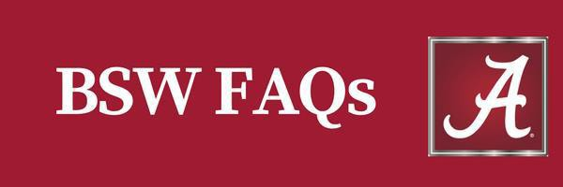
- Why should I declare a major in social work?
A degree in social work prepares students for professional social work practice, a growing and dynamic profession in which you promote the well-being of individuals, groups, and communities. Social workers are employed by hospitals, schools, child welfare agencies, criminal justice settings, advocacy organizations, organizations that serve veterans and active-duty military, mental health service providers, and more. The degree also provides an excellent foundation in problem-solving, communication, and inter-professional collaboration, skills which are valued by many professions and graduate degree programs.

- What are the prerequisites for the BSW Professional Program?
    - 54 hours, overall minimum GPA of 2.25
    - PY 101 or PY 105, SOC 101, and BSC 108 or BSC 109 or BSC 114/115, or BSC 116/117 or BSC 118 or BSC 120 completed with a C- or higher.
    - Math 100 or placement into college-level math (Math 110 or Math 112 or higher). Math classes must be completed with a C- or higher.
    - Minimum GPA of 2.50 in social work courses
    - Completed Professional Program application.
    - SW 100 or 105, SW 101, SW 310, SW 200 or 205, and SW 351 or 355 completed with a C- or higher.

- Do I have to take two literature classes and two history classes? NO!
    - You must take HY 101 or HY 102 (Western Civilization) or HY 105 or 106 (Honors Western Civilization) or HY 117 or 118 (World History). A student may take HY 103 or HY 104 (or 107 or 108) instead of HY 101, HY 102, 105, 106, HY 117 or HY 118 if they have taken GY 105 or SW 419 or ANT 225 or an Education Abroad Course at UA.
    - You must take either two literature classes and one history or two histories and one literature class.
    - You must take a sequence in either history or literature (e.g., HY 101 & HY 102 or HY 117 & 118); any two literatures).
    - Taking two literatures and one history will allow you to easily complete your humanities and fine arts requirements (e.g., any two literatures and HY 101, 102, 105, 106, 117 or 118).

- What else do I have to take to complete my core requirements?
    - You must complete Public Speaking (COM 123) or Critical Decision Making (COM 122) or one of the affiliated Honors sections of these courses) with a C- or higher. These are humanities classes.
    - You must complete two courses from the following list. At least one course must hold the SB designation and the two courses selected must not be from the same department. Honors sections of the courses listed below are also acceptable.

AAST | 201 | African American Studies (SB)
ANT | 100 | Introduction to Anthropology (SB)
ANT | 102 | Introduction to Cultural Anthropology (SB)
ANT | 103 | Discoveries in Archeology (SB) (HU)
ANT | 225 | Introduction to Global Health (SB)
BUI | 102 | Blount Initiative (SB)
COM | 220 | Interpersonal Communication (SB)
EC | 110 | Microeconomics (SB) (SS)
EC | 111 | Macroeconomics (SB) (SS)
GY | 105 | World and Regional Geography (SB) (SS)
GY | 110 | People, Places, and Environment (SB) (SS)
PSC | 101 | American Politics (SB)
PSC | 211 | State and Local Government
PSC | 370 | American Public Policy (SB)
SOC | 202 | Social Problems (SB)

- How do I decide what foreign language to take?
    - Computer Science classes do not satisfy our foreign language requirement.
    - If you did not have foreign language in high school, you should begin with a 101 class.
    - If you had less than two years of foreign language in high school, you should begin with a 101 class.
    - If you had two years of foreign language in high school, please refer to the Undergraduate Catalog for placement information or begin with a 101 class in another language.
    - If you place into a 102 class, or higher, you are required to take only that class (only one semester).
    - Many students choose Spanish because of the growing Spanish speaking population but others choose from the variety of language classes available.
    - American Sign Language (ASL) 101 and 102 satisfy this foreign language requirement.
    - Heritage language speakers should contact their appropriate language office to learn more about which classes they can take to fulfill this requirement.

- How can I complete my science requirements?
    - UA requires 8 credit hours of natural science, including a lab with each of the two classes.
      - The School of Social Work requires human biology (BSC 108 or 109 or BSC 114/115, or BSC 116/117 or BSC 118 or BSC 120) as one of your natural sciences. You must complete biology with a C- or better. If you earn a D in biology, that course can be used to satisfy the other Natural Science requirement.

- What math courses do I need to take and when?
    - One core math class (Math 110, Math 112, or a higher-level math class) completed at a C- or higher.
    - During orientation you may be informed that you need to complete Math 100 (and/or Math 005) before taking a core math.
    - You must be eligible for a core math before entering the Professional Program.
    - You must complete a statistics course before enrolling in SW 420/425 and beginning your field placement. Check the Undergraduate Catalog for Math prerequisites for each statistics class.

- What electives should I take?

    - To complete your required 120 credit hours, you may take “free electives.” “Free elective” means any university class of your choice.
    - If you are having difficulty with classes, you may want to take some of the study help classes, such as BEP 110, or BCE 101.
    - Some students choose to double major. If you choose to do so, your free electives should be taken in the second major subject area—discuss this with your advisor in the division of your other major.
      - You may wish to declare a minor. If so, you should take the classes required for that minor. You need to check with an advisor in the department of study to determine requirements for a minor.
    - In addition to your free electives, you must complete 6 hours of social work electives.
    - Refer to the class schedule in MyBama for social work electives that are offered in a given semester.

- What courses are considered social work electives?
Courses at the 100-400 level that are not required are considered social work electives. Below is a list of three-hour social work electives that have been offered in the past. Please note that additional electives may be offered in future semesters and not every elective is offered every semester.
        - SW 206 Growing Old in America
        - SW 208 Juvenile Delinquency
        - SW 210 Family and Child Welfare
        - SW 212 Death, Dying, and Bereavement
        - SW 300 Special Topics (topics vary from semester to semester)
        - SW 320 Volunteerism in Human Services
        - SW 414 Chemical Dependency
        - SW 415: Psychopathology*
        - SW 419 International Social Work
        - SW 457 Special Topics
        - SW 498 Independent Study
*SW 415: Psychopathology can serve as an elective and satisfy the Ancillary Psychopathology requirement.

- What grades do I need?
    - You must meet the University’s Scholastic Progress Standard. This standard specifies a minimum GPA—it varies with the number of credit hours you have achieved. Refer to https://catalog.ua.edu/undergraduate/about/academic-regulations/policies/warning-suspension/ for more information..
    - To be accepted into the Professional Program, you must have achieved an overall GPA of at least 2.25 and a Social Work GPA of at least 2.5.
    - Once you are in the Professional Program, you must maintain an overall GPA of at least 2.25 and a Social Work GPA of at least 2.5.
    - You must earn at least a C- in each course required by the School of Social Work.

- When is the deadline for application into the Professional Program?

    - The deadline for application is February 15 for admission in the following fall semester. The deadline for application is September 15 for admission in the following spring semester.
    - Missing the deadline may delay your admission into the program for 1 year.

- Why is the Professional Program application deadline so early?
    - Faculty need time to review all the applications and to make decisions. (Few faculty are available for such tasks during the summer.)
    - Having a decision during the spring semester allows you to plan for fall if you are beginning the program in the fall. Likewise, having a decision early in the fall semester allows you to plan for spring and summer.

- What if I think I am ready for the Professional Program, but I have not met all the prerequisites?
    - SEE YOUR ADVISOR
    - You may be eligible for conditional admission.

- Where can I find more information?
UA School of Social Work BSW Website: https://socialwork.ua.edu/academics/bsw-program/

